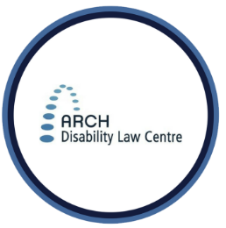
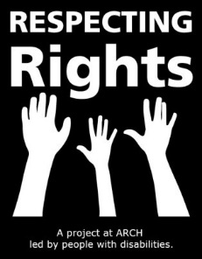
RESPECTING RIGHTS

Your Legal Right to Make Decisions about Your Health

In Ontario, the law says that people can make their own decisions about their health. This includes what medicine to take and other decisions about your health.
The law also says that in some situations your right to make decisions about your health can be taken away. Sometimes the law allows other people to make these decisions for you.
If you are a person with a disability living in Ontario and you want legal advice about your rights, call ARCH: 1-866-482-2724.

THINK ABOUT …

Have you had times you are not supported to ask
your doctor questions about your health care?
You can ask for help to make things easier when you go to the doctor. Help could be for:
- asking the doctor to say things so that you can understand
- asking for more time to make a decision about your health-having a support person come with you to doctor’s appointments
A support person can be someone you trust to help like:
- your parent
- a staff
- a friend
A support person can help you understand and remember what the doctor tells you.
A support person can help you to make decisions about your health.
CONTACT US
Respecting Rights Coordinator: Sue Hutton
huttons@lao.on.ca
1-866-482-2724 (Toll free)
416-482-8255 (Toronto)
416-482-1254 (TTY)
Extension: 2227
Staff/Parent Tip ...
Are there ways that the person with a disability in your life overcome barriers that prevent them from participating in activities?
Are they supported in knowing about their rights and asking for accommodations to make things more accessible?

