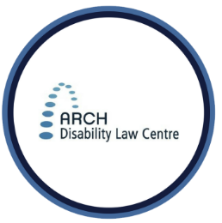
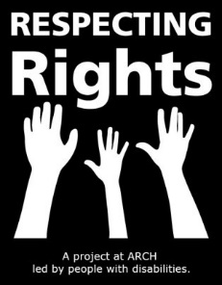
RESPECTING RIGHTS

Human Rights, Accessibility and Accommodations

In Ontario, people with disabilities have the human right to not be treated differently and unfairly.
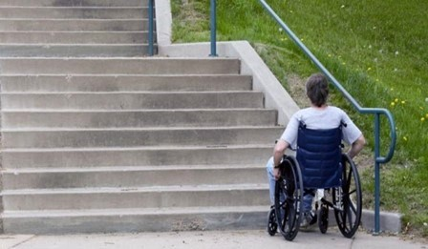
People with disabilities are allowed to participate, learn and make decisions just like everyone else.
You can ask government offices, landlords, schools, bosses at work and others to work with you to make sure you can understand and participate.
If you feel like you are in a situation where someone isn’t respecting your rights, try to get legal advice.
If you are a person with a disability living in Ontario and you want legal advice about your rights, call ARCH: 1-866-482-2724.

THINK ABOUT …
What are human rights? What are

accommodations? What is accessibility?
Being treated differently and unfairly because you have a disability is called discrimination.
Accommodations are things that you may need to help you be able to take part in activities. Accommodations help to fix some of the things that get in the way and stop people with disabilities from being able to participate or understand things.
You can ask for accommodations to help you participate, learn and make decisions.
REMEMBER: YOUR CHOICES MATTER
You can always ask for help in making sure you can let people know what you need or what you want.
CONTACT US
Respecting Rights Coordinator: Sue Hutton
huttons@lao.on.ca
1-866-482-2724 (Toll free)
416-482-8255 (Toronto)
416-482-1254 (TTY)
Extension: 2227
Staff/Parent Tip ...
Are there ways that the person with a disability in your life overcome barriers that prevent them from participating in activities?
Are they supported in knowing about their rights and asking for accommodations to make things more accessible?

