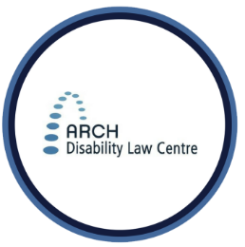
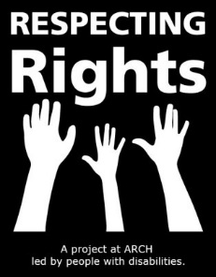
RESPECTING RIGHTS: MY VOICE, MY CHOICE

Your Legal Right to Make Decisions about Your Money

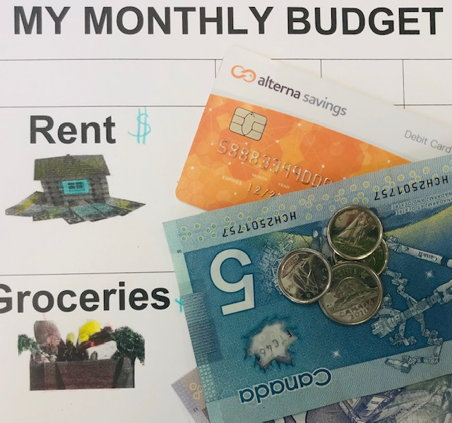
In Ontario, the law says that adults can make their own decisions about their money and property.
This includes decisions about how to spend your money, whether to apply for ODSP, Passport or other benefits, and managing an RDSP.
In some situations your right to make decisions about your money and property can be taken away.
Sometimes the law allows other people to make these decisions for you. If you are in this situation, try to get legal advice.
If you are a person with a disability living in Ontario and you want legal advice about your right to make decisions about your money, call ARCH: 1-866-482-2724.

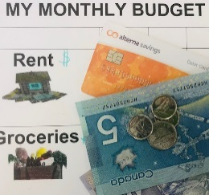
THINK ABOUT …

Are there times you were not supported to be
involved in decisions about your money?
Some people may need help to make decisions about their money.
For example, some people need help to make a budget. A budget is a plan which can help you understand how much money you can spend.
A support person (like a staff or family member) can help you with money, but how you use it is still up to you.
Remember: It’s YOUR money!
CONTACT US
Respecting Rights Coordinator: Sue Hutton
huttons@lao.on.ca
1-866-482-2724 (Toll free)
416-482-8255 (Toronto)
416-482-1254 (TTY)
Extension: 2227
Staff/Parent Tip ...
Are there ways that the person with a disability in your life overcome barriers that prevent them from participating in activities?
Are they supported in knowing about their rights and asking for accommodations to make things more accessible?

