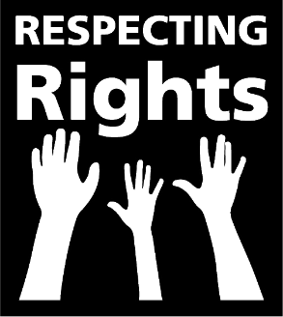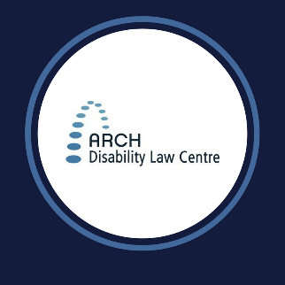

**5**

**Things to make Developmental Services Better**



**People’s Voices Need to Be Heard**

The government should learn from self-advocates by having regular accessible and supported meetings with them.

Self-Advocates must be part of helping to make developmental services better.



**Making Complaints Accessible**

People who use developmental services need a safe, accessible way to complain when there is a problem with their services.

Complaints should make services better.

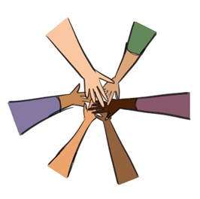

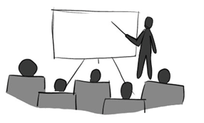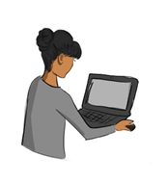

**Developed by Respecting Rights self-advocates across Ontario** [**www.archdisabilitylawcentre.ca/respectingrights**](http://www.archdisabilitylawcentre.ca/respectingrights)

**Same Rights for Everyone**

Everyone who uses developmental services should have the same rights.

Rights in developmental services should be written in a law so everyone has to follow them.

**Accessible Technology**

If the government decides to use technology in developmental services, it must be accessible and in plain language.

People must be given supports to use it.

**Better Staff Training**

Developmental services staff need better training about legal rights for people with disabilities.

People want supports to make decisions and choices in their lives.