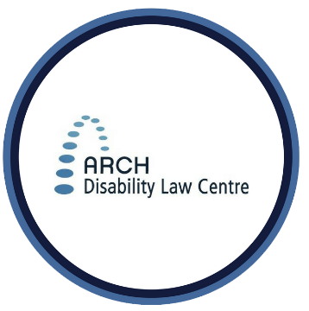
Summary for Video #1:
FACTSHEET
Accessible Canada Act

An Introduction to the Accessible Canada Act

What is this video about?
This first video is about the Accessible Canada Act (or the Act for short).

What are 3 important points covered in this video?
- The Act is a federal law. It explains how to make spaces and services more accessible. It has to be followed by the federal government and federal businesses and organizations.
- The Act works with human rights laws. Human rights laws give everybody the right to be treated equally. This includes people with disabilities and Deaf people. These laws protect people from discrimination.
- The Act gives goals for accessibility. It gives general rules about what federal organizations have to do to make things more accessible.

Looking for more information about the Accessible Canada Act and its regulations?
- To access the Accessible Canada Act, go to: https://laws-lois.justice.gc.ca/eng/acts/A-0.6/?wbdisable=false
- To access the Government of Canada’s description of the Accessible Canada Act, go to: https://www.canada.ca/en/employment-social-development/programs/accessible-canada.html
- To access ARCH’s fact sheet about the Accessible Canada Act, go to: https://archdisabilitylaw.ca/resource/fact-sheet-what-is-the-new-accessible-canada-act-aca/

For more information
ARCH offers public legal education presentations and free, confidential summary legal advice about the ACA and other accessibility laws to persons with disabilities in Ontario. Contact ARCH for more information about these services.
* The information provided in these materials is not intended to be legal advice. Consult a lawyer or legal worker if you need legal advice on a specific matter. This information is current as of April 2021.
Tel.: 416-482-8255; Toll-free: 1-866-482-2724
TTY: 416-482-1254; Toll-free: 1-866-482- 2728
www.archdisabilitylaw.ca

