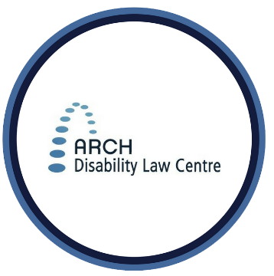
Summary for Video #2:
FACTSHEET
Accessible Canada Act

The Accessible Canada Act, Accessibility Regulations and Standards

What is this video about?
This second video is about rules and guidelines that come with the Accessible Canada Act. These are called ‘regulations’ and ‘standards.’ They are meant to help make our country more accessible and inclusive for people with disabilities and Deaf people.
Accessibility rules and standards are important. They set concrete rules and guidelines for federal organizations. They tell us how the Act will be put into action.

What are 3 important points covered in this video?
- The Act gives goals and general rules about accessibility. The Act says which government offices and lawmakers will make more specific regulations (or rules). These regulations are made by the Government of Canada, the Canadian Transportation Agency and the Canadian Radio-television and Telecommunications Commission (CRTC).
- Accessibility regulations tell federal organizations what they must do to remove barriers. They give the details on what must be done. The federal government must follow these rules. Federal businesses and organizations must also follow these rules.

- Accessibility standards give guidelines on how to make things more accessible. These standards are voluntary. Federal organizations can choose to follow the guidelines if they want. Guidelines are made by Accessibility Standards Canada. They describe how to offer information, products and services in an accessible way.

Looking for more information about the Accessible Canada Act and its regulations?
- To access the Accessible Canada Act, go to: https://laws-lois.justice.gc.ca/eng/acts/A-0.6/?wbdisable=false
- To access the Accessible Canada Act’s regulations, go to: https://www.canlii.org/en/ca/laws/stat/sc-2019-c-10/latest/sc-2019-c-10.html#regulation

For more information
ARCH offers public legal education presentations and free, confidential summary legal advice about the ACA and other accessibility laws to persons with disabilities in Ontario. Contact ARCH for more information about these services.
* The information provided in these materials is not intended to be legal advice. Consult a lawyer or legal worker if you need legal advice on a specific matter. This information is current as of April 2021.
Tel.: 416-482-8255; Toll-free: 1-866-482-2724
TTY: 416-482-1254; Toll-free: 1-866-482- 2728
www.archdisabilitylaw.ca

