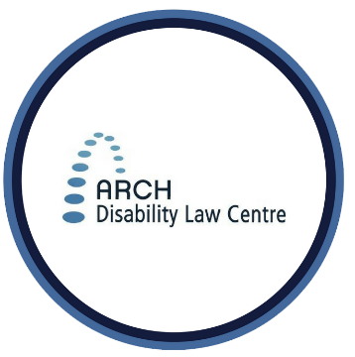
Summary for Video #4:
FACTSHEET
Accessible Canada Act

Giving Your Input when Regulations are Being Made

What is this video about?
This is the fourth video in this series. This video gives tips about how to give input to the Government of Canada, Canadian Transportation Agency, and CRTC when new regulations are being made. It explains how to get ready to give feedback. It tells you how to get the information you need. It also describes how to relate your living experiences to regulations when you give your input.

What are 3 important points covered in this video?
- The Government, Agency or CRTC may publish information about the regulation that has less legal language. This information may be a good starting point to understand the regulation. Reading this information is one way you can get ready to give your feedback about regulations that are being made.
- When giving your feedback, you may want to relate living experiences to regulations. One way to do this is to think about the problem the regulation is meant to solve. Will the regulation help to solve this problem? How might the regulation affect you or your community? Personal experiences and stories show how the regulation might affect people with disabilities and Deaf people.
- When giving your feedback, if you represent a disability organization or group, you should tell the Government, the Agency or the CRTC about who is in your group. It is also important to tell them about diversity in your group so they can understand your group’s perspectives.

For more information
ARCH offers public legal education presentations and free, confidential summary legal advice about the ACA and other accessibility laws to persons with disabilities in Ontario. Contact ARCH for more information about these services.

* The information provided in these materials is not intended to be legal advice. Consult a lawyer or legal worker if you need legal advice on a specific matter. This information is current as of April 2021.
Tel.: 416-482-8255; Toll-free: 1-866-482-2724
TTY: 416-482-1254; Toll-free: 1-866-482- 2728
www.archdisabilitylaw.ca

