___________________________________________
Request for Thematic Hearing during the 185th Period of Sessions of the Inter-American Commission on Human Rights
Human Rights Violations in Canada due to Medical Assistance in Dying Legislation
_______________________________________________

Submitted by a Coalition of Disability and Civil Society Groups and Organizations in Canada:
Association pour la santé environnementale du Québec – Environmental Health Association of Québec
British Columbia Aboriginal Network on Disability Society
Canadian Association of the Deaf
Citizens with Disabilities – Ontario
Council of Canadians with Disabilities
Dignity Denied
DisAbled Women’s Network Canada
Disability Filibuster
Disability Justice Network of Ontario
Disability Without Poverty
Inclusion Alberta
Inclusion BC
Inclusion Canada
Independent Living Canada
L’Arche Canada
National Network for Mental Health
People First of Canada
Tangled Art + Disability
Toujours Vivant - Not Dead Yet
Vulnerable Persons Standard August 15, 2022

Table of Contents
I. Summary 4
II. About Medical Assistance in Dying Legislation in Canada 6
III. For Persons with Disabilities who are Not Dying, Canada’s MAiD Law Violates the Right to Equality, Contrary to Article II of the American Declaration 8
A. The Law Targets Disability-related Suffering as an Eligibility Criterion for MAiD 8
B. The Law Devalues the Lives of Persons with Disabilities and Reinforces Negative Stereotypes about Disability 9
IV. Canada’s MAiD Law Fails to Safeguard Persons with Disabilities from Pressure, Coercion or Inducement to Resort to MAiD, Contrary to the Rights to Life and Equality (Articles I and II) in the American Declaration 13
A. Documented cases demonstrate that persons with disabilities are pressured, coerced or induced to resort to MAiD 13
B. Inequality experienced by persons with disabilities contributes to external pressure, coercion and inducement to resort to MAiD 14
C. Canada fails to safeguard persons with disabilities from pressure, coercion or inducement to resort to MAiD, contrary to the Rights to Life and Equality (Articles I and II) in the American Declaration 20
V. There is No Meaningful Autonomy When Choices are Severely Constrained 23
VI. Lack of Adequate Data Collection and Monitoring to Understand Discriminatory Impact of MAiD on Persons with Disabilities 26
A. About MAiD Data Collection and Monitoring 26
B. Gaps in MAiD Data Collection, Monitoring and Dissemination 27
C. Existing MAiD Monitoring and Data Collection Requirements Do Not Comply with International Human Rights Norms 29
VII. MAiD-related Government Processes are Not Addressing Human Rights Concerns of Persons with Disabilities 30
VIII. Conclusion 33
APPENDIX 1: Summary of Canada’s MAiD Legislation 35
APPENDIX 2: Summary of Federal MAiD Data Collection and Monitoring Regulations 37
APPENDIX 3: About the Organizations and Groups Presenting this Request for Thematic Hearing 40
APPENDIX 4: Cases of Concern 44

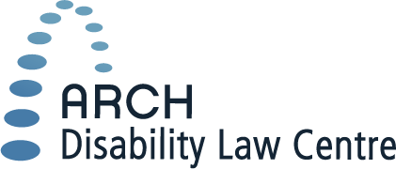
55 University Avenue, 15th Floor
Toronto, Ontario M5J 2H7
www.archdisabilitylaw.ca
(416) 482-8255 (Main) 1 (866) 482-ARCH (2724) (Toll Free)
(416) 482-1254 (TTY) 1 (866) 482-ARCT (2728) (Toll Free)
(416) 482-2981 (FAX) 1 (866) 881-ARCF (2723) (Toll Free)

Tania Reneaum Panszi, Executive Secretary
Inter-American Commission on Human Rights
Organization of American States
1889 F. St., NW
Washington, DC 20006
United States of America
cidhoea@oas.org

August 15, 2022
Dear Executive Secretary Tania Reneaum Panszi:

RE: Request for Thematic Hearing – Medical Assistance in Dying Legislation in Canada

On behalf of a coalition of 20 disabled people’s groups, grassroots disability justice advocates, and disability organizations, ARCH Disability Law Centre (ARCH) requests a thematic hearing during the 185th Period of Sessions of the Inter-American Commission on Human Rights (October 24-November 4, 2022), on a human rights matter of utmost urgency to persons with disabilities in Canada: medical assistance in dying.
“Medical assistance in dying” (referred to as MAiD) is the term used in Canada to describe legal, deliberate termination of life through the use of a substance administered by a medical practitioner or the person themselves.
In Canada, some persons with disabilities have died by MAiD because of their desperate social and economic circumstances, not because of suffering related to their medical conditions. Some persons with disabilities have resorted to medical assistance in dying out of desperation – because they are living in poverty, extreme isolation, loneliness, want to avoid institutionalization, or cannot get the services, supports or affordable healthy housing they need. Some have been encouraged to consider medical assistance in dying; we consider this to be a form of coercion. Appendix 4 (page 44) describes some of these cases.
Canada’s MAiD framework institutes measures to cause these deaths. Canada’s MAiD legislation targets disability-related suffering: disabled people who experience intolerable suffering may be eligible for MAiD, while those who experience intolerable suffering but are not disabled cannot be eligible for MAiD. The coalition requesting this thematic hearing is deeply distressed at the inherently discriminatory nature of the legislation and its grave consequences for persons with disabilities. In addition, Canada is considering further expanding eligibility for MAiD, without fully understanding the impact of the current and future legislation on persons with disabilities.
This is the coalition’s fourth request for a hearing at the Commission. As time goes on, the situation only continues to worsen. The coalition again requests a thematic hearing, under Article 66 of the Rules of Procedure of the Inter-American Commission on Human Rights, in order to give the Commission information about Canada’s MAiD legislation, its impact on the human rights of persons with disabilities in Canada, and the manner in which the recently amended law violates Canada’s obligations under the American Declaration on the Rights and Duties of Man (“American Declaration”).
The coalition does not seek to undermine the right to autonomy or legal capacity. Coalition members firmly believe that everyone must be free to choose, especially with regards to deeply personal decisions about life and death. The coalition submits that Canada’s law appears to offer freedom to choose medical assistance in dying, but in fact there is no freedom of choice for many disabled people who the legislation targets. Instead, they are pressured into MAiD by social and economic inequality, a lack of real alternatives to live with dignity in the community, or lack of appropriate medical services.

ARCH represents a coalition of 20 disability groups and civil society organizations who make this request for a thematic hearing, including:
- Association pour la santé environnementale du Québec – Environmental Health Association of Québec;
- British Columbia Aboriginal Network on Disability Society;
- Canadian Association of the Deaf;
- Citizens with Disabilities – Ontario;
- Council of Canadians with Disabilities;
- Dignity Denied;
- DisAbled Women’s Network Canada;
- Disability Filibuster;
- Disability Justice Network of Ontario;
- Disability without Poverty;
- Inclusion Alberta;
- Inclusion BC;
- Inclusion Canada;
- Independent Living Canada;
- L’Arche Canada;
- National Network for Mental Health;
- People First of Canada;
- Tangled Art + Disability;
- Toujours Vivant - Not Dead Yet; and
- Vulnerable Persons Standard.
This coalition is made up of disabled people’s groups, grassroots disability justice advocates and disability organizations from across Canada. They are secular organizations that represent or work directly with diverse communities of persons with disabilities. They are dedicated to disability rights advocacy and have been actively involved in domestic advocacy regarding MAiD.
In addition to the coalition, the following civil society organizations endorse and support this request:
- BCEd Access Society;
- Canadian Institute for Inclusion and Citizenship;
- Community Living Ontario;
- Department of Disability Studies, King’s University College at Western University;
- Disability Rights Coalition of Nova Scotia;
- Doing Disability Differently (research and activist group at the Ontario Institute for Studies in Education- University of Toronto);
- Eviance (CCDS Inc. operating as);
- Inclusion Saskatchewan;
- Institute for Research and Development on Inclusion and Society;
- New Brunswick Association for Community Living;
- Planned Lifetime Advocacy Network;
- School of Disability Studies, Toronto Metropolitan University; and
- Société québécoise de la déficience intellectuelle.

To date, the Commission has not yet examined the issue of medical assistance in dying legislation. Canada’s MAiD regime has been described as one of the most radical in the world. Although this request for a hearing focuses on Canada’s MAiD legislation, UN officials have expressed distress about a growing global trend to legalize medical assistance in dying or euthanasia. In particular, we draw the Commission’s attention to the fact that other states in the Americas have legislation similar to Canada’s MAiD law or have proposed to legalize some form of assisted death. A thematic hearing would be an effective means to bring regional and international attention to this critical human rights issue in Canada and throughout the Americas. Additionally, a statement and recommendations from this Commission about the implications of MAiD for Canada’s compliance with its international human rights obligations would encourage the Government of Canada to address the human rights concerns of persons with disabilities as they relate to MAiD.

Summary
In Canada, medical assistance in dying is a legal, public policy, and health care practice framework to enable the administration of a substance that will cause a person’s death at their request and the prescription or provision of a substance that a person can self-administer to cause their own death. To receive MAiD, Canadian law requires that a person must meet certain eligibility criteria, including having a serious and incurable disability, disease or illness; being in a state of irreversible decline of capability; and experiencing intolerable suffering caused by their illness, disease, disability or state of decline. When MAiD was first legalized in Canada, it was limited to situations where natural death was reasonably foreseeable, intended to allow people who were already dying or approaching death to seek a hastened death. In March 2021, the legislation was amended to expand eligibility for MAiD to people with serious disabilities, illnesses or diseases who are not dying.
In this request for a hearing, we use the terms persons with disabilities or disabled persons to mean all persons with disabilities, including those who have serious and incurable disabilities, diseases or illnesses (the language used in Canada’s MAiD legislation). This is consistent with the explanation provided by the UN Special Rapporteur on the Rights of Persons with Disabilities, the Independent Expert on the Enjoyment of all Human Rights by Older Persons, and the Special Rapporteur on Extreme Poverty and Human Rights, in their Joint Communication to Canada concerning MAiD:
In its present formulation this legislation risks furthering the devaluation of life with a disability and reiterating the ableist stereotype that significant disability can be worse than death. What if the term ‘disability’ were to be removed from the draft Bill? That would leave standing ‘serious and incurable illness, disease.’ However, what is a ‘serious and
incurable illness, [or] disease’ but a disability? Put another way, many if not most such illnesses or diseases either stem from or cause disability.
Canada’s MAiD legislation explicitly includes a distinction based on the legally protected ground of disability: under the law, disabled people who experience intolerable suffering may be eligible for MAiD, while those who experience intolerable suffering but are not disabled cannot be eligible for MAiD. This distinction in the law reflects the discriminatory view that the lives of people who experience disability-related suffering are less tolerable, less valuable, and less worthy of protection than the lives of people who experience suffering for reasons unrelated to a disability. This devaluing of the lives of persons with disabilities reinforces negative stereotypes about living with a disability, contributing to systemic ableism and negative social perceptions of persons with disabilities in Canada.
Persons with disabilities live in conditions of civil, social and economic inequality in Canada. The number of documented accounts involving persons who appear to have resorted to MAiD out of desperation arising from this inequality, rather than their personal medical conditions continues to grow. These accounts demonstrate that many people with disabilities cannot exercise free choice when it comes to MAiD because they do not have access to meaningful alternatives.
This coalition asserts that these factors amount to serious and urgent violations of the human rights of persons with disabilities under the American Declaration, including Article I - the right to life, which includes “having access to the conditions that guarantee a dignified existence”, and Article II – the right to equality and non-discrimination.
Moreover, this coalition is deeply troubled that Canada is not meeting the standard required under international law to collect and publish data which provide a true and comprehensive assessment of the impact that MAiD legislation has on persons with disabilities, and the extent to which safeguards in the legislation are effective at preventing people from being pressured, coerced or induced to resort to MAiD. Without such data, Canada can neither effectively monitor MAiD, nor ensure that the regime complies with its obligations to protect the rights to life and equality under Articles I and II of the American Declaration.
Further, this coalition is extremely concerned that, to date, government processes to study the impact of MAiD legislation have not adequately addressed the human rights concerns of persons with disabilities. Despite this, government-led processes to further expand eligibility for MAiD to other vulnerable groups are proceeding, causing concern that expanded eligibility for MAiD is likely to be layered onto an existing discriminatory regime.
Below we provide more details about the ways in which Canada’s MAiD legislation violates Articles I and II of the American Declaration.

About Medical Assistance in Dying Legislation in Canada
MAiD was legalized throughout Canada in 2016, when the Government of Canada amended Canada’s Criminal Code to allow for medically assisted death in certain circumstances. These amendments responded to a case decided by the Supreme Court of Canada which struck down the prohibition on assisted suicide in the Canadian Criminal Code. According to this decision, the Criminal Code prohibition on assisted suicide created a deprivation of the right to life, liberty and security of person not in accordance with fundamental justice under the Canadian Charter of Rights and Freedoms (Canadian Charter) because it prevented people who could clearly consent to MAiD from obtaining it when they had a “grievous and irremediable medical condition [...] that causes enduring suffering that is intolerable to the individual”. The case dealt with a person who was approaching their natural death due to a fatal illness (ALS) and the Court explicitly stated that it responded to the factual circumstances of the case and made no declaration about other circumstances in which people may seek MAiD.
The 2016 amendments to Canada’s Criminal Code provide a legal exception to the prohibition on assisted suicide that still applies. The law permits physicians and nurse practitioners to provide MAiD and pharmacists, family members or other people to assist in providing MAiD within certain conditions, without facing criminal charges. Under this law, MAiD was permitted only for persons with a serious and incurable illness, disease or disability; accompanied by an advanced state of irreversible decline of capability; and the presence of enduring and intolerable suffering to the person caused by the illness, disease, disability or decline.
On its face, the 2016 law was clear that MAiD was limited to end of life situations: the law authorized medical practitioners to administer MAiD only to persons suffering with serious diseases, illnesses or disabilities who were approaching death. Persons with or without disabilities whose death was not reasonably foreseeable were not legally eligible to receive MAiD. Limiting MAiD to people who were on a clear trajectory toward death was a critically important safeguard. It was included in the legislation to prevent the premature death of persons who might have years to live. It was understood as an absolute minimum level of protection. Disability rights advocates characterized this safeguard as preserving, “fundamental principles of equality by recognizing disability as a characteristic that is relevant but not determinative of MAiD eligibility.”
Subsequently, in a 2019 court decision, the Superior Court of Québec held that the 2016 MAiD law and Quebec’s Act Respecting End-of-Life Care violated the Canadian Charter. The Court found that restricting MAiD to persons whose death was reasonably foreseeable violated the right to equality and the protection against deprivations of life, liberty and security of the person in Canadian law that are not consistent with the principles of fundamental justice.
The Superior Court of Québec is a trial court in one province of Canada, and therefore its ruling applied only to that province. Instead of subjecting that ruling to the scrutiny of a higher appeal court and ultimately the Supreme Court of Canada, the Government of Canada chose not to challenge it. It is rare for a government not to defend its own legislation that has been found to be unconstitutional, particularly a law that was enacted only recently. However, rather than defend the legislation, the Government introduced new amendments to MAiD legislation, which Parliament adopted in March 2021.
The 2021 amendments significantly expanded eligibility for MAiD. MAiD is now legally permitted for persons whose death is reasonably foreseeable and for persons who are not near the end of their natural life and who meet the other eligibility criteria. For both categories, the legislation requires that certain threshold requirements must be met - for example, the person must be 18 years old or older, and must have made the request voluntarily. The person must also be provided with information about ways to alleviate suffering, give informed consent, make a written request that is signed, dated, witnessed, and supported by an opinion of a second independent medical practitioner, and receive an opportunity to withdraw their request. Where death is not reasonably foreseeable, the legislation includes additional requirements: consulting with a third independent practitioner if needed; informing the person of available medical and disability services and supports; and offering consultations with service providers; ensuring that available means to relieve suffering are discussed and considered; and providing a waiting period of 90 days. Appendix 1 at page 35 provides a more detailed description of the legislation.
In short, Canadian law now allows people who are suffering but not at the end of life to die by MAiD, provided they have a disability and meet the other eligibility criteria in the legislation. This expansion of MAiD means that it is no longer strictly a way to ease people into a less painful death (as it was under the 2016 MAiD legislation), but now is also a state-authorized response to claims of intolerable suffering from persons with disabilities who are not at the end of their lives.
Notably, in March 2023 eligibility for MAiD will be further expanded to people whose only underlying condition is a mental health disability.

For Persons with Disabilities who are Not Dying, Canada’s MAiD Law Violates the Right to Equality, Contrary to Article II of the American Declaration

The Law Targets Disability-related Suffering as an Eligibility Criterion for MAiD
Canadian disability rights advocates across a full spectrum of civil society, including grassroots groups, regional and national disability organizations, have been clear that the 2021 expansion of MAiD legislation to persons with disabilities who are suffering but not dying violates the right to equality and constitutes discrimination on the basis of disability. Under the law, where natural death is not reasonably foreseeable, only suffering that is caused by disability can render a person eligible for MAiD. No other group of people can receive MAiD due to suffering as a result of an immutable personal characteristic.
All people experience suffering at some point in life such as the loss of a child or partner, loneliness or social isolation, and for some, extreme poverty. For many people, this suffering is at times sustained and intolerable. Governments may respond with policies and programs aimed at remediating suffering, such as suicide prevention programs and social supports. MAiD is not, for good reason, counted among such social remedies. Nevertheless, under Canada’s current law, an exception exists for persons with disabilities who suffer intolerably: they are eligible to receive MAiD. In this way, the 2021 amendments to Canada’s MAiD legislation target disability-related suffering as an eligibility criterion for MAiD. Canada’s legislation treats people with disabilities who are suffering as a result of their disability differently than non-disabled people who are suffering: the former may be eligible for assisted death while the latter are not. It is this distinction, based on the protected ground of disability, that is discriminatory on its face and that has a discriminatory impact, thereby violating the right to equality under Article II.
Article II of the American Declaration provides that “[a]ll persons are equal before the law and have the rights and duties established in this Declaration, without distinction as to race, sex, language, creed or any other factor.” Since its inception, the Inter-American system has recognized the rights of persons with disabilities to equality and non-discrimination. Disability is a protected ground, which cannot be a legitimate basis
for arbitrary distinctions in law. This Commission has held that equality is especially important because it is the foundation for other laws and rights.
With respect to equality and non-discrimination, this Commission has noted that persons with disabilities have the right to special protection and that states have a special duty to satisfy the general obligations to respect and ensure human rights for vulnerable groups. This special duty extends to persons with disabilities.
This Commission has stated that “laws and policies should be examined to ensure that they comply with the principles of equality and non-discrimination; an analysis that should assess their potential discriminatory impact, even when their formulation or wording appears neutral, or they apply without textual distinctions”.
This Commission has also affirmed that equality and non-discrimination include both formal and conceptual or material equality. Formal equality requires objective and reasonable criteria for distinctions in the law and eschews unreasonable, arbitrary or capricious differences in treatment. Conceptual or material equality obligates states to create conditions of equality for historically disadvantaged groups.
The distinction that Canada’s MAiD law makes is explicitly based on the protected ground of disability. Those who experience intolerable suffering caused by their disability may be eligible for MAiD, while those who experience intolerable suffering related to exclusion and disadvantage they experience directly associated with their identity in other protected groups based on gender identity, sexual orientation, Indigenous status, race or ethnicity, but who are not disabled cannot be eligible for MAiD. This legal distinction discriminates against persons with disabilities, contrary to Article II of the American Declaration. This Commission has employed “a particularly strict level of scrutiny” when distinctions are made explicitly on prohibited grounds.

The Law Devalues the Lives of Persons with Disabilities and Reinforces Negative Stereotypes about Disability
Underlying this distinction in the law between those who are suffering as a result of their disability and those who are suffering for other reasons is the discriminatory view that living with a disability may be worse than death. It is not intolerable suffering that makes a person eligible for MAiD in Canada, but rather intolerable suffering caused by a disability. It follows that according to the law’s logic, there must be something about disability that is bad enough to justify the state’s intervention to hasten death. By targeting disability-related suffering for assisted death, MAiD legislation signals in Canadian public policy that the lives of people with disabilities who desire an end to suffering are less valuable and less worthy of preservation than others.
In turn, this devaluing of the lives of persons with disabilities reinforces negative stereotypes about living with a disability, thereby contributing to systemic ableism and negative social perceptions of persons with disabilities in Canada. During Parliamentary hearings about Canada’s current MAiD legislation, persons with disabilities testified before Canadian lawmakers. They spoke and wrote about how the legislation reinforces systemic ableism. For example, in a letter to Canada’s Senate, Aislinn Thomas wrote:
Many panelists and senators seem to be treating the expansion of MAID and the creation of a special track to early death as an intellectual exercise while those with lived experience and expertise seem to be seen as “too sensitive.” Our emotion is for good reason. As Trudo Lemm[e]ns points out, politicians seem to be pretending that this is a new conversation, one that it is detached from the traumatizing legacy of (and, many would argue, ongoing practices of) eugenics. Politicians seem to choose not to acknowledge that the majority of disabled people in Canada are also poor, racialized, struggling to survive, and not afforded access to the resources needed to live, let alone thrive. The passion expressed by so many disabled people is, I believe, the appropriate response to this conversation. What I want you to understand is that offering early death for disabled people in this context is not just morally reprehensible, which it most certainly is. It is also a loss. A collective loss. Disabled lives, like all lives, have inherent value. Disabled lives enrich our world. Grief, fear, outrage, and trauma are entirely appropriate responses to the status-quo, and to these discussions of Bill C-7. My heart hurts at the meagre support for, and continual devaluing of marginalized people in Canada. Everybody’s heart should be hurting.
People with disabilities also shared their concerns as part of a Government-led online public consultation about MAiD:
I am worried that people with disabilities could be seen as less worthy of life, or to have inherently less quality of life than non-disabled folks, consciously or not, by those around them including service providers, family members and physicians and that these attitudes and biases could affect decision making on the part of all parties involved.
Opening up MAID to people who are not dying poses significant risk to the lives of people with a disability. Throughout history, people with various types of disabilities have been devalued to the point that their deaths have been advanced and promoted within our health care and other systems. I was personally involved with 2 such situations a few years ago which left me shocked and saddened that people could be so vulnerable in spite of our rights to equality for all people.
These are just a few of the many grave concerns about the law’s discriminatory impact expressed by persons with disabilities to Canadian government officials and lawmakers.
Significantly, these concerns were echoed in a February 2021 Joint Communication to Canada by the UN Special Rapporteur on the Rights of Persons with Disabilities, the Independent Expert on the Enjoyment of all Human Rights by Older Persons, and the Special Rapporteur on Extreme Poverty and Human Rights. They stated that Canada’s current MAiD law risks, “reinforcing (even unintentionally) ableist and ageist assumptions about the value or quality of life of persons with disabilities and older persons with or without disabilities.” Further they stated that, “[f]rom a disability rights perspective, there is a grave concern that, if assisted dying is made available for all persons with a health condition or impairment, regardless of whether they are close to death, a social assumption might follow (or be subtly reinforced) that it is better to be dead than to live with a disability.” They found that “(b)y expanding access to medical assistance in dying based on disability …. the policy would ... have a potentially discriminatory impact on persons with disabilities and older persons who are not at the end of their life or nearing death from natural causes”.
In accordance with the Convention on the Rights of Persons with Disabilities, this Commission has interpreted Article II of the American Declaration as recognizing the social model of disability and the barriers that persons with disabilities experience. It has stated that “disability is not only defined by the presence of a physical, mental, intellectual or sensory impairment, but is interrelated with the barriers or limitations that exist socially for persons to be able to exercise their rights effectively.” Article II should be interpreted with reference to Article 5 of the CRPD, which specifically addresses non-discrimination against persons with disabilities. The CRPD Committee has stated that the right to equality should account for the human rights model of disability -- “that disability is a social construct and impairments must not be taken as a legitimate ground for the denial or restriction of human rights”.
International law recognizes that central to the right to be free from discrimination is the need to combat negative stereotypes which undermine equality. This Commission has held that under the American Declaration, states have a duty to implement positive measures, “to ensure the exercise of the rights of persons belonging to groups that are victims of structural inequality or have been the victims of historic processes of exclusion”. These positive measures should focus on removing barriers that “perpetuate or deepen” the “vulnerability and exclusion” of persons with disabilities. Rather than implementing positive measures, Canada’s legislation promotes the proposition that ending the lives of some people with disabilities is a preferable intervention.
The duty to take positive measures should be interpreted in accordance with Article 8 of the CRPD. Article 8 calls on States Parties to “promote positive perceptions and greater social awareness towards persons with disabilities” and to “combat stereotypes, prejudices and harmful practices” relating to persons with disabilities. In their February 2021 Joint Communication to Canada, the UN Special Rapporteur on the Rights of Persons with Disabilities, the Independent Expert on the Enjoyment of all Human Rights by Older Persons, and the Special Rapporteur on Extreme Poverty and Human Rights stated that, “Article 8 envisages a positive policy eco-system that takes great care to ensure that otherwise sound and well-intentioned legislation does not indirectly pivot on, or subtly reinforce, ableist assumptions in society. It is hard to see how a legislative proposal that extends a right to medically assisted dying to persons with disabilities who are not themselves close to death could send a signal that is compatible with Article 8 (obligations to combat ableism) combined with Article 5 (obligation to secure equal respect for rights) of the CRPD.”
Contrary to the duty under Article II of the American Declaration to implement positive measures, Canada’s MAiD legislation serves to reinforce rather than counteract damaging social forces of systemic ableism and negative social perceptions of persons with disabilities. These societal implications are particularly concerning, in light of the existing ableism and inequality experienced by persons with disabilities in Canada, as detailed in the next section below. MAiD legislation also serves to reinforce historical ableism. The Supreme Court of Canada has recognized the long history of discrimination and exclusion experienced by persons with disabilities in Canada. These discriminatory impacts of the law further demonstrate the manner in which the law violates the right to equality.
Legislation that contributes to systemic societal ableism must never be considered consistent with the American Declaration or international human rights standards.

Canada’s MAiD Law Fails to Safeguard Persons with Disabilities from Pressure, Coercion or Inducement to Resort to MAiD, Contrary to the Rights to Life and Equality (Articles I and II) in the American Declaration

Documented cases demonstrate that persons with disabilities are pressured, coerced or induced to resort to MAiD
In Canada, many persons with disabilities are at grave risk of being pressured, coerced or induced to resort to MAiD - not because they want to die but because they do not have the services, supports, affordable healthy housing, social conditions and resources necessary to live dignified lives in the community.
Deplorably, these are not theoretical concerns. In 2019, former Special Rapporteur on the Rights of Persons with Disabilities, Catalina Devandas Aguilar, reported that she had received information about persons with disabilities in institutions being persuaded to seek MAiD and of medical practitioners not formally reporting cases involving persons with disabilities. During her country visit to Canada, persons with disabilities told her they were offered the illusory “choice” between living in a nursing home and MAiD.
Since MAiD legislation was introduced in Canada, there are growing numbers of documented cases of persons with disabilities being pressured, coerced or induced to resort to MAiD because of a lack of viable alternatives:
- Archie Rolland, who was diagnosed with ALS or Lou Gehrig’s disease, requested and received MAiD after being transferred against his will from highly specialized care to a geriatric long-term care facility. In his new home, he did not have staff who could communicate with him and provide the essential care he needed. After documenting his sustained efforts at advocacy, he eventually resorted to MAiD. He told reporters that it wasn’t the illness that was killing him, but that he was “tired of fighting for compassionate care”.
- Similarly, Sean Tagert requested and received MAiD after he was told that he would have to move to a residential care facility far from home because he could not afford the 24-hour care he required at home. Moving would have required him to leave much of his essential communication technology behind and surrender the life-affirming pleasures of time spent with his young son. After fighting for home care for years, Sean Tagert resorted to MAiD, describing the funding decisions and institutional offerings available to him as “a death sentence.”
Members of this coalition have compiled more cases like Archie’s and Sean’s in which persons with disabilities experiencing extreme poverty, food insecurity, inadequate housing, and inadequate or inaccessible and prohibitively expensive medical care and/or services have considered, been pressured or resorted to die by suicide or MAiD. Significantly, Jean Truchon, one of the plaintiffs in the Québec court case that led to the 2021 changes to the law which expanded MAiD to people who are not dying, expressed a similar sentiment to Sean Tagert and Archie Rolland. In a statement made at a press conference announcing his court case, Mr. Truchon declared, "[a] life in institutions is not for me.”
These accounts are consistent with Canadian academic literature. For example, a recent study demonstrates that persons with disabilities are more likely to report suicidal ideation in part because of greater economic hardship, food insecurity, and a lesser sense of belonging in the community.
To understand how persons with disabilities are vulnerable to being pressured, coerced or induced to resort to MAiD, it is necessary to appreciate the systemic inequality that many persons with disabilities experience in Canada.

B. Inequality experienced by persons with disabilities contributes to external pressure, coercion and inducement to resort to MAiD
In Canada, persons with disabilities are more likely to experience poverty, inadequate housing or homelessness, unmet healthcare needs, incarceration, and ableist barriers that prevent them from living lives of dignity and human flourishing. Persons with disabilities who are further marginalized by their racialized, Indigenous, gender, sexual orientation or other identity status may have more barriers preventing them from accessing appropriate services and supports, thus compounding their vulnerability to being subtly or overtly pressured to resort to MAiD.
Persons with disabilities in Canada are more likely to be low income and to be disproportionately affected by homelessness and precarious housing. The Canadian Survey on Disability conducted in 2017 demonstrated that persons with disabilities between the ages of 25 to 64 years were less likely to be employed (59%) as compared to those without disabilities (80%). In particular, the income of persons categorized as having “severe disabilities” was half that of persons without disabilities. Estimates suggest that as many as 45% of the overall homeless population in Canada have physical and mental health disabilities. It is estimated that over one million Canadians with multiple chemical sensitivity (MCS) disability experience unmet needs including a severe lack of appropriate healthy housing on the lower end of the income scale. While a diagnosis is difficult to obtain, MCS continues to easily qualify for MAiD. Moreover, persons with disabilities experience long wait times for affordable accessible housing and some people - especially those labelled with intellectual disabilities, mental health disabilities, or cognitive disabilities - are frequently housed in institutions rather than in the community.

Although Canada’s single-payer, publicly administered healthcare system provides basic “core services” free of charge, some essential out-patient treatments and services, including drug therapies, some home care, communication and mobility technologies, some mental health and addiction supports and many community supports are paid out-of-pocket or by private insurers. People with disabilities who do not have independent financial means therefore find their options for living severely constrained. They are often forced to surrender a large measure of dignity and autonomy in order to secure needed care in state-managed residential or long-term care facilities.
Institutionalization and poor conditions in institutions have been reported as factors that contribute to people with disabilities suffering and seeking MAiD. In a Facebook post written in August 2020, Jennifer Turton-Molgat wrote: “My mom, the most positive, resilient, loving person I know has requested an assisted suicide. She wants to end her life, not because she is in pain or intolerable discomfort, but because she is being held prisoner in her long-term care home and has lost her will to live.” Raymond Bourbounnais died by MAiD after experiencing a “constant degradation of services” in a nursing home, wanting “to forget this bad part of my life”. Meanwhile, Arleen Reinsborough expressed a wish to apply for MAiD to avoid having to go to a long-term care home. Institutional living is particularly concerning, since the COVID-19 pandemic has exposed shocking conditions in long-term care homes in some Canadian provinces.

Speaking of his experiences with MAiD and living in an institution, Jonathan Marchand told the Canadian Senate:
In 2010, following a severe pneumonia, I ended up in intensive care. … Unable to speak, several doctors pressured me to accept euthanasia, “comfort care” as they called it, to end my life. I never asked for this. …
There are no support services to live outside of hospitals. I had to choose between killing myself or living in a hospital for the rest of my life. I was never offered the choice to continue my life at home with the required assistance. I wasn’t ready to abandon my partner, my family and my friends. I signalled my refusal to be euthanized.
I was prepared to do anything to get out of this medical hell, but just like Jean Truchon, I was denied the home care support that I needed. I complained to the highest instances. I was told that it was a political issue as living in the community with the necessary support is not a right in Canada. After two and a half years in the hospital, I ended up in a long-term care facility.
This place is a medical prison. You no longer have choice and control over your life. Your love life? It’s over. You can’t live with your partner. Your private life? Forget it. A record is kept on your every move. You are now the property of the government. Now it is managers, civil servants, nurses and others who will decide how you will live. You are too independent for their taste? They will break you. You have to submit to their rules. You have to be a good, kind, obedient, grateful little cripple.
Persons with disabilities in Canada also encounter ableist structures and practices in health services, and persons with disabilities are more likely than non-disabled persons to have unmet health care needs. Structural limitations of Canada’s health care system are more likely than personal reasons to be the cause of these unmet health care needs. Persons with disabilities also experience significant delays in receiving disability and health care services.
Some of these barriers reflect intersectional discrimination. For example, women with disabilities experience discrimination in health care when their self-reported pain is minimized, they are not given enough time to communicate, or they are provided with limited treatment options. LGBTQI2S persons with disabilities experience barriers to accessing health care, as they may be stigmatized and their health issues may be ignored because of attitudes about their sexual orientation or gender identity.
Data capturing the health outcomes of racialized people in the Canadian healthcare system is lacking, with studies of racialized people with disabilities being particularly sparse. Anti-Black racism, in the form of stereotypes, provider bias or lack of awareness has been reported by those interacting with the healthcare system. The few Black people with disabilities invited to testify before Canada’s Senate regarding MAiD called the now-current legislation “anti-black and anti-working class” and warned that the law may be “stigma-inducing.”
Indigenous persons with disabilities experience racism and ableism in health care services. There is a high rate of suicide in Indigenous communities attributed to inequalities in these communities and the devastating impacts of colonialism. Indigenous persons who testified before Canada’s Senate expressed concern about Canada’s MAiD legislation, referring to the health inequalities experienced by their communities.
The civil, social and economic inequality in which persons with disabilities live in Canada contributes to the very real and grave risk that they will be subtly or overtly coerced, pressured or induced to resort to MAiD. Within this context, MAiD is being provided to people whose suffering can be alleviated through other measures, such as the provision of timely, affordable, accessible housing, health care, income supports and disability services and supports. These forms of suffering are demonstrably preventable in Canada and should not be embraced as justifications for MAiD.

C. Canada fails to safeguard persons with disabilities from pressure, coercion or inducement to resort to MAiD, contrary to the Rights to Life and Equality (Articles I and II) in the American Declaration
Cases like those described above, involving persons who have resorted to MAiD out of desperation arising from their social circumstances, rather than their medical conditions, demonstrate that Canada has failed to implement adequate safeguards to prevent people from being pressured, coerced or induced to receive MAiD. This assessment is supported by data from Health Canada, which shows that a significant number of people who sought MAiD did so because of loss of dignity, a perceived burden on family and friends, isolation or loneliness. In 2021, Health Canada reported that 179 people that died by MAiD required disability supports but did not receive them. An additional 358 people that required disability supports died by MAiD and it is unknown whether they received those supports. Moreover, 1,968 individuals died by MAiD without the Government knowing whether they needed disability supports. In considering Health Canada’s reports from 2019 to 2021, it becomes apparent that 5,340 people in Canada who died by MAiD during this time period may not have had access to needed disability supports.
This coalition is extremely concerned that under Canada’s expanded MAiD regime, persons with disabilities who are dying and those who are not near the end of their natural lives are all made vulnerable to MAiD by external social pressure, coercion and inducement. However, for reasons outlined on pages 8-12 above, this coalition asserts that no safeguards can save the legislative provisions which permit access to MAiD for persons who are not near the end of life. As explained above, in their very intent and design, these legislative provisions constitute a fundamental violation of the right to equality protected under Article II.
In this section we explain how, for persons who are near the end of their natural lives (whose death is reasonably foreseeable), Canada’s failure to implement adequate safeguards violates the right to life on an equal basis as others, contrary to Articles I and II of the American Declaration.
Article I of the American Declaration provides that “[e]very human being has the right to life, liberty and the security of his person.” This Commission has held that the right to life is necessary to enjoy other human rights and if it is not respected, other rights have
less meaning. The Inter-American Court has stated that the right to life is the most fundamental right, without which other rights cannot be enjoyed. In Sawhoyamaxa, the Court explained that the fundamental nature of the right to life means that states have positive obligations, “to guarantee the creation of the conditions that may be necessary in order to prevent violations of such inalienable right.”
The Inter-American Court has confirmed that the right to life is to be interpreted broadly, and includes states’ duties to prevent and avoid circumstances that can lead to a person’s death. In Yakye Axa, the Court found that this is especially important for vulnerable groups, who are subject to poor or deteriorating social conditions.
For persons with disabilities the right to life is fundamentally interrelated with the right to equality. The UN Human Rights Committee has explained that the right to life (Article 6) in the International Covenant on Civil and Political Rights (ICCPR) recognizes the rights of persons with disabilities to “the effective enjoyment of the right to life on an equal basis with others.” States are required to provide “measures of protection” to guarantee this right, including “the provision of reasonable accommodation when necessary to ensure the right to life, such as ensuring access of persons with disabilities to essential facilities and services”. The right to life (Article 6) in the ICCPR includes obligations on states to ensure access to the essentials of life such as food, shelter, and water, as well as measures to combat stigmatization associated with disabilities which can undermine access to health care.
The UN Committee has interpreted the right to life (Article 6) contained in the ICCPR with reference to the right to life (Article 10) contained in the CRPD, which provides that, “States Parties reaffirm that every human being has the inherent right to life and shall take all necessary measures to ensure its effective enjoyment by persons with disabilities on an equal basis with others.” It is clear that the right to life is connected with the right to equality, and that it includes obligations on states to ensure access to the social conditions necessary for meaningful enjoyment of the right.
With respect to assisted dying, the UN Human Rights Committee’s General Comment on Article 6 states that it requires “robust legal and institutional safeguards to verify that medical professionals are complying with the free, informed, explicit and unambiguous decision of their patients, with a view to protecting patients from pressure and abuse.”
Consistent with the General Comment, the UN Committee has previously recommended that states strengthen their assisted dying safeguards.
This requirement for safeguards is imperative for persons with disabilities, given the civil, social and economic disadvantages they experience that contribute to their preventable suffering, and that may induce them to resort to MAiD. To be effective, safeguards must provide real options that actually ameliorate suffering and allow for meaningful alternatives to MAiD at the end of life. In her report to the Human Rights Council at its 43rd session, former UN Special Rapporteur on the Rights of Persons with Disabilities, Catalina Devandas Aguilar, called on the Government of Canada to enact adequate safeguards to ensure that persons with disabilities do not resort to MAiD because of the absence of community-based alternatives and palliative care. A similar recommendation was made to Canada by the CRPD Committee in its 2017 Concluding Observations. The Committee expressed its concern about the adoption of MAiD based on disability and recommended that Canada ensure that people who seek MAiD at the end of life have access to alternative courses of action and the supports necessary to live a full life in the community.
However, contrary to the CRPD Committee’s recommendation, Canada’s MAiD law requires that persons whose natural death is reasonably foreseeable only be provided with information about interventions and supports that might alleviate suffering. There is no explicit assurance that such services be available. There is no guaranteed right to access palliative care, in-home supports, affordable accessible housing, appropriate health care, essential services, employment, and the community, or other disability services and supports in Canada. The legislative language of these provisions carefully skirts any question of what happens when critical services and supports are not available, have excessively long waitlists or are only offered at levels that do not meet actual needs. In addition, many health care practitioners are not aware of available disability services, supports and resources and how to access them. Moreover, the legislation requires the practitioner to take all necessary measures to provide a reliable means by which the person may understand the information provided to them and communicate their decision, but it does not explicitly require the provision of disability accommodations to ensure that there is effective communication between the person requesting MAiD and the practitioner providing it. With no assurance that conditions of civil, social and economic inequality will be directly and positively addressed, there is no procedural safeguard sufficient to bring the MAiD provisions for people whose death is reasonably foreseeable into compliance with the requirements of the right to life. Canada’s MAiD regime falls short of the necessary institutional and legal safeguards to meet international law requirements. Without meaningful safeguards, persons with disabilities at the end of their lives are vulnerable to external pressure to resort to MAiD, contrary to Articles I and II of the American Declaration.

There is No Meaningful Autonomy When Choices are Severely Constrained
The Government of Canada has consistently taken the position that the 2021 expansion of MAiD eligibility to persons with disabilities who are suffering intolerably but are not dying appropriately balances the interests of autonomy (people should have the right to choose MAiD) with the need to prevent suicide and protect vulnerable persons from ending their lives prematurely.
This coalition submits that the Government of Canada’s position should be rejected because it is overly simplistic and fails to account for the context in which autonomy is exercised. Autonomy, in this case the choice to request MAiD, must be understood in the context in which it operates. People do not make choices in a vacuum, but rather their choices are influenced and determined by the civil, social, economic and political context in which they live. To be eligible for MAiD, whether at the end of life or not, Canada’s legislation requires that a person have a serious and incurable illness, disease or disability. As a result, it is only persons with disabilities (including illnesses and diseases) who meet the remaining eligibility requirements who can request MAiD. The choice to do so must, therefore, be understood within the context in which persons with disabilities live in Canada.
Equality rights principles affirm the need to understand autonomy contextually. The Supreme Court of Canada has held that “equality looks not only at the choices that are available to individuals, but at ‘the social and economic environments in which [they] pla[y] out’”. An equality analysis recognizes that some people may be disproportionately affected by structural conditions which constrain their choices.
As explained above, the choices available to people with disabilities can be profoundly limited by poverty, inadequate inaccessible housing, limited access to healthcare and other services, institutionalization, social isolation and loneliness as well as intersecting discrimination and marginalization. In testimony before Canada’s Senate, Jonathan Marchand explained that, “[t]here can be no death with dignity and freedom of choice as long as we are forced to live in institutions, made to feel like burdens, while we face discrimination and systemic violence at all levels.” For many people with disabilities who lack meaningful alternatives to assisted death, choice is illusory at best, and at worst a smokescreen for social abandonment.
The UN Special Rapporteur on the Rights of Persons with Disabilities, the Independent Expert on the Enjoyment of all Human Rights by Older Persons, and the Special Rapporteur on Extreme Poverty and Human Rights have recognized that many persons with disabilities in Canada are not in a position to exercise free, unconstrained choice when making decision about MAiD. In their February 2021 Joint Communication to Canada, these experts stated:
It is not beyond possibility that, if offered an expanded right as per Bill C-7, persons with disabilities may decide to end their lives because of broader social factors, including loneliness, social isolation and lack of access to quality support services. Indeed, persons with disabilities, particularly older persons with disabilities, may be vulnerable to explicit or implicit pressures arising from their context, including expectations from family members, financial pressures, cultural messages.
The Government’s position that MAiD legislation appropriately balances competing interests of autonomy and protection of vulnerable groups fails to account for the real-world context that severely constrains free choices about MAiD for persons with disabilities in Canada. There can be no meaningful autonomy when choices are severely constrained. The Government’s position also disregards alternative policy proposals advanced by members of this coalition. These failings seriously undermine the validity of the balancing that the Government purports the legislation achieves.
The Government of Canada defends the legislation by asserting that the additional safeguards of MAiD for people whose death is not reasonably foreseeable are an adequate response to concerns raised by disability rights advocates. In doing so, the Government has conceded that expanding eligibility for MAiD to persons who are not dying does in fact create greater vulnerability for persons with disabilities. For reasons similar to those outlined above at pages 20-23, this coalition emphasizes that the additional safeguards in the legislation do not adequately address this heightened vulnerability; the safeguards require the provision of information and referrals but do not ensure real life access to appropriate accessible housing, income supports, disability services, and medical care needed to ensure that people with disabilities have meaningful choices and can exercise free and informed consent to MAiD. The legislation does not create any new rights or entitlements guaranteeing access to necessary social and economic supports. In addition, the legislation requires the practitioner to take all necessary measures to provide a reliable means by which the person may understand the information provided to them and communicate their decision, but it does not explicitly require the provision of disability accommodations to ensure that there is effective communication between the person requesting MAiD and the practitioner providing it. The Government’s position demonstrates a fundamental failure to appreciate the context in which MAiD operates in Canada and the nature of the elevated risks that are triggered by expanding eligibility for MAiD to persons with disabilities who are not dying.
The Government’s reliance on safeguards to respond to the concerns of disabled advocates is naïve to the pervasive and pernicious influence of ableism in the healthcare context. Research demonstrates that medical practitioners are not immune to ableist influence in their assessments and practice. Given this context, it stands to reason that legislative safeguards are not always implemented fully or effectively. Indeed, members of this coalition have observed that in practice, safeguards are not always meaningful.
Moreover, the Government’s position does not respond to the argument described above that the legislative provisions allowing for MAiD for people whose death is not reasonably foreseeable are inherently discriminatory; these provisions make a direct distinction based on the protected ground of disability and result in the deepening of existing ableism and negative stereotypes about the value of disabled lives.

Lack of Adequate Data Collection and Monitoring to Understand Discriminatory Impact of MAiD on Persons with Disabilities
Collecting sufficient data and monitoring the impact of MAiD is essential to understanding whether Canada’s MAiD regime complies with its obligations to protect the rights to life and equality under Articles I and II of the American Declaration.

About MAiD Data Collection and Monitoring
On November 1, 2018, federal regulations regarding MAiD data collection and monitoring came into force. These regulations created a pan-Canadian MAiD monitoring regime that set out the reporting requirements for physicians and nurse practitioners who provide MAiD, and pharmacists who dispense MAiD drugs. Health care practitioners are required to collect and submit MAiD-related information to the Federal Minister of Health. The regulations also require the Federal Minister of Health to publish a public report each year with some, but not all, of the collected data. Appendix 2 at page 37 provides a more detailed description of the data required to be collected and reported under these regulations.
When MAiD legislation was expanded in March 2021, changes were also made to Canada’s data collection and reporting regime. These changes authorize the Minister of Health to develop additional regulations regarding the collection of information about unwritten MAiD eligibility assessments and information from pharmacists who may provide MAiD drugs to medical practitioners. These amendments also allow for the development of federal regulations to collect data related to race, Indigenous identity and disability, and to seek to determine the presence of individual or systemic inequality. The Government anticipates that data reflecting these changes will only be reported in 2024 or 2025, leaving several years during which MAiD will operate with neither government monitoring nor public accountability for inequality or adverse impact upon vulnerable groups.

Gaps in MAiD Data Collection, Monitoring and Dissemination
Since the implementation of the MAiD data collection and monitoring regulations, it has become clear that there are gaps in the data being collected about each MAiD death, gaps in the information being disseminated in the Minister of Health’s annual report, and gaps in the analysis of the data that is collected. To date, data collection and measurement efforts have provided a superficial understanding of the impact that Canada’s MAiD regime has on persons with disabilities. “By the end of December 2019, over 13,000 Canadians died with medical assistance. For almost 10,000 of those MAiD cases, we have no publicly accessible evidence that the eligibility criteria and safeguards prescribed by law were respected.” Furthermore, the data does not offer an accurate account about whether those who received MAiD lived in a long-term care or residential care facility, were homeless, or in a private residence because it does not offer important data for those who received MAiD in hospitals. This demonstrates an error in the way in which the data is collected.
In 2021, Health Canada reported that there were 10,064 individuals that died by MAID in Canada, which represents a staggering 32.4% growth rate from 2020. This amounts to a total number of deaths since the passing of the legislation in 2016 at 31,664 deaths (excluding 2022). With the introduction of the MAiD amendments in 2021, 219 individuals who died by MAiD were identified as not having a reasonably foreseeable natural death.
Other stark examples of the inadequacy of data collection are the growing number of documented cases of persons with disabilities being pressured, coerced or induced to resort to MAiD because of a lack of viable alternatives, described in Appendix 4 at page 44. These cases did not come to light via the official MAiD data collection and monitoring regime. Instead, they were documented by media, family and friends, and community-based disability organizations, including members of this coalition.
Despite the 2021 amendments to the data collection and monitoring regulations, disability communities remain deeply concerned that existing and future data collection and monitoring will fail to capture and analyze information necessary to understand the real impact of MAiD on persons with disabilities.
When the 2018 MAiD monitoring regulations were being developed, disabled persons organizations (DPOs) and disability groups called for a robust and holistic monitoring system. DPOs insisted that this system should include information that provided a fulsome understanding of the nature and extent of the suffering that motivates people to resort to MAiD. These data should also reflect the extent to which that suffering is the result of lack of services, supports and resources to ensure a dignified life in the community. DPOs called for information about the person’s income, social support network, whether or not the individual requesting MAiD had access to the services and supports they required, and the nature of their disability. Additionally, DPOs called for data regarding what alternative courses of action to relieve suffering had been identified and explored by the individual’s medical practitioner(s) and care team. This information would help to understand the supports that were available and whether the options presented to the person actually ameliorated suffering and allowed for meaningful alternatives to MAiD. This information is crucial in order to understand whether the safeguards in the legislation fulfill the requirement, under Article I (right to life) of effective procedural and institutional safeguards.
Much of the data that DPOs advocated for is not required to be collected by the regulations. Below are just a few examples of gaps in MAiD data collection, analysis and dissemination. Many additional gaps exist.
No information directly from the person requesting MAiD: Current data collection provides an incomplete profile of persons with disabilities and their civil, social and economic circumstances, making it impossible to assess whether persons with disabilities are being pressured, coerced or induced to resort to MAiD. For example, the regulations do not require the collection of a first-person narrative as to why MAiD is being requested. As recommended by DPOs, this information is necessary to understand the extent to which MAiD requests are motivated by preventable suffering linked to structural inequalities and the absence of services, supports and resources.
Incomplete demographic data: Notably, disaggregated demographic data is collected in other policy areas, but demographic data about MAiD is incomplete. For example, income of persons requesting MAiD, immigration status, language spoken other than English or French, and information on social support networks are not currently collected. This results in a gap in understanding whether low-income persons, racialized and immigrant persons, and socially isolated persons (with and without disabilities) are over-represented in MAiD. Postal codes of residence are collected but need to be expanded to identify homeless persons (with and without disabilities) to ensure that this population is not over-represented in MAiD.
Incomplete data about services and supports: Data collected on whether a person receiving MAiD had access to palliative care and disability services and supports are incomplete. These data do not include an assessment of what type of disability services and supports were received, what type of palliative care was received, from whom, and the quality and adequacy of that care in meeting the person’s needs. Data are not collected about access to specialized health practitioners such as geriatricians or specialists in care for persons with intellectual and/or developmental disabilities. This results in a gap in understanding whether seniors (with and without disabilities) and persons with disabilities who have complex needs are over-represented in MAiD.

C. Existing MAiD Monitoring and Data Collection Requirements Do Not Comply with International Human Rights Norms
The jurisprudence of the Inter-American Court has established that states have a duty to monitor the provision of health care services. In Ximenes-Lopes, the Inter-American Court considered the mistreatment of a person with a mental health disability in a private institution contracted by the state. The Court found that states have a duty to regulate and supervise institutions which provide health care services, as part of their special responsibility to protect the life and integrity of people receiving care. Further, the case affirmed that states are required to investigate any breaches of human rights that they have reason to believe may be occurring, and to take measures to improve or prevent violations of the rights of people who use health care services. Like institutions, MAiD is provided as part of Canada’s public health care services. As such, Canada has a duty to monitor the provision of MAiD as part of its special responsibility to protect the right to life and the integrity of persons who resort to MAiD.
Article 31 of the CRPD requires States to collect statistics and data to identify how CRPD rights are being implemented and to design programs and policies that give effect to the CRPD. Data collection must measure socially constructed barriers (physical, communicative, attitudinal) that could prevent or impede a person’s full and effective participation in society on an equal basis with others. States are required to use an intersectional approach to data collection, and to publicly disseminate data in accessible formats while also protecting confidential information.
To comply with the standard for monitoring described in Ximenes-Lopes and the data collection requirements elaborated in the CRPD, Canada must collect and publish data which provide a true and comprehensive assessment of the impact that MAiD legislation has on persons with disabilities, and the extent to which safeguards in the legislation are effective at preventing people from being pressured, coerced or induced to receive MAiD. This is essential in order to monitor whether Canada’s MAiD regime complies with its obligations to protect the rights to life and equality under Articles I and II of the American Declaration.
Gaps in data currently collected under the existing regulations make it clear that the regulations do not meet this standard. Canada’s existing regime is wholly inadequate at identifying barriers created by and related to MAiD legislation that prevent persons with disabilities from freely exercising their rights to life and equality.
The Government of Canada consulted on amendments to the MAiD monitoring and data collection regulations. Going forward, persons with disabilities must be meaningfully engaged in any changes the Government makes to MAiD monitoring regulations and requirements. Article 31 of the CRPD calls for the inclusion of persons with disabilities and their representative organizations in the collection, analysis and dissemination of data. Any changes to MAiD monitoring regulations must address the identified data gaps and human rights concerns of persons with disabilities.

MAiD-related Government Processes are Not Addressing Human Rights Concerns of Persons with Disabilities
Since MAiD was first legalized throughout Canada in 2016, disability rights advocates have expressed grave concerns about the legislation to lawmakers, elected officials and Government representatives. They continue to do so. Despite these significant and ongoing efforts, the Government of Canada has failed to address these human rights concerns appropriately.
At the time of writing, the Government of Canada has initiated several policy and law-making processes concerning MAiD. We will speak about the two most recent: The Parliamentary review of MAiD legislation and the Expert Panel on MAiD and Mental Illness.
The Parliamentary review of MAiD legislation was supposed to be conducted before the 2021 amendments that expanded eligibility for MAiD to people whose death is not reasonably foreseeable. However, the review was delayed and only began after the expanded MAiD regime became law. During Parliamentary debates about the 2021 amendments to MAiD legislation, Government officials stated that this review would be the appropriate forum to address the human rights concerns of persons with disabilities. This coalition submits that, to date, this Parliamentary review has not done so.
The Special Joint Committee on MAiD is tasked with reviewing Canada’s MAiD legislation and its application with respect to mature minors, advance requests, mental illness, the state of palliative care in Canada and the protection of Canadians with disabilities. Each of these five issues is multi-faceted and highly complex. It is not possible for the committee to adequately review and make recommendations on even one of these issues, let alone all five, within the short time frame allotted for this work.

People with disabilities and their allies have been met with procedural barriers to participation. The parliamentary committee has been exclusionary in determining who to invite to present. Presentations are by invitation only and people with disabilities and their allies are most often positioned as the opposing voice on a panel. When a person is called to present, they are given very little time to prepare and are allocated five minutes to speak. This process unfolds despite how the Minister of Justice positioned the parliamentary review process as “an appropriate forum for examining the issues without time constraints.”

The parliamentary committee put a 1000-word cap on submissions for written evidence. It is impossible to adequately address the long list of issues before the committee in 1000 words. The committee put this word limit in place and imposed a new submission deadline mid-way through the study process. Committee members voted to alert the public through a press release because, in the words of one committee Senator, "those people who are interested will be following along."

Coalition members who presented to the Special Joint Committee on MAiD as part of the parliamentary review note that the process was very politicized, that they felt dismissed and ignored, and that they were the recipients of aggression and unprofessional behavior. Some spoke of marginalization due to race and disability.

Coalition members spoke of a “zealous partisan atmosphere” that was “remarkably biased”. Hearings were structured so that each panelist was given 5 minutes to speak followed by a question and answer period. Coalition members report that committee members directed “snide and self-serving questions” towards people who affirmed their personal ideology. Concerning cases of MAiD for persons with disabilities were said to be “anecdotes and not evidence” serving to undermine the credibility of the disability rights community’s claims of abuse.

Coalition members felt ignored. Few if any questions were directed towards them. In effect, this meant that they were not given the opportunity to expand on issues of concern. One shared that the lack of follow up questions, “felt like a passive way of dismissing what I had to say”.

This “micro-aggression of being deliberately ignored” was just one form of aggression being directed towards those who presented to the committee. Coalition members also reported being “talked over,” “cut off from answering,” “argued with,” and “badgered,” as well as having their “words twisted,” and their “credibility undermined.” In summary, a coalition member shared, “I have never in my life been treated so poorly.”

The committee will reconvene in September 2022 but has already failed to live up to what had been promised before the passage of the legislation expanding Canada's medical assistance in dying regime. The committee's final report is due in October 2022 - the report is non-binding and can only be accepted or rejected by the Government.

The Expert Panel on MAiD and Mental Illness was charged with a narrow exercise of studying the safeguards for MAiD on the basis of “mental illness”. The Expert Panel’s process and its final report have been criticized as being biased and failing to include the perspectives of persons with disabilities. Of the 12 people on the Expert Panel, the vast majority were psychiatrists and health care professionals. Only two were representatives from communities of persons with mental health disabilities, one of whom resigned before the Expert Panel concluded its work. A second Expert Panel member also resigned. He publicly denounced the Expert Panel’s process and governance. He explained that the Chair of the Expert Panel was a nationally-recognized strong advocate for MAiD on the basis of mental illness; that the process discouraged Expert Panel members from bringing forward relevant issues for deliberation; and that there was a lack of transparency regarding dissenting views or opinions. Ultimately, this Panel member could not sign off on the final recommendations of the Expert Panel.
The Expert Panel concluded that Canada’s existing MAiD regime provides an adequate structure for the provision of MAiD on the basis of mental illness. The Expert Panel recommended that additional safeguards should apply to the provision of MAiD, but stated that these safeguards do not need to be legislated. This undermines the seriousness of the recommendation, since there is no requirement for medical practitioners to implement or comply with safeguards that are not legislated.
However, the panel also recommended, for example, that a person be permitted to request MAiD while confined to a psychiatric facility and being forcibly treated, provided that they have been in this “situation of involuntariness” for more than six months. The Expert Panel report further provided guidance on providing MAiD when capacity to consent is in question. The committee then went so far as to recommend that these lessons, on MAiD in “situations of involuntariness” and when capacity is in question among other things, be applied to the eligibility of persons with intellectual disabilities.
Going forward, Canada is considering further expanding MAiD to include mature minors and persons who are no longer capable of consenting to MAiD but have made prior capable advance requests. Each of these developments raise serious alarms about the normalization of death as a remedy for suffering, exclusively for persons with disabling conditions. It is deeply concerning that processes to further expand eligibility for MAiD are proceeding without having addressed the human rights concerns with the existing legislation. Expanded eligibility for MAiD is likely to be layered onto an existing discriminatory regime.
Government-initiated processes intended to address the human rights concerns of disability advocates have, thus far, been ineffective. Given the failures to date of Canada’s domestic processes, it is even more vital that this Commission hold a hearing about MAiD. A hearing is necessary to ensure that these concerns are not ignored, and to allow the Commission to examine the extent and manner in which Canada’s MAiD legislation violates Canada’s obligations under Articles I and II of the American Declaration.

Conclusion
Based on the information and legal arguments detailed above, this coalition of 20 disabled people’s groups, disability advocates and disability organizations representing diverse disability communities from across Canada asserts that Canada’s medical assistance in dying legislation discriminates against persons with disabilities, in violation of their rights to life and equality (Articles I and II) set out in the American Declaration.
The coalition respectfully requests that this Commission hold a thematic hearing to receive and examine information about the human rights situation of persons with disabilities in Canada in relation to medical assistance in dying.
Should the thematic hearing be granted, this coalition will respectfully request that the Commission:
- Issue a statement describing the nature and extent to which Canada’s MAiD legislation violates the American Declaration on the Rights and Duties of Man.

- Issue a statement expressing serious concern about these international human rights violations resulting from Canada’s MAiD legislation, and urging the Government of Canada to take comprehensive measures to bring the legislation into compliance with international human rights laws. Included among these measures is removing the legislative provisions allowing persons with disabilities whose death is not reasonably foreseeable to be eligible for MAiD.
- Conduct a study to investigate and document civil, social and economic conditions that lead people with disabilities in Canada to suffer intolerably and to consider, request, resort to or access MAID, whether voluntarily or as a result of external pressure, coercion or inducement. This study must include the experiences and perspectives of persons with disabilities, disability rights advocates, and disabled persons organizations. It must include the experiences and perspectives of Indigenous disability groups, women with disabilities, racialized persons with disabilities, gender diverse persons with disabilities, and other people with disabilities who experience intersectional discrimination. This coalition will provide as much assistance and support as possible to the Commission to conduct this study.
- Urge the Government of Canada to significantly strengthen MAiD monitoring and data collection regulations by:
  - Ensuring that amendments to these regulations address identified data gaps and concerns of persons with disabilities; and
  - Ensuring that adequate data, including disaggregated demographic data, are collected, analyzed and reported to truly and comprehensively understand the impact of MAiD on: people with disabilities who resort to MAiD and whose natural death is reasonably foreseeable; people with disabilities who resort to MAiD and whose natural death is not reasonably foreseeable; and people with disabilities who do not resort to MAiD but whose lives and self-perceptions are affected by a law and health care system that provide for terminating the lives of people like them, based on their disability.
This coalition requests that representatives from Health Canada, Department of Justice, and Disability Inclusion participate in the hearing, if granted.
On behalf of this coalition, we thank you for considering this request for a thematic hearing. Please do not hesitate to contact us if you require more information or clarification.
Sincerely,
ARCH Disability Law Centre

Original letter has digital signature Original letter has digital signature

Kerri Joffe Robert Lattanzio
Staff Lawyer Executive Director
joffek@lao.on.ca lattanr@lao.on.ca
Legal Counsel for the Coalition Legal Counsel for the Coalition

APPENDIX 1: Summary of Canada’s MAiD Legislation
With the 2021 amendments, MAiD is now permitted for persons whose death is reasonably foreseeable and for persons who are not near the end of their natural life and who meet the eligibility criteria. To be found eligible for MAiD, a person:
- must be eligible for government-funded health services in Canada;124

- be 18 or older and capable of making health-related decisions;
- have a “grievous and irremediable medical condition”. This means that a person must have a serious and incurable illness, disease or disability, be in an advanced state of irreversible decline in capability, and have enduring physical or psychological suffering “that is intolerable to them and that cannot be relieved under conditions that they consider acceptable”;
- make a voluntary request for MAiD that is not the result of external pressure; and
- after having been provided with information about ways to alleviate suffering, give informed consent to MAiD.
In addition, for persons whose natural death is reasonably foreseeable, a medical practitioner must:
- ensure that the person’s request for MAiD was made in writing and signed and dated;
- ensure that the person was informed they have a grievous and irremediable medical condition;
- ensure that the request was signed and dated before an independent witness. This is a less stringent requirement than under the 2016 MAiD law, which required 2 witnesses;
- ensure the person was informed that they may at any time withdraw their request;
- ensure that a second independent medical practitioner provides a written opinion confirming that the person meets all the criteria;
- if the person has difficulty communicating, take all necessary measures to provide a reliable means by which the person can understand information provided to them and communicate their decision; and
- immediately before providing MAiD, give the person an opportunity to withdraw their request.
For persons whose natural death is not reasonably foreseeable, a medical practitioner must fulfill the above requirements and the following additional requirements:
- if neither the medical practitioner nor the independent medical practitioner has expertise in the condition that is causing the person’s suffering, they must consult with another independent practitioner who does have that expertise;
- ensure that the person has been informed of the means available to relieve their suffering, including counselling services, mental health and disability support services, community services and palliative care and has been offered consultations with relevant professionals who provide those services;
- ensure that they have discussed with the person the reasonable and available means to relieve the person’s suffering and agree that the person has given serious consideration to those means; and
- ensure that there are at least 90 days between the day on which the person was assessed for eligibility for MAiD and the day on which MAiD is provided. This 90-day period can be shortened if the person will imminently lose their capacity to consent to MAiD.

APPENDIX 2: Summary of Federal MAiD Data Collection and Monitoring Regulations
These regulations require health care practitioners to collect and submit MAiD-related information to the Federal Minister of Health. In some provinces, this information is submitted directly to the Federal Minister of Health; in other provinces, the data are submitted to a provincial or territorial authority and then provided to the federal government; and, in some provinces there is a hybrid approach.
Collected MAiD data includes:
- patients’: (1) date of birth, (2) sex, (3) health insurance number or province of residence and (4) postal code;
- information about the practitioner including (1) licence number, (2) whether they are a medical practitioner or nurse practitioner, (3) their specialty (if any), (4) the provinces/territories where they practice, and (5) whether the patient consulted them about health-related concerns before resorting to MAiD;
- details about the request for MAiD including (1) the date, and (2) how the request was received (for example, from the patient themselves or through someone else, such as another practitioner or care coordination service);
- details about referrals or transfers of patient including the reason for the referral, e.g. whether the request was contrary to the practitioner’s conscience and beliefs and whether the practitioner believed that the patient was eligible for MAiD;
- patient’s eligibility for MAiD including (1) any consultations regarding eligibility, (2) which eligibility criteria were assessed and if the patient meets those criteria, (3) whether the patient received palliative care and if so for how long, (4) whether the patient received disability support services and if so for how long, (5) if the patient did not receive disability support services, whether those services were available, and (6) if the patient met the criteria at one time but did not at a later date and whether this was because of a loss of capacity to make healthcare decisions or because the practitioner became aware that the request was not voluntary;
- documentation of the procedural steps that are required in the context of a request for MAiD, including the date that the request was signed;
- information about the self-administration of a substance to effect MAiD including (1) the date that the substance was provided, (2) the place where the patient was staying, (3) whether the patient self-administered the substance, (4) the date and the place the substance was administered, (5) whether the practitioner was present at the time of administration, or (6) if the patient did not administer the substance whether the patient has died and the date of death;
- information about the administration of a substance by a practitioner to effect a request for MAiD including (1) the date and (2) the place where the substance was administered; and
- information about the dispensing of a substance to effect a request for MAiD including (1) the patient’s date of birth, (2) their health insurance number or usual place of residence, (3) information about the pharmacist’s licence and provinces/ territories where they practice, (4) the name and licence number of the practitioner who prescribed the substance or obtained it from the pharmacist, (5) the date the substance was dispensed, and (6) whether it was dispensed from a hospital or community pharmacy.
The regulations also require the Federal Minister of Health to publish a public report each year with some, but not all, of the data that are collected. This public report must contain:
- the number of requests that were made and the results of those requests;
- the characteristics of patients, including medical characteristics;
- the nature of the intolerable physical or psychological suffering of patients who requested MAiD;
- the reasons for which patients did not receive MAiD, including which of the eligibility criteria were not met by patients;
- the places in which medical assistance in dying was provided;
- time periods relating to the handling of requests for, and the provision of, MAiD;
- information as to whether practitioners consulted with other health care professionals or social workers regarding requests for MAiD;
- the nature of involvement of practitioners in requests and the provision of MAiD, including the respective involvement of medical practitioners and nurse practitioners;
- information as to whether patients consulted with practitioners concerning their health for a reason other than seeking MAiD before practitioners received their requests for MAiD;
- the methodology employed to arrive at any findings set out in the report;
- information on trends in written requests for, and the provision of, MAiD; and
- the period covered by the report.

APPENDIX 3: About the Organizations and Groups Presenting this Request for Thematic Hearing
The coalition presenting this request includes disabled people’s groups and disability organizations from across Canada, many of which have been actively involved in domestic advocacy regarding MAiD. The coalition includes:
The Association pour la santé environnementale du Québec – Environmental Health Association of Québec is dedicated to improving the lives of people experiencing environmental sensitivities/multiple chemical sensitivities (ES/MCS). In Canada, over 1 million people are diagnosed with MCS, where up to 75% are women and close to 50% are over the age of 55 and the prevalence is increasing. This is an underserved, ignored and stigmatized community which falls through the cracks of systems in place to help, heal, support and protect the population. More information is available at https://www.aseq-ehaq.ca/
The British Columbia Aboriginal Network on Disability Society (BCANDS) is an award-winning, Indigenous not for profit society serving the unique and diverse disability and health resource and support service needs of Indigenous peoples across Canada. BCANDS has successfully delivered Indigenous disability and health programs and services across Canada for 30 years. More information is available at: https://www.bcands.bc.ca/
The Canadian Association of the Deaf – Association des Sourds du Canada protects and promotes the needs, rights, and concerns of Deaf people in Canada. We are the national information, research, and community action organization of people who are culturally and linguistically Deaf. We partner with national organizations of persons with other communication disabilities including Deaf-blind, blind, developmentally delayed, intellectually disabled, language deprived, and literacy challenged. We combine the purposes of a research and information centre, advisory council, representative body, self-help society, and community action group. Founded in 1940, we are the oldest national-level disabled consumers organization in Canada. More information is available at: http://cad.ca/
Citizens With Disabilities - Ontario (CWDO) is committed to the rights of all persons to participate fully in the civil, cultural, economic, political and social life of their communities. CWDO actively promote the rights, freedoms and responsibilities of persons with disabilities through community development, social action, and member support and referral. CWDO’s primary activity is public education and awareness about the social and physical barriers that prevent the full inclusion of persons with disabilities in Ontario. CWDO acts in the interests of the 1.85 million Ontarians who live with one or more disabilities. More information is available at: https://cwdo.org/
The Council of Canadians with Disabilities (CCD) is a national human rights organization of people with disabilities working for an inclusive and accessible Canada. CCD has members from almost all provinces and territories in Canada. Its members are national, provincial and territorial cross-disability, consumer-controlled, human rights organizations. More information is available at: www.ccdonline.ca

Dignity Denied is a defiant group of disabled people demanding the right to live in dignity. Dignity Denied formed in 2020 as an organized effort to fight Bill C-7, and will continue to lobby all levels of government for the protection of disabled people. Now that C-7 has passed Dignity Denied is transitioning into providing policy analysis, researching and sharing of information that supports disabled people and highlights the current risks we face. More information is available at: https://dignitydenied.ca

The DisAbled Women’s Network Canada (DAWN-RAFH) works toward the advancement and inclusion of women and girls with disabilities and Deaf women in Canada. It’s mission is to end the poverty, isolation, discrimination and violence experienced by women with disabilities and Deaf women. More information is available at: https://www.dawncanada.net/
The Disability Filibuster is a grassroots activist assembly of disabled Canadians with a diverse range of intersecting identities who, along with non-disabled and international allies, formed an online community early in 2021 to mobilize a robust resistance to eugenic state policies in general and the expansion of MAiD in particular. We honour disability history and celebrate disability culture, as we work to expose and unsettle the pernicious forces of ableism, sanism, audism, white supremacy, colonialism, racism, sexism, misogyny, classism, heterosexism, transphobia and all of the oppressive forces of power that privilege some and imperil the human rights and lives of others. More information is available at https://disabilityfilibuster.ca/
The Disability Justice Network of Ontario (DJNO) aims to build a just and accessible Ontario, wherein people with disabilities have personal and political agency; can thrive and foster community; and can build the power, capacity, and skills needed to hold people, communities, and institutions responsible for the spaces they create. DJNO's work is community-led and accountable to people with disabilities. DJNO works beyond current legislation to prioritize access, empowerment and liberation for people with disabilities, including the creation of sustainable support systems. More information is available at: https://www.djno.ca/
Disability Without Poverty is a grassroots movement built on the need to eradicate disability poverty in Canada. The movement is led by disabled people, and works to mobilize the voice and power of disabled people, to work with government, and to secure public support for ending disability poverty. More information is available at: https://www.disabilitywithoutpoverty.ca
Inclusion Alberta is a provincial advocacy federation, of more than 65 years standing and comprised of over 40 local associations, that advocates on behalf of children and adults with intellectual/developmental disabilities and their families. It has been formally internationally recognized for world leading innovative approaches to inclusion and leadership development. Its advocacy extends across the lifespan and across every dimension of community life.

Inclusion BC is a non-profit provincial organization that advocates for the rights and opportunities of people with intellectual disabilities and their families. We are a federation of members that include people with intellectual disabilities, their families and organizations that serve them. More information is available at: https://inclusionbc.org
Inclusion Canada, formerly the Canadian Association for Community Living, is a national federation of 13 provincial-territorial associations and over 300 local associations working to advance the full inclusion and human rights of people with intellectual disabilities and their families in Canada. More information is available at: https://inclusioncanada.ca/
Founded in 1986, Independent Living Canada (IL Canada) is the national umbrella organization, representing and coordinating a network of 24 Independent Living Centres (IL Centres) at the national level. IL Canada’s aim has been about empowering the individual to self-identify positive changes. IL Centres are designed to facilitate greater independence through the active and meaningful involvement of persons living with a disability in all aspects of their lives. More information is available at: https://www.ilc-vac.ca/
L’Arche Canada is a network of 29 L’Arche communities in nine provinces across Canada and a national organization working with diverse community partners to welcome the gifts and abilities of persons with intellectual disabilities and create a more just, vibrant, and inclusive society for all. More information is available at: https://www.larche.ca/
The National Network for Mental Health, operating as the National Mental Health Inclusion Network, acts to advocate, to educate, and to offer expertise and resources to increase the health and well being of the community of Canadians with the lived experience of mental health issues. The NMHIN will provide a framework of communications to serve as inclusive and collective voices across Canada, to dispel the stigma and myth of mental illness through, education, health promotion. More information is available at: https://nmhin.ca/
People First of Canada is a national non-profit member-led organization of people labelled with an intellectual or developmental disability formed to advance and protect rights, freedom, and inclusion. We share our stories and work together to educate and influence communities and government so all labelled people are fully included and supported to live as equal citizens in Canada. More information is available at: www.peoplefirstofcanada.ca

Tangled Art + Disability is a disability-led charitable non-profit actively working towards creating a more inclusive and accessible arts and culture sector. Our mandate is to support Deaf, Mad and disability-identified artists, to cultivate Deaf, Mad and disability arts in Canada, and to enhance access to the arts for artists and audiences of all abilities. Our activities currently include: rotating visual art exhibitions presented at Tangled Art Gallery in downtown Toronto; a variety of project and event partnerships with other social service, educational, public health, and artistic organizations; and access & inclusion consultation services offered to cultural agencies in Canada. More information is available at: www.tangledarts.org

Toujours Vivant - Not Dead Yet is a project of the Council of Canadians with Disabilities, focusing on ending-of-life policy and practice through a disability rights lens. Since 2010, TVNDY has testified before Québec's Select Committee on Dying with Dignity, in hearings in Québec's National Assembly on Bill 52, and before parliament regarding Bills C-14 and C-7. We were active in the Carter, Truchon and Lamb court cases, and developed a set of principles and recommendations for legislation governing assisted death. TVNDY has also produced more than 200 webcasts in French and English articulating the disability rights perspective on ending-of-life issues. More information is available at: https://tvndy.ca/en/
The Vulnerable Persons Standard (VPS) was created by over 50 disability rights, legal, ethics and medical experts to support and assist policy-makers now working to regulate the practice of medical assistance in dying. The Standard incorporates five evidence-based safeguards intended to protect the lives of Canadians and ensure that MAiD does not jeopardize the lives of persons who because of their personal characteristics, circumstances or social position may be vulnerable to abuse, coercion, undue pressure and inducement to suicide. More information is available at: www.vps-npv.ca

APPENDIX 4: Cases of Concern
Select Cases of concern regarding Medical Assistance in Dying and the Inducements of Social Deprivation
Persons with disabilities and disabled persons organizations have become aware of the following cases of concern through mass media channels. These people can be considered the tip of the iceberg – the cases which have made their way into the public eye that were picked up by news channels, deemed “newsworthy”.
While these cases do concretise the dire situations which bring many Canadians with disabilities to seek assistance in dying, this document is certainly not expansive. Many of our coalition members know of other Canadians who wish to keep their wish to die out of the public eye. It is impossible to determine, under Canada’s current monitoring regime, how many others have died because of conditions of social deprivation.
We’ve grouped the below into four categories, however there is significant overlap between them:
- Canadians with disabilities, like Sean Tagert, Rosina Kamis, “Sophia”, Kim, “Madeline”, Denise, Anonymous @ALYSM745, Alexis Wilson, “Susan”, Yvan Tremblay , Richard Elward, and Tracy Thompson are (considering) dying by MAiD because they are not adequately supported and are living in poverty.
- Canadians with disabilities like “Kat”, Rosie Ashcraft, Eric Coulam, “Gwen” and Natalie Jarvis are dying by MAiD because of inadequate or otherwise inaccessible healthcare.
- Canadians with disabilities, like Chris Gladders, Jennifer Turton-Molgat’s mother, Archie Rolland, Raymond Bourbonnais, Jonathan Marchand, Arleen Reinsborough, and Gabriel Bouchard are (considering) dying by MAiD because they are being dehumanized in institutions and do not have the option of living in community.
- Canadians with disabilities, like Roger Foley, Randy and Candice Lewis are being presented with MAiD,
unprompted when accessing healthcare and disability supports.
- Canadians with disabilities, like “Mr. X”, Alan Nichols, and Tommy Sec are dying by MAiD despite concerns about their mental health and considerable barriers to mental wellness.

Canadians with disabilities, like Sean Tagert, Rosina Kamis, “Sophia”, Kim, “Madeline”, Denise, Anonymous @ALYSM745, Alexis Wilson, “Susan”, Yvan Tremblay , Richard Elward, and Tracy Thompson are (considering) dying by MAiD because they are not adequately supported and are living in poverty.
- Sean Tagert

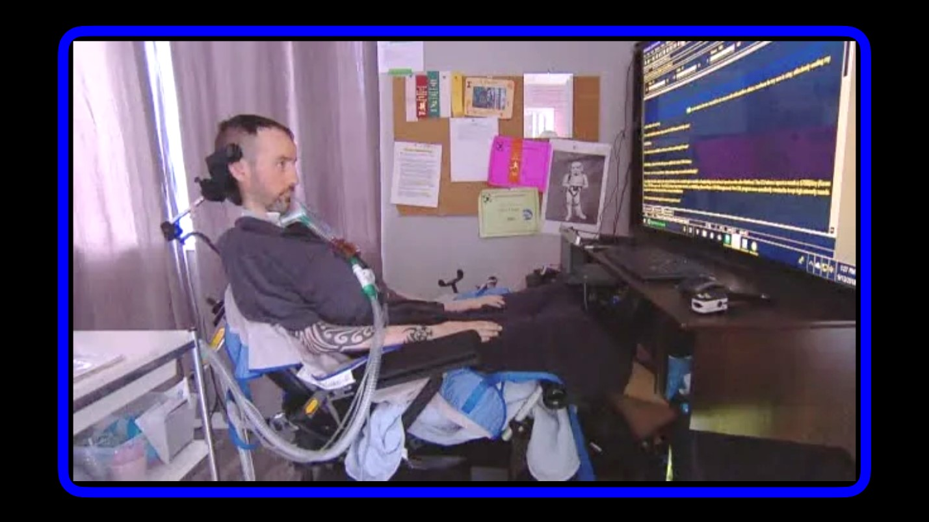
A devoted father, Sean Tagert had pieced together suitable care arrangements in his own home, including extensive personal supports and highly sophisticated communications technology. Although he required 24-hour care, he received only 15 hours of care daily from Vancouver Coastal Health. This left him with a shortfall of $263.50 daily, and a “constant struggle and source of stress”.
Once his personal savings were exhausted, Tagert’s only option was to move to a Vancouver residential care facility, more than 4 hours away from his home in Powell River. Such a move would have required him to leave much of his communication technology behind, and effectively curtailed his relationship with his 10-year-old son, who spent weekends with him in Powell River as part of a shared custody arrangement.
In 2019, exhausted from years of battling to secure funding for life-sustaining home care, Tagert chose to die by MAID.
In a final Facebook post chronicling his struggle Tagert wrote: “I know I’m asking for change. I just didn’t realize that was an unacceptable thing to do. Hundreds of British Columbians are dying horribly every year.” He described the funding decisions and institutional offerings advanced by the local health authority as “a death sentence.”
SOURCE: https://www.cbc.ca/news/canada/british-columbia/als-bc-man-medically-assisted-death-1.5244731
and https://bc.ctvnews.ca/we-need-a-public-outcry-b-c-father-with-als-ends-life-after-struggle-to-stay-at-home-1.4543983

- Rosina Kamis

In a series of YouTube video, Rosina shares why she sought MAiD. “Anything can happen from this moment until the euthanasia date that could cause me to change my mind. From physicians deciding to provide adequate pain relief to friends deciding to step up and help me and so on. [Applying for MAiD] is also a way of saying to the doctors ‘hey the law has changed and now I have this option of ending it all. But I have this much time, so get moving’.”
Rosina lived in isolation. She explained that “When a person is suffering, you don’t leave them alone, with nobody at all! When someone is suffering, you don’t lock them up in a home or a psychiatric facility for life! Sometimes all the pain will go away just by having another human being here. Let me go through it with them.”
She was not cared for, living in poverty, and avoiding institutionalization. “In Canadian society, we have a culture of killing instead of caring… Nobody is holding my hand... If I were to die, nobody is going to grieve. The government doesn’t give you enough money to survive. I don’t want to accept institutionalization”
Rosina recorded a virtual appointment with her doctor and two friends whom she trusted to join her on the call. One of those friends on the call brings up the issues of poverty and uncontrolled pain affecting her quality-of-life.
Rosina died by MAiD in Sept 2021.
SOURCE: (184) Why did I apply for euthanasia? - YouTube
and (184) Is euthanasia the only solution? - YouTube

- “Sophia”

In a video filmed 8 days before her death, Sophia stated that, ““The government sees me as expendable trash, a complainer, useless and a pain in the a**.”
Sophia suffered from a chronic condition known as multiple chemical sensitivities (MCS). She chose medically assisted death after her two-year search for safe and affordable housing failed.
Symptoms of MCS worsen when cleaning chemicals and cigarette smoke are present in a person’s environment. Due to the COVID-19 pandemic and its restrictions, both indoor smoking and heavy cleaning practices increased, sending fumes through the vents of Sophia’s apartment building. As a result, Sophia was confined to her bedroom, where the vents were sealed to keep the fumes out.
Four Toronto-based doctors who were aware of Sophia’s case, wrote letters to the federal housing and disability government officials on her behalf, imploring that the government help to find or build a chemical-free residence. Sophia’s friends even set up a fundraiser to try to help her get better housing, where they raised approximately $12,000.
There was no response from any officials and no housing had turned up before Sophia’s appointment for medically-assisted dying. She had a way out. She didn’t have any fight anymore.
Sophia died by MAiD on February 22, 2022.
SOURCE: https://www.ctvnews.ca/mobile/health/woman-with-chemical-sensitivities-chose-medically-assisted-death-after-failed-bid-to-get-better-housing-1.5860579

and https://aseq-ehaq.ca/pdf/Urgent-affordable-Healthy-Housing-for-the-Disability-of-MCS.pdf

- Kim, and countless other social assistance recipients

Kim has significant disabilities and lives in a rented 300 square-foot RV in Ontario. She has received notice of eviction. She relies upon ODSP payments for the necessities of her life.
In a recent investigation of how Covid 19 affects people with disabilities, Kim declared “It’s like I’m being punished for being born disabled, like I committed some kind of crime.”
Kim has considered applying for MAiD. She says “I have no dignity left… I don’t feel like I’m worth anything to anyone anymore.”
Kim reports knowing of many people in similar circumstances who have applied for MAiD, and has personally “lost six friends to suicide since [the beginning] of COVID.… They don’t want to live this way anymore, there is no safety net at all for people that are disabled.”
The same investigation described how others in similar circumstances have sought MAiD for relief from intolerable poverty. A Twitter posting from one woman read “I’ve enrolled in MAiD, seeing as I can no longer afford to live, nor can I afford the food & medicine I need to get better.”

SOURCE: https://toronto.citynews.ca/2020/09/02/odsp-covid19-pandemic/

- “Madeline”

For the past 20 years, the 54-year-old Vancouver woman has amassed $40,000 in debts trying to treat myalgic encephalomyelitis and other ailments. When her money runs out, she says a medically assisted death may be her only option.
Madeline has Myalgic encephalomyelitis/chronic fatigue syndrome. She estimates that the supports she needs to live “not in agony” cost about $100,000 per year.
Madeleine faces the decision, each month, to either accrue more debt or go into rapid deterioration and escalating pain. She is now in a position to access support because of donations to a GoFundMe page. However, in order to stretch her funds, Madeline was doing about half of the therapies recommended so she could stretch her quality of life as long as possible.
Madeleine knows that when her credit runs out she will have to stop taking supplements, receiving physiotherapy and intravenous naturopathic treatments she says are finally helping her find balance. She says she’s already isolated and alone.
Madeleine says “I want to live, and with more support I can… I shouldn’t have to beg for my life.” Madeleine is seeking medically assisted dying.
SOURCE: https://www.citynews1130.com/2020/07/27/vancouver-woman-disabilities-medically-assisted-dying/
And https://www.thestar.com/news/canada/2021/07/05/i-shouldnt-have-to-beg-for-my-life.html?rf

- “Denise”

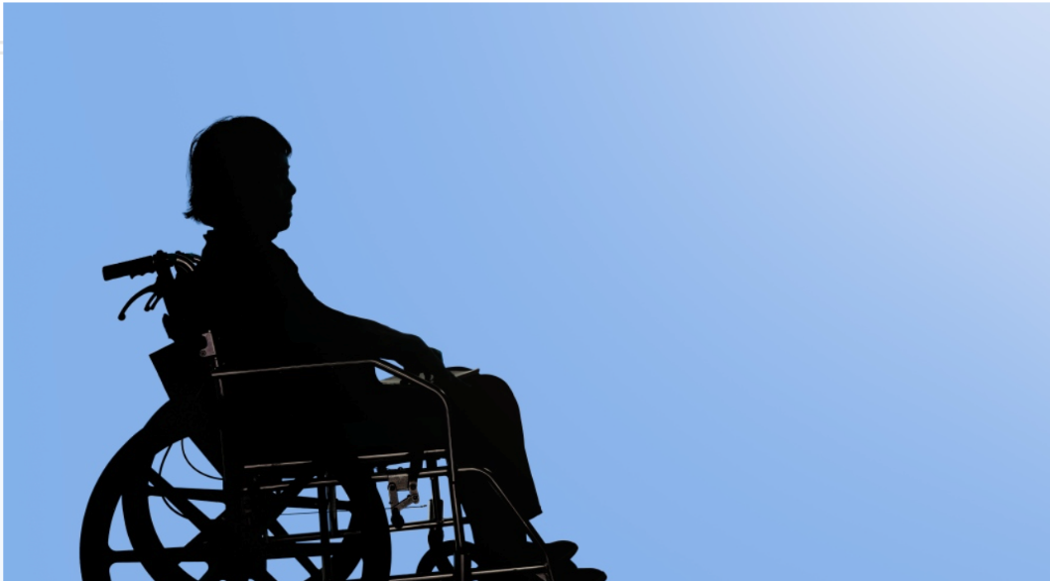
Denise lives with a chronic condition called Multiple Chemical Sensitivities (MCS) and has been wheelchair bound since suffering a spinal cord injury six years ago. MCS can cause difficulty breathing, rashes, and hemiplegic migraines that cause temporary paralysis.
Denise is seeking to move to an apartment that has cleaner air and is wheelchair accessible. Her only income is from the Ontario Disability Support Program, where she receives a total of $1,219 a month. She applied for MAiD due to abject poverty.
Denise and her supporters had called several housing agencies in Toronto in an attempt to find housing she can afford, but her searches up until now had failed. The application process for MAiD, on the other hand, had been much easier.

SOURCE: https://www.ctvnews.ca/health/woman-with-disabilities-nears-medically-assisted-death-after-futile-bid-for-affordable-housing-1.5882202

- Anonymous @ALYSM745

Anonymous @ALYSM745 spoke at a webinar called Death by Coercion. They said “[Choosing to access MAiD] truly was a matter of pure mathematic fact that I just simply could no longer afford to live. I started getting really sick about a year and a half ago and on Ontario Disability I can’t even afford to get an ear or tooth ache. Pre pandemic I was struggling to get by on $1.50 or less per day. The pandemic would have me attempting to exist on less than $1 per day if not for my food intolerances and need for over the counter medicines because most drugs are no longer covered under Ontario Drug Benefit. Needing to purchase over the counter medications, coupled with my food intolerances maxed out my $2000 limit credit card and drove me deeper into my overdraft until I hit my limit so that when my $800 disability cheque arrives its only for $300 because the rest is in overdraft. I was in danger of my account being closed and therefore not able to purchase medications and food that somewhat help prevent bouts of cyclical vomiting. With those guardrails removes I would be ten times as sick and I didn’t want to suffer for months waiting to get approved. The math was clear that the time to start the assisted suicide process was now, especially with no sign of hope for increases coming down the line.”
SOURCE: https://www.youtube.com/watch?v=AZYPLoWVRlQ

- Alexis Wilson
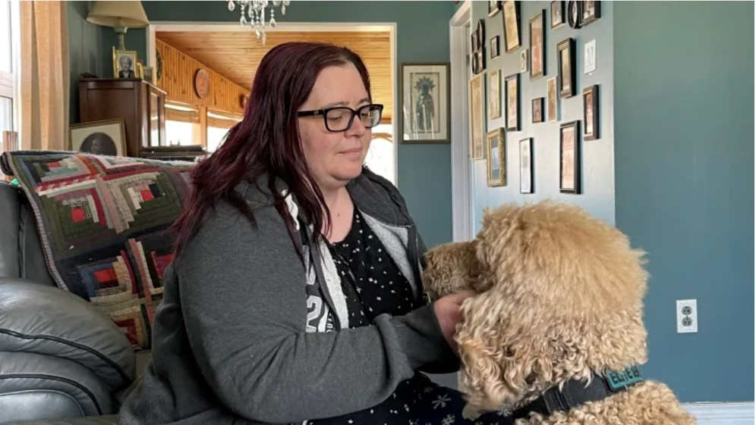

Alexis lives with numerous conditions including bipolar disorder, PTSD, arthritis and other physical disabilities that limit her mobility.
Alexis receives an income of $1,169 each month from the Ontario Disability Support Program (ODSP). This is her only income as she is unable to work with her several health conditions. After paying her rent and bills, she is left with exactly $125 for food each month.
Alexis is fearful for the day that her mother eventually passes away. Alexis’s mother, a senior with a limited income, provides her with some food and other supports. Even with her mother’s help, Alexis often skips meals because she cannot afford to feed herself.
If the ODSP rates don’t improve, then Alexis says she will have to seriously consider applying for medically-assisted death.
SOURCE: https://bit.ly/3vIZ4q0

- “Susan”
- Multiply disabled but none of her diagnoses are terminal.
- She says she has dietary restrictions making food banks an inaccessible option, and a livable income is literally a matter of life and death.
- A victim of a violent assault.
- Like many disabled Canadians forced into poverty by insufficient income support, Susan exists in a space between not wanting to die and not wanting to live the life she is currently living.

SOURCE: Dying for the right to live - Macleans.ca

- Yvan Tremblay
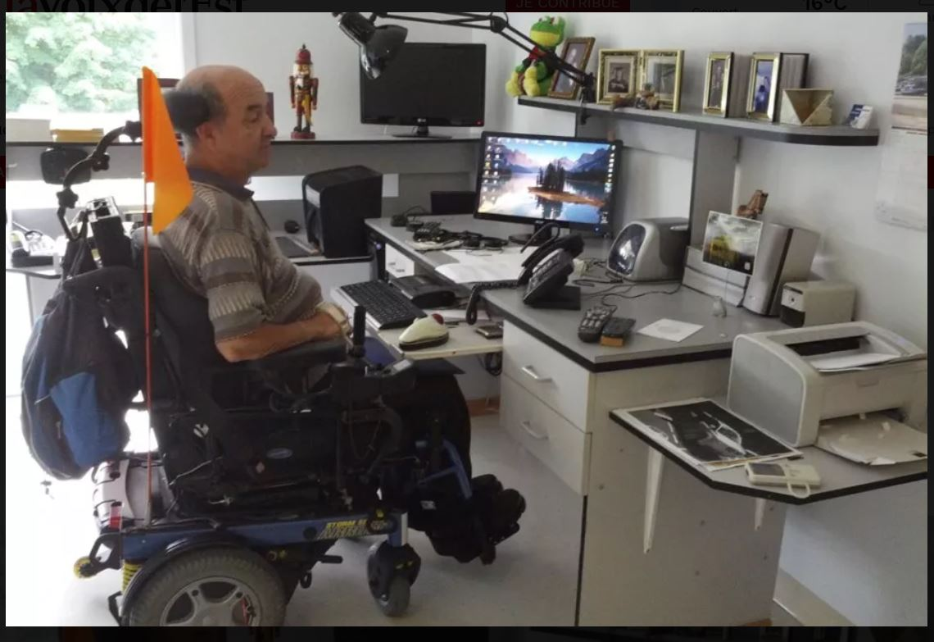
- For over a decade, Yvan Tremblay lived independently in his own apartment with many customized adaptations to accommodate his significant disability.
- When new fire regulations deemed that he could not be safely evacuated from his apartment, he received notice of eviction.
- With his alternative housing options extremely limited and certain to curtail his independence and quality-of-life, he made multiple attempts to protest this judgement and retain his apartment.
- When these attempts failed, Tremblay committed suicide in September 2014. Although it was not an option at the time, under the proposed amendments to the current law, Tremblay would be eligible to receive MAiD.

SOURCE: https://plus.lapresse.ca/screens/8d84a4bb-79fd-4cef-9a87-f8311d3a3160%7C_0
and https://www.lavoixdelest.ca/actualites/ils-lui-ont-tout-enleve-en-une-journee-b3e3846d3a221c56fa4c7cc5a8bbdbdf
See also: Beaudry, Jonas-Sébastien, The Way Forward for Medical Aid in Dying: Protecting Deliberative Autonomy is Not Enough (June 30, 2018). First published in the Supreme Court Law Review, Second Series, Vol. 85., Available at SSRN: https://ssrn.com/abstract=3189417 (link no longer available)

- Richard Ewald

Richard Ewald has chronic obstructive pulmonary disease (COPD), stage four liver disease and suffers from chronic pain and depression. He survives on Ontario Disability Support Payments (ODSP), but barely.
Ewald’s payments total $1,169 per month to cover rent, food, and other essentials. He tells CityNews he will apply for MAID if his situation gets worse and knows several others who are doing the same.
“I’m not suicidal. Sometimes it’s a choice between burning to death and jumping out of a high-rise building. I’d like to have that choice. I’ve suffered. I really don’t want to suffer past a certain point,” said Ewald. “I wouldn’t be doing it if I wasn’t so stuck in this situation with ODSP.”
SOURCE: https://toronto.citynews.ca/2022/04/21/odsp-payments-ontario-ford-election/

- David Douglas Wilkinson

David is a 59 year old man who has initiated the process to receive MAiD.
David developed multiple chemical sensitivity and following several exposures, could no longer live in his newly rented apartment and became homeless. Due to his disability, living in a tent was also not possible and is now forced to live in his car.
Following many attempts to secure safe and healthy housing, David is resorting to MAiD because there are no other viable options available to him.
In a letter to Canada’s Prime Minister, the Association pour la santé environnementale du Québec / Environmental Health Association of Québec states that David explained the following: “ ‘there is no hope for me, I cannot find a place to live that does not make me very ill’, ‘at least I will have a dignified death’, ‘I would hate to freeze to death in winter’. He is painfully aware that winter is approaching – and so are we”.
SOURCE: https://aseq-ehaq.ca/pdf/2022-July_ASEQ-EHAQ_PM_Urgent-Housing-Need.pdf

- Tracy Thompson

Tracy has Long COVID. A year after Thompson became ill, MAiD legislation was revised in Canada. and has begun the process of applying for MAiD. She says that “[MAiD] is exclusively a financial consideration,”
After 26 months of lost income since the onset of symptoms, no foreseeable ability to work and an absence of support, Thompson said she expects to run out of money in about five months.
Since Thompson’s illness is not clearly outlined in the Ontario Disability Support Program (ODSP) eligibility, which currently grants a single applicant a maximum amount of $1,169 a month, she believes it could take years to qualify – something that many Ontarians who’ve applied to the program say is not uncommon. Even if Thompson did qualify, she says the whole sum of the monthly support would, at best, cover her rent.
So far, Thompson has sought one doctor’s approval for MAiD and is waiting to hear back from a second specialist.
SOURCE: https://toronto.ctvnews.ca/ontario-woman-enduring-effects-of-long-covid-begins-process-for-medically-assisted-death-1.5976944

Canadians with disabilities like “Kat”, Rosie Ashcraft, Eric Coulam, “Gwen” and Natalie Jarvis are dying by MAiD because of inadequate or otherwise inaccessible healthcare.

- “Kat”

About a decade ago, Kat received a diagnosis of Ehlers-Danlos Syndrome (EDS). EDS is a disease that weakens the connective tissues of a person’s body. Kat is suffering from organ failure as a result of complications with EDS. Her body is shutting down.
Struggling to access healthcare, Kat decided to look into getting end-of-life care. While she was hoping to get access to palliative care, she instead found herself being approved for MAiD.
Kat says, that she cannot afford the resources and supports that would help improve her quality of life. It is her disability and poverty that led her to MAiD. The healthcare provider noted that the “patient has an extensive medical chart” and that “there were no other treatment recommendations or interventions that were suitable to the patient’s needs or to her financial constraints.”
Kat has not yet scheduled her MAiD appointment. She has what she calls an “open invitation” to schedule her death at any time.
It is not likely that Kat has a long life ahead of her, but she is still hopeful that her request for palliative care will be approved.
SOURCE: https://bc.ctvnews.ca/easier-to-let-go-without-support-b-c-woman-approved-for-medically-assisted-death-speaks-out-1.5937496

- Rosie Ashcraft
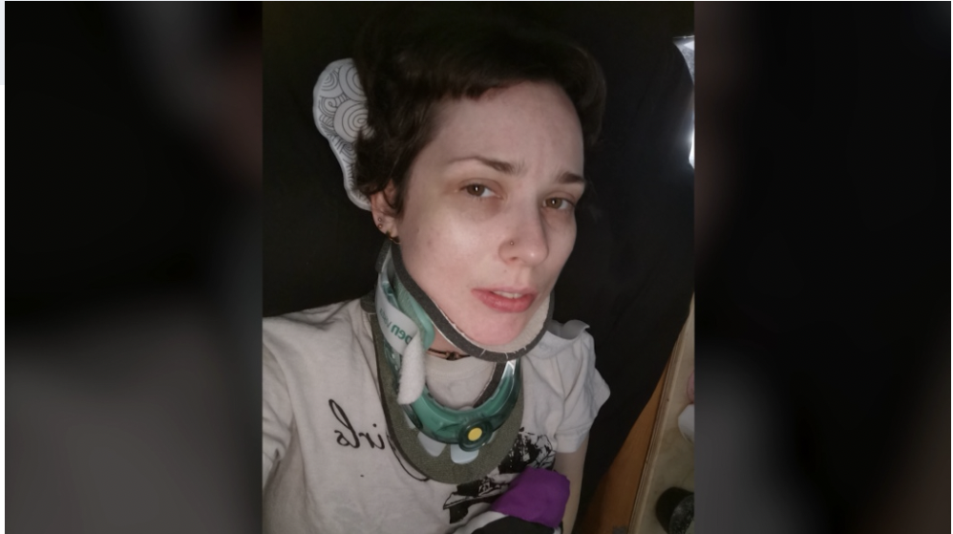
Rosie, a mom from BC living with Ehlers-Danlos Syndrome (EDS), is considering applying for medical assistance in dying. EDS is a disorder that affects connective tissue.
As a result of EDS, Rosie has to wear a neck brace to keep her neck stable. She is in constant pain and spends most of her days at home in a medical bed.
Rosie is wants to get surgery to help stabilize her neck, as her condition is getting worse, but she has been waiting almost fours year to see a neurosurgeon. She has looked into getting the surgery in the U.S. but the cost is around $100,000.
Rosie has been considering MAiD as she feels she has been left with no other options to alleviate her suffering.
Her family has insisted that what she desperately needs is help.

SOURCE: https://bc.ctvnews.ca/after-years-waiting-for-surgery-b-c-woman-considering-medically-assisted-death-1.5922445

- Eric Coulam

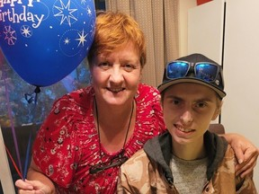

Coulam has been living with an undiagnosed gastrointestinal condition which has led to multiple hospital stays, liver and kidney disease, and severe chronic pain. He has visited countless doctors and endured many months in hospitals but has yet to get a diagnosis.

After struggling for almost a decade, Coulam, who now lives in Fort St. John, B.C., has decided to get medical assistance in dying, known also as MAID. He is 20 years old.

Coulam said that while in hospital, one of the other patients in his room was provided MAID. He asked his doctor what that entailed, and after doing research and speaking to specialists, he decided it was the best option for him.

Eric says he will ultimately decide when to officially end his life. He has not chosen a specific date and it will be his choice when he has done certain things and seen specific people before saying his final goodbye.

SOURCE: https://vancouversun.com/news/eric-coulam-medically-assisted-death

and https://www.cjdctv.com/it-was-hard-to-tell-everyone-else-20-year-old-from-fort-st-john-makes-decision-to-get-medical-assistance-in-dying-1.5906159?cache=yes%3FclipId%3D375756

- Gwen

“It's eugenics, because they don't want us to be properly supported and be OK. And if we don't have family to take care of us, it's `Please just go and die,”' said Gwen.

Gwen has Hypermobile Ehlers-Danlos Syndrome and Autism. After her back was injured in a 2013 car accident, Gwen developed chronic intolerable pain. She uses a walker for mobility and will soon have a wheelchair after a two-year wait.

She cannot access essential treatment for her chronic pain and disabilities, which make it impossible at times to eat, sleep, move or play with her child. Gwen says she fears losing custody if her pain worsens or her support network falters.

Gwen receives $1,694 per month in provincial disability assistance, which barely covers rent and food for her and her daughter, let alone accessibility improvements such as a ramp she needs to get into housing.

Gwen said ICBC and the province have both declined to pay for a treatment course recommended by her doctors that would help desensitize her central nervous system and bring her pain to a more manageable threshold so that she can get surgery for her back injury.

SOURCE: https://bc.ctvnews.ca/medically-assisted-death-needs-to-be-a-good-choice-not-a-choice-of-last-resort-1.6006282

- Natalie Jarvis
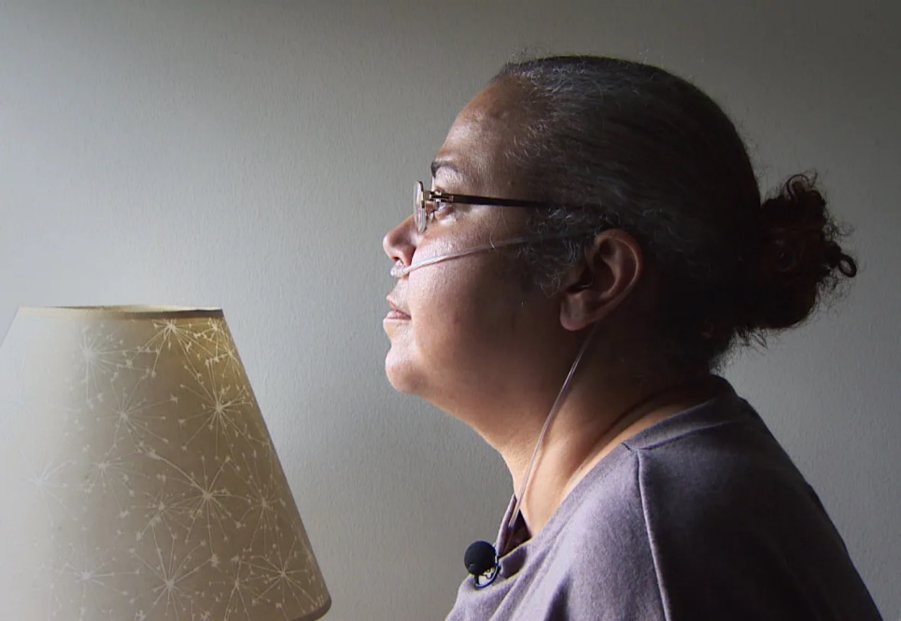
Natalie Jarvis has antisynthetase syndrome with interstitial lung disease, a rare auto-immune condition.
When her Halifax specialist informed her that her only chance to survive would be a double-lung transplant. It wasn't the surgery that scared her. Or the lengthy recovery. It was the cost.
Natalie would have to move to Toronto to await her surgery.
"Ten grand may not sound like a lot to some people, but when you're living paycheque to paycheque and you need at least $10,000 to get you started to live somewhere else, it's a lot."
While Jarvis desperately wanted a lung transplant, the stress on her family financially was becoming too much. It's then that she started thinking about palliative care.
She found a former university residence, where she now shares a room with her mother.There's a kitchenette within arm's reach of her bed. But she's not complaining: it's only $2,000 a month. In the end, her employer and friends chipped in, raising $7,000 to help her start paying rent.
While Natalie changed her mind received her transplant, she said that two other patients that year made that decision [to die] and didn't change their minds. It is unclear whether they died by MAiD.
SOURCE: https://www.cbc.ca/news/canada/nova-scotia/lung-transplants-atlantic-canada-toronto-financial-cost-1.5047818?fbclid=IwAR14RO7LOqKbp0mQDeJPi6yax5228hiQxDSgJppL8Qs8AaygEhe7_c2us-Y
and https://www.cbc.ca/news/canada/nova-scotia/lung-transplant-organ-donation-natalie-jarvis-1.5106606

Canadians with disabilities, like Chris Gladders, Jennifer Turton-Molgat’s mother, Archie Rolland, Raymond Bourbonnais, Jonathan Marchand, Arleen Reinsborough, and Gabriel Bouchard are (considering) dying by MAiD because they are being dehumanized in institutions and do not have the option of living in community.

- Chris Gladders

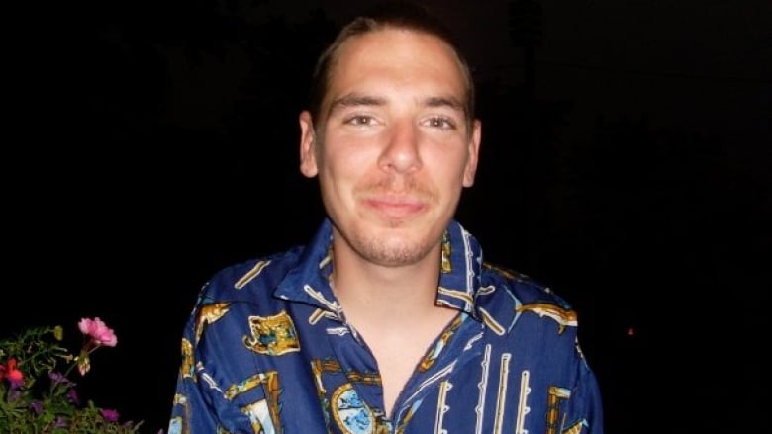
Chris, was suffering from a rare disease and died with medical assistance.
He was battling Fabry's disease, a genetic condition which affects the body's ability to break down a specific fatty acid and causes a number of side-effects.
He had two daughters Hailee, 13, and Savannah, 5.
His brother reported that at the time of his assisted death "The bedding hadn't been changed for weeks. There was feces on the bed. There was urine on the bed. There was urine and feces on the floor, the room was absolutely disgusting ... it's time for someone to take over." And that the day before his death “"He pulled the call bell beside his bed. I was on the phone with him for 40 minutes and nobody answered that bell. That was his last night,"
SOURCE: Niagara MPP calls for province to take over 'disgusting' Greycliff Manor after 35-year-old dies | CBC News

- Mother of Jennifer Turton-Molgat

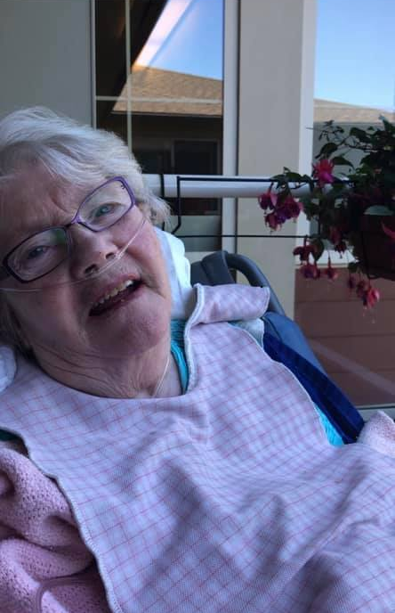
In a Facebook post written in August 2020, Jennifer Turton-Molgat wrote: “My mom, the most positive, resilient, loving person I know has requested an assisted suicide. She wants to end her life, not because she is in pain or intolerable discomfort, but because she is being held prisoner in her long-term care home and has lost her will to live.”
Prior to the severe Covid-era restrictions in her long-term care home, Turton-Molgat wrote that her mother’s “only enjoyment in life was feeling the sunshine and fresh air on her face and spending time with her family. And that was enough for her. Despite [her significant disabilities] she would often say, ‘I’m so lucky’.”
SOURCE: https://www.facebook.com/jturtonmolgat/posts/10157236222225925

- Archie Rolland

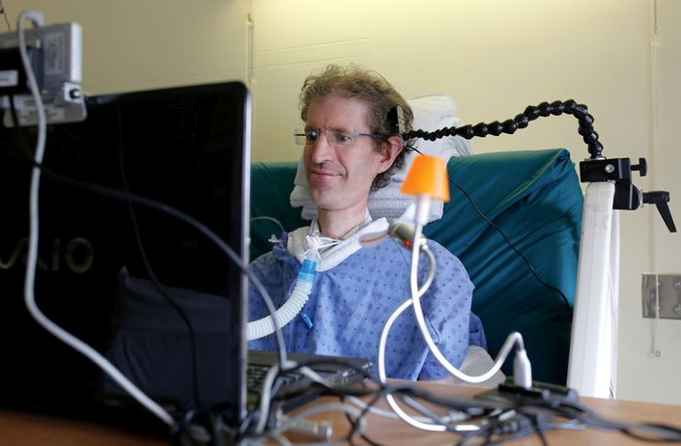
Eighteen months before his death by MAiD, Archie Rolland was transferred against his will from a residence that provided highly specialized care to a geriatric long-term care facility in Lachine Québec.
Without staff adequately trained to communicate with him and provide essential care, he spent the remaining days of his life documenting the suffering that this caused and advocating for humane and capable care.
When he began to lose hope and found continued life under these conditions intolerable, he made his request for MAID, which was readily approved.
At the time, Rolland told the Montreal Gazette that “it wasn’t the illness that was killing him. He was tired of fighting for compassionate care.”
SOURCE: https://montrealgazette.com/news/local-news/life-in-long-term-hospital-unbearable-montreal-man-with-als
and https://montrealgazette.com/news/local-news/saying-goodbye-to-archie-rolland

- Raymond Bourbonnais
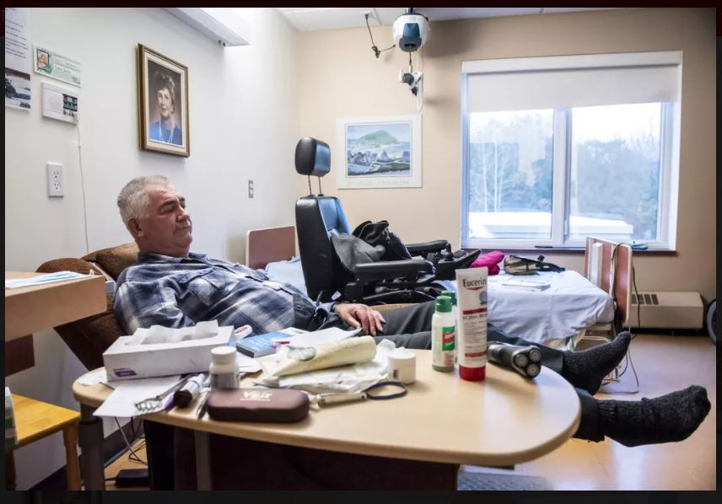
When Raymond Bourbonnais was no longer able to manage all his personal care needs at home, he was relocated to a Québec nursing home. During the 13 months that he lived in this facility, he filed multiple complaints about inadequate staffing, unbearable temperatures due to a lack of proper ventilation or air conditioning, and stressful and unwelcome interactions with older residents with dementia with whom he could not avoid contact.
With conditions in his residence only deteriorating and his complaints seeming to go unheard, Bourbonnais hoped for a cure for his disease. When a physician confirmed that no cure was possible, she broached the subject of MAID, and Bourbonnais is reported to have “jumped at the chance”.
In a farewell video in which he recorded a final “crie de coeur”, Bourbonnais spoke of a “constant degradation of services” at his long-term care facility, and pleaded for others to “do everything possible to put pressure on the government” to address the deplorable conditions in these facilities.
Before dying by MAID, Bourbonnais said that he was “very happy to forget this bad part of my life”.
Raymond Bourbonnais died by MAID in December 2019.
SOURCE: https://www.latribune.ca/actualites/denoncer-avant-de-mourir-video-6b5b5b9901c42d9660ec5ba19a0eda78?fbclid=IwAR0y-ihHsHkge1fONPqix2Qxte0YXzNWXu3MWqH7csvoz3FFyeqEtCUI6e0 and https://youtu.be/fyAlPID7c40

- Jonathan Marchand
Jonathan Marchand is 43 years old and fiercely independent but forced to live in a nursing home for the elderly in Québec. Because he relies upon a ventilator to breathe, he requires 24-hour care. With no appropriate supports available in the community, a long-term care facility was his only choice.
Marchand describes a satisfying life with good relationships and personal and professional success until he “hit the wall” of requiring government-funded assistance to support his life.
Marchand argues that “increasingly, euthanasia is offered as a solution to institutionalization. The idea is that if you don’t want to die slowly in a long-term care facility, we are going to help you kill yourself.”
By his own account, Marchand had friends who killed themselves rather than go into long-term care. He “decided that I would not go ahead with euthanasia, but I would fight to get out of this place.”
To draw attention to his circumstances, and to force the government to provide the support that he needs to live independently in the community, Marchand set up a large cage outside the Québec legislature, where he lived for 5 days and 5 nights, in protest of the intolerable conditions of his life.
As a result of this extraordinary effort and the significant media attention that it attracted, the Québec government set up a “working group” to advise on alternatives to institutionalization.
Jonathan was told he’d be part of a new pilot project that would provide for the support necessary to move out of long-term care and live in community. He was later told this “pilot” would be effectively a group home.
SOURCE: https://www.cbc.ca/listen/live-radio/1-15/clip/15793158?fbclid=IwAR2pDbx4bJRpVXtLLC7WLweoYvYUQrQrhfTr6DsaX-Mc6rl3JcPyVXAG30A&share=true (link no longer available)

and https://youtu.be/MLvMh45l_Zc and https://www.cbc.ca/player/play/1856420419644 (link no longer available) and https://www.cbc.ca/news/canada/montreal/quebec-abandons-pilot-project-young-chsld-1.6119581

- Arleen Reinsborough

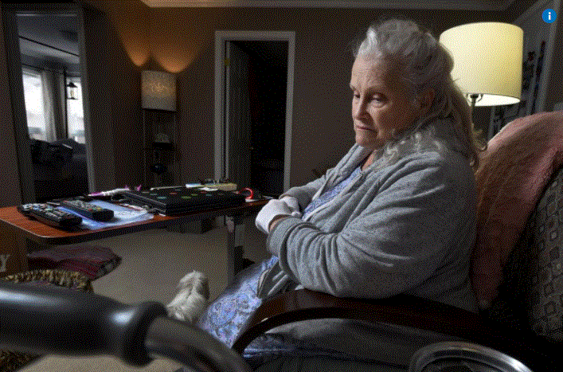

Arleen is 75 years old and her fear of nursing homes has her more determined than ever to seek assisted suicide.
Her fear of long-term care doesn’t qualify her for MAiD. She is confident her unbearable pain will.
Reinsborough says, “It isn’t depression that makes me want to die, it’s the fear of living with inhumane, overcrowded conditions, loneliness and lack of hope… I’m trying to do all I can to prevent going to long-term care”.
She says that all the homes she can afford are “worse than living on the street or living at all”.
Reinsborough cites other serious senior problems that spur her desire for assisted dying. They include small pensions, medical services that the Ontario Health Insurance Plan (OHIP) won’t pay for, and prescriptions not convered by the Ontario Drug Benefit program.
She also says it is impossible to get into senior (affordable, accessible) housing.
SOURCE: https://www.thestar.com/news/canada/2019/01/20/hamilton-senior-in-unbearable-pain-wants-assisted-dying-to-save-her-from-nursing-home.html

- Gabriel Bouchard
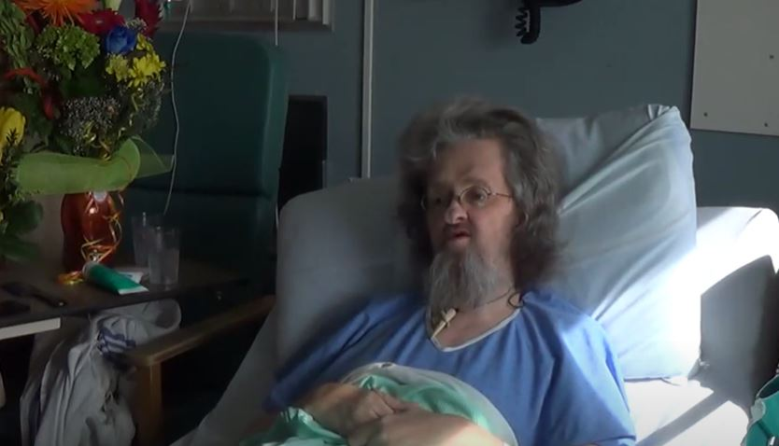

Gabriel Bouchard was a 57-year-old man with lifelong disabilities. As his disabilities progressed in late adulthood, he found it necessary to resign from his employment as a social service professional that had been a great source of pride and satisfaction for 35 years.
He then faced an existential question: “Would you prefer to leave this life as a man who gladly, proudly gave 35 years to social service? Or after another 15 or 20 years, leave a life of degradation? I have no one in my life, no family, I’m alone, I would have ended up on welfare. I would have ended up in a nursing home, and I had no desire to do that, I know too well the quality of life in there — or the lack of quality! Or to go out with the memory of a job well done. The choice was easy for me.”
Bouchard chose to die by voluntary starvation, while being provided comfort care in hospital.
When asked in a video recorded interview what might have made his life worth living, he responded “If I had good service, a livable income – welfare is not livable… Yes, if it were possible, but it’s a dream!” He explained that he had declined provincially available services “because although the people were good, they weren’t paid fairly.”
At the end of his interview, he muses “People with disabilities are costly, right? I’ll be one less expense, right?”
SOURCE: https://youtu.b on these e/duEC3TqpsV4

Canadians with disabilities, like Roger Foley, Randy, and Candice Lewis are being presented with MAiD, unprompted when accessing healthcare and disability supports.
- Roger Foley

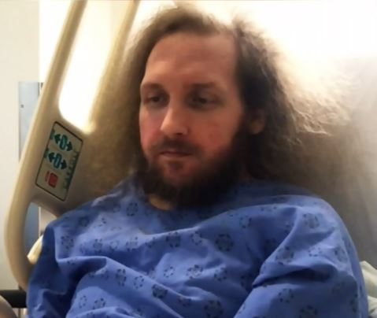
Roger Foley is 42 years old and has significant disabilities that require 24-hour care. He seeks to receive that care at home, rather than in a London Ontario hospital where he has lived for at least 2 years.
Foley has advocated forcefully that his discharge from hospital must be to his home environment, with a commitment to provide the care that he requires in his home.
Foley has said that he is “always thinking I want to end my life” because his demands for appropriate care at home have been denied. He asserts that he is being pressured to end his life.
Foley publicly released audio recordings of hospital staff offering him an assisted death and outlining how much it costs to keep him in hospital instead of getting the home care he desires and requires.
His case attracted the attention of the UN Special Rapporteur on the Rights of Persons with Disabilities, Cataline Devandas Aguilar, when she visited Canada in spring 2019. Following her visit to Canada, she issued a statement that she had "received worrisome claims about persons with disabilities in institutions being pressured to seek medical assistance in dying." She urged the federal government to investigate and prevent such cases.
SOURCE: https://www.ctvnews.ca/health/chronically-ill-man-releases-audio-of-hospital-staff-offering-assisted-death-1.4038841

and https://www.ctvnews.ca/health/barely-hanging-on-to-life-roger-foley-shares-his-fight-for-home-care-with-un-envoy-1.4378334

- Randy
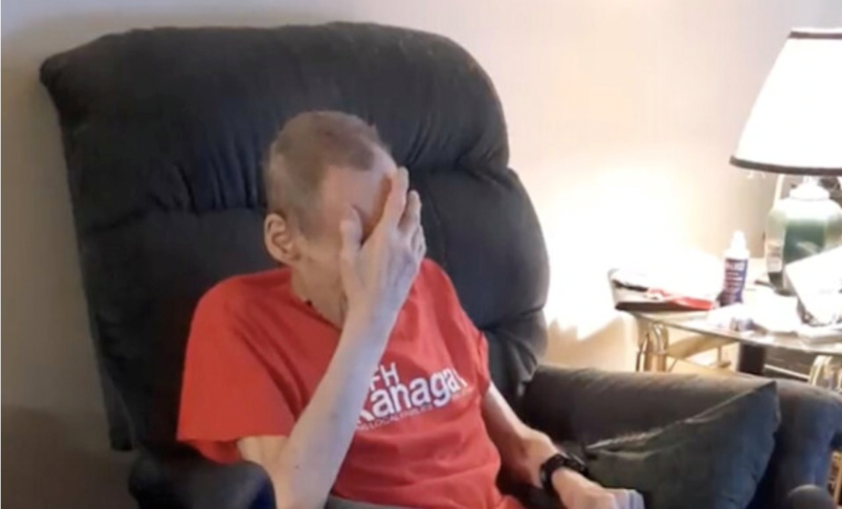

Randy has suffered from a string of medical issues that have left him in need of constant in-home care.
Over a decade ago, Randy endured an injury that put him off work for the past 10-15 years, and for which he has been receiving compensation. Now, Randy is experiencing heart and lung problems, leaving him unable to do much.
Most recently, Randy had to have a catheter inserted to help with gallstone issues. With no family, and his care worker retiring, Randy doesn’t know what he will do for care.
Care workers have tried to convince Randy to enter a care home, but he just wants to stay in his own home, where he can die peacefully. Some care providers have even suggested placing Randy in palliative care or signing him up for medically-assisted death.
Vince Campbell, Randy’s friend and neighbour, says he can’t bear to watch Randy suffer. He can’t believe the way in which Randy is being treated by health care providers.
SOURCE: https://www.richmond-news.com/highlights/bc-man-exasperated-as-elderly-friend-struggles-to-receive-healthcare-at-home-5434889

- Candice Lewis
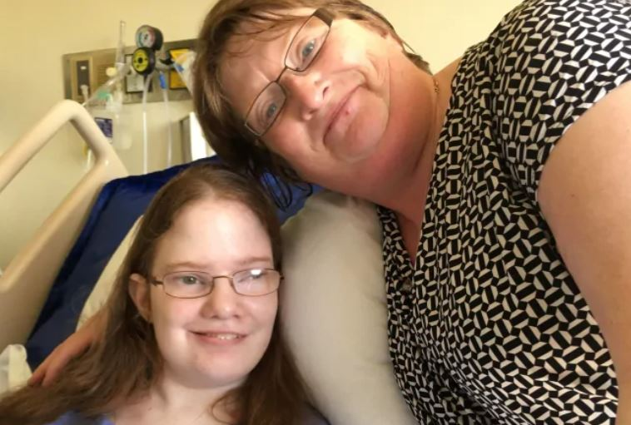

- Candice Lewis is a 25-year-old woman with significant disabilities who lives in Newfoundland with her mother, Sheila Elson.
- Elson reported that when Candice was receiving emergency medical treatment in hospital in 2017, a doctor approached her to propose MAiD for her daughter.
- According to Elson, when she firmly stated that she would not consider MAiD for Candice, the doctor accused her of being selfish.
- Candice recovered from her acute illness and was discharged home from hospital. However, both Candice and her mother were traumatized by this encounter. Elson spoke out about this experience publicly because, in her words “We don’t want it to happen to anybody else.”

SOURCE: https://www.cbc.ca/news/canada/newfoundland-labrador/doctor-suggested-assisted-suicide-daughter-mother-elson-1.4218669

and https://www.cbc.ca/news/canada/newfoundland-labrador/medical-assisted-dying-disability-reaction-1.4222833

Canadians with disabilities, like “Mr. X”, Alan Nichols, and Tommy Sec are dying by MAiD despite concerns about their mental health and considerable barriers to mental wellness.
- “Mr. X”

- A man in his 80s with chronic shortness of breath causing extreme fatigue wished to die by MAID because he was no longer able to perform the activities that are important to him. He reported that he had “lost his sense of purpose”.
- Referred to as “Mr. X” in court hearings related to his approval for MAID, he had seven different MAID Assessors review his application. Some of these Assessors raised concerns of anxiety, depression, and dementia.
- “Mrs. Y”, his wife of 48 years, sought to intervene, asserting that he lacked capacity to make this request and did not know what he was doing due to his mental illness.
- Mrs. Y’s effort to stop her husband from receiving MAID ultimately was heard by the Court of Appeal for Nova Scotia, which ruled in favour of proceeding with Mr. X’s approved MAID.

SOURCE: https://www.cbc.ca/news/canada/nova-scotia/nova-scotia-medical-assistance-in-dying-supreme-court-injunction-1.5691456
and https://www.thestar.com/news/canada/2020/09/04/nova-scotia-woman-fails-to-win-stay-as-husband-seeks-medically-assisted-death.html

- Alan Nichols

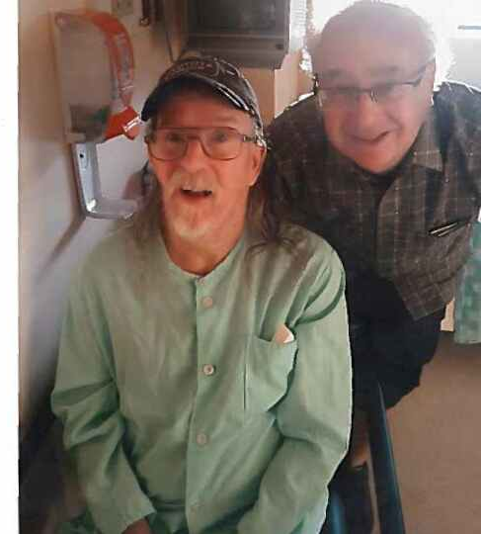
- Alan Nichols was admitted to Chilliwack General Hospital in June, suffering from acute dehydration and malnourishment.
- While in hospital for treatment, Nichols was approved for and received MAID.
- Nichols’ family members were notified of the scheduled procedure four days before it took place.
- Aware that their brother had a history of intermittent severe depression and knowing that his patterns of behaviour during these episodes included failing to eat and care for himself, the family protested, demanding that the hospital provide Alan with the care he actually needed.
- Because Nichols had been deemed capable and eligible for MAID, his family was unable to intervene to save his life.
SOURCE: https://www.ctvnews.ca/health/family-says-b-c-man-with-history-of-depression-wasn-t-fit-for-assisted-death-1.4609016
and https://www.ctvnews.ca/health/advocates-urge-better-safeguards-after-medically-assisted-death-of-b-c-man-1.4610949

- To Phat “Tommy” Sec

- Tommy Sec was 41 years old and had been living his life from bed for several years, stuck in a nursing home. His wife had divorced him, and he had lost custody of his only child.
- Increasingly isolated from family and friends, he described himself in an autobiographical film as being “in a rage”, feeling “hatred towards everyone”.
- Alert and articulate but with significant physical and sensory impairments, Sec described his life as “like being trapped in a coffin and buried alive”. Although he was able to communicate through his computer, he said that “no one listens”.
- Sec was informed of his eligibility for MAID in May 2019.
- After media attention to his plight, Sec began to have more visitors from local Vietnamese and Cantonese communities, and according to a reporter who helped bring his story into the public domain, this social contact elevated his spirits.
- In November he was reported to be demanding to be moved out of his nursing home into a private residence with a live-in caregiver. As well, he was taking steps to repair his relationship with his estranged family, particularly his teenage son.
- Tommy Sec’s current status went unknown until, in 2022, we found, through the following Facebook Post, that Tommy remains in long term care.
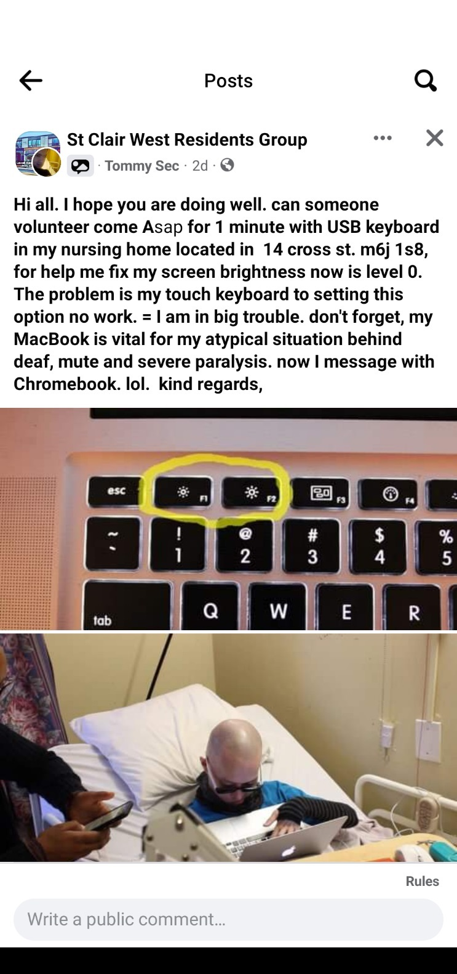

SOURCE: http://jane-finch.com/articles/whyamistillalive.htm

and https://www.thestar.com/news/gta/2019/11/18/confined-to-a-toronto-nursing-home-bed-24-hours-a-day-tommy-sec-wants-to-die.html

- Donna Duncan
Donna Duncan died on October 29, 2021 by MAiD.
The medically-assisted death of Donna Duncan is being investigated by police, as her daughters have claimed that she should not have been approved for the procedure given the state of her mental health.
In February 2020, Donna was in a car accident and suffered a concussion. Due to the onset of COVID-19 restrictions, her rehabilitation and medical care were cut back and she did not receive treatment for months.
In the summer of 2020 she was diagnosed with post-concussion syndrome. According to Donna’s family, she had been acting very out of character. Medical records from her family physician reveal that she had anxiety and depression, likely linked to the car accident.
Donna was rapidly losing weight, weighing just 82 pounds. She was in constant pain. She refused to take any medication for her mental health, claiming they didn’t work. Donna asked her family physician to grant her approval for medically-assisted death, but he declined and referred her to a psychiatrist. The psychiatrist’s assessment of her revealed that he believed her depression was related to her physical illness and pain.
Donna ended up going to Fraser Health to get MAiD where she was assessed and approved. When her daughters heard of this they obtained a court injunction to halt the procedure were granted a mental health warrant. Donna was taken to the hospital where she received a psychiatric consult, which found her to be competent to make the choice for MAiD.
After being sent home that night, Donna’s partner found her on the floor with a lacerated wrist. She received another psychiatric evaluation which found that she was depressed and had little insight into her problem. She was transferred to another hospital where she was assessed again and was again found to be competent.
After being released from the hospital, Donna went home and received medically-assisted death that night.

SOURCE: https://www.ctvnews.ca/health/police-investigating-medically-assisted-death-of-b-c-woman-1.5877288

American Declaration on the Rights and Duties of Man (Resolution XXX, adopted by the Ninth International Conference of American States, Bogotá, Colombia, 1948), online: http://www.oas.org/en/iachr/mandate/Basics/american-declaration-rights-duties-of-man.pdf [American Declaration].
More information about each of the groups that make up the coalition is available in Appendix 3 at pages 40-43
Rene Leiva et al, “Euthanasia in Canada: A Cautionary Tale” (2018) 64(3) World Medical Journal 17, online: https://www.wma.net/wp-content/uploads/2018/10/WMJ_3_2018-1.pdf
February 2021 Joint Communication to Canada, below at note 8.
MAiD is currently legalized in some form in parts of the United States and Colombia. Colombia has passed Resolución número 1216, online: https://www.minsalud.gov.co/Normatividad_Nuevo/Resolución%201216%20de%202015.pdf and Resolución número 825/2018, online: https://www.minsalud.gov.co/sites/rid/Lists/BibliotecaDigital/RIDE/DE/DIJ/resolucion-825-de-2018.pdf. In the United States: Maine’s Death with Dignity Act, online: https://www.mainelegislature.org/legis/bills/bills_129th/billtexts/HP094801.asp; Oregon’s Death with Dignity Act, online: https://www.oregon.gov/oha/PH/PROVIDERPARTNERRESOURCES/EVALUATIONRESEARCH/DEATHWITHDIGNITYACT/Pages/ors.aspx; Montana’s court decision regarding medical assistance in dying, Baxter v Montana, online: http://eol.law.dal.ca/wp-content/uploads/2015/06/Baxter-v-Montana.pdf; Colorado’s End of Life Options Act, online: https://www.sos.state.co.us/pubs/elections/Initiatives/titleBoard/filings/2015-2016/145Final.pdf; Vermont’s Act relating to patient choice and control at end of life, online: http://www.leg.state.vt.us/docs/2014/Acts/ACT039.pdf; Hawaii’s Our Care, Our Choice Act, online: https://health.hawaii.gov/opppd/files/2018/11/OCOC-Act2.pdf; New Jersey’s Medical Aid in Dying for the Terminally Ill Act, online: https://www.nj.gov/health/advancedirective/documents/maid/2019_MAID_DataSummary.pdf; Washington’s Death with Dignity Act, online: https://app.leg.wa.gov/rcw/default.aspx?cite=70.245; California’s End of Life Option Act, online: https://leginfo.legislature.ca.gov/faces/billNavClient.xhtml?bill_id=201520162AB15. As well, a bill to legalize MAiD was introduced in Uruguay in March 2020: https://parlamento.gub.uy/documentosyleyes/ficha-asunto/145735/tramite .
Criminal Code, RSC 1986, c C-46, s 241.1, as amended by An Act to amend the Criminal Code, SC 2021, c 2 [Criminal Code]
Ibid, s 241.2(2).
“Mandates of the Special Rapporteur on the rights of persons with disabilities; the Independent Expert on the enjoyment of human rights by older persons; and the Special Rapporteur on extreme poverty and human rights” (3 February 2021) UN Doc OL CAN 2/2021, available online: https://spcommreports.ohchr.org/TMResultsBase/DownLoadPublicCommunicationFile?gId=26002 . [February 2021 Joint Communication to Canada] at 6.
“Several Cases of concern Medical Assistance in Dying & the Inducements of Social Deprivation”, online: https://static1.squarespace.com/static/56bb84cb01dbae77f988b71a/t/615716183c30976483303da6/1633097241515/Updated+Cases+of+Concern+.pdf.
Street Children case (Villagrán Morales et al), 1999 Inter-Am CHR, Ser C, No 63 at para 144 (19 November 1999).
Carter v Canada (Attorney General), 2015 SCC 5 [Carter].
Ibid at paras 66, 86-88, 107, 121.
Trudo Lemmens, Heesoo Kim & Elizabeth Kurz, “Why Canada’s Medical Assistance in Dying Legislation Should be C(h)arter Compliant and What it May Help to Avoid” (2018) 11(1) McGill JL & Health S61 at S103
Criminal Code, RSC 1986, c C-46 s 241.2(1)(c), as amended by An Act to amend the Criminal Code and to make related amendments to other Acts (medical assistance in dying), SC 2016, c 3.
Inclusion Canada, “Bill C-7 Through a Disability Lens” (2020), online (pdf): https://inclusioncanada.ca/wp-content/uploads/2020/11/Bill-C-7-Through-a-Disability-Lens.pdf.
Truchon v Procureur général du Canada, [2020] QJ No 1553.
Criminal Code, above at note 6, s 241.2(b).
Criminal Code, above at note 6, s 241.2(1)(d).
Criminal Code, above at note 6, s 241.2(1)(d), 241.2(1)(e), 242.2(3), 242.2(3.1).
Criminal Code, above at note 6, s 242.2(3.1). The waiting period can be shortened if the person will imminently lose their capacity to consent to MAiD: s 242.2(3.1)(i).
Criminal Code, above at note 6, s 241.2(2.1); C-7, An Act to amend the Criminal Code (medical assistance in dying), 2nd Sess, 43rd Parl, 2021, preamble (assented to 17 March 2021); Government of Canada, “Canada’s New Medical Assistance in Dying (MAiD) Law” (19 March 2021), online: https://www.justice.gc.ca/eng/cj-jp/ad-am/bk-di.html .
IACHR, Merits Report 111/18, Case 12.786, Luis Eduardo Guachalá Chimbó (Ecuador) 5 October 2018 at para 113.
Ibid at para 59.
Ibid at para 113.
IACHR, Merits Report No 80/11, Case 12.626, Jessica Lenehan (Gonzales) et al (United States) 21 July 2011 at para 109.
Luis Eduardo Guachalá Chimbó, above at note 22 at para 119; IACHR, Merits and Admissibility Report No 210/20, Case 13.361, Julius Omar Robinson (United States of America) 12 August 2020 at para 60.
Julius Omar Robinson, above at note 26, para 60.
Evidence of Taylor Hyatt, House of Commons, Standing Committee on Justice and Legal Affairs, Evidence, 43-2, No 6 (10 November 2020) at 1225, online: https://www.ourcommons.ca/DocumentViewer/en/43-2/JUST/meeting-6/evidence :”(b)reathing supports would be considered standard treatment for a non-disabled person in my situation, especially somebody in their mid-20s as I was. That's supposed to be the prime of your life. All the doctors seemed to see was a disabled woman alone, sick, tired, and probably tired of living. This is nothing new." Evidence of Heidi Janz, House of Commons, Standing Committee on Justice and Legal Affairs, Evidence, 43-2, No 6 (10 November 2020) at 1215, online: https://www.ourcommons.ca/DocumentViewer/en/43-2/JUST/meeting-6/evidence : “(p)eople with disabilities are at a higher risk of suicide due to systemic and internalized ableism, yet they face substantial barriers when trying to access suicide prevention services. Medical professionals overlook typical sources of stress. Problems arising from relationship breakdowns, depression and isolation are wrongly attributed to disability. The removal of ‘reasonably foreseeable’ natural death as a limiting eligibility criterion for the provision of MAiD will result in people with disabilities seeking MAiD as an ultimate capitulation to a lifetime of ableist oppression. In a truly just and progressive society, suicide prevention measures should be applied equally to all people."
Letter from Aislinn Thomas to the Senate (15 February 2021), online: https://sencanada.ca/content/sen/committee/432/LCJC/Briefs/Brief_AislinnThomas_e.pdf
Vulnerable Persons Standard, “Voices from the Margins” (2020), online: https://static1.squarespace.com/static/56bb84cb01dbae77f988b71a/t/5f9065e56d65272858143fca/16032%2098789807/Voices+from+the+Margins.pdf
Ibid.
February 2021 Joint Communication to Canada, above at note 8.
Ibid at 5. This same concern was raised by former Special Rapporteur on the Rights of Persons with Disabilities, Catalina Devandas Aguilar: UNHRC, “Visit to Canada: Report of the Special Rapporteur on the Rights of Persons with Disabilities” (19 December 2019) UN Doc A/HRC/43/41/Add.2 UN at paras 68-69 & 99.
February 2021 Joint Communication to Canada, above at note 8.
Convention on the Rights of Persons with Disabilities, 13 December 2006, 2515 UNTS 3 (entered into force 3 May 2008, Convention ratified by Canada on 11 March 2010, Optional Protocol ratified by Canada on 3 December 2018) [CRPD].
IACHR, Merits Report No 175/20, Case 12.861, Luis Fernando Guevara Díaz (Costa Rica) 2 July 2020 at para 48.
UNHRC, “General comment No. 6 (2018) on equality and non- discrimination” CRPD/C/GC/6 at para 5 [CRPD General Comment No 6].
Ibid at para 8.
Luis Fernando Guevara Díaz, above at note 36, para 49; Luis Eduardo Guachalá Chimbó, above at note 22 at para 118.
Luis Eduardo Guachalá Chimbó, above at note 22 at para 120.
February 2021 Joint Communication to Canada, above at note 9. In addition to the CRPD, Article 26 of the ICCPR requires states “to take affirmative action in order to diminish or eliminate conditions which cause or help to perpetuate discrimination prohibited by the Covenant. For example, in a State where the general conditions of a certain part of the population prevent or impair their enjoyment of human rights, the State should take specific action to correct those conditions”: UNHRC “General Comment No 18” (1989) at para 10 [ICCPR General Comment No 18]. The Commission has stated that other international human rights instruments, such as the ICCPR, should be used to interpret Article II as well: Report No 50/16 (US) at para 75.
Eldridge v British Columbia (Attorney General), [1997] 3 SCR 624 at para 56.
UNHRC above at note 33 at para 69.
Ibid.
“Several Cases of concern Medical Assistance in Dying & the Inducements of Social Deprivation”, online: https://static1.squarespace.com/static/56bb84cb01dbae77f988b71a/t/615716183c30976483303da6/1633097241515/Updated+Cases+of+Concern+.pdf .
Charlie Fidelman, “Life in long-term hospital ‘unbearable’: Montreal man with ALS” (Montreal Gazette, 27 June 2016), online: https://montrealgazette.com/news/local-news/life-in-long-term-hospital-unbearable-montreal-man-with-als . Also go to Charlie Fidelman, “Saying goodbye to Archie Rolland, who chose to die: ‘It is unbearable’” (Montreal Gazette 29 March 2018), online: https://montrealgazette.com/news/local-news/saying-goodbye-to-archie-rolland .
Charlie Fidelman, “Life in long-term hospital”, above at note 46.
Canadian Broadcasting Corporation, “BC Man with ALS chooses medically-assisted death after years of struggling to fund 24-hour care” (13 August 2019), online: https://www.cbc.ca/news/canada/british-columbia/als-bc-man-medically-assisted-death-1.5244731 ; Penny Daflos, “'We need a public outcry': B.C. father with ALS ends life after struggle to stay at home” CTV News Vancouver (9 August 2019), online: https://bc.ctvnews.ca/we-need-a-public-outcry-b-c-father-with-als-ends-life-after-struggle-to-stay-at-home-1.4543983.
Ibid.
Ibid.
Cases of Concern, Appendix 4 at page 44. See also “Several Cases of concern Medical Assistance in Dying & the Inducements of Social Deprivation”, online: https://static1.squarespace.com/static/56bb84cb01dbae77f988b71a/t/615716183c30976483303da6/1633097241515/Updated+Cases+of+Concern+.pdf.
Verity Stevenson, “2 Montrealers with degenerative diseases challenge medically assisted dying law” (CBC News, 14 June 2017), online: https://www.cbc.ca/news/canada/montreal/assisted-dying-quebec-canada-legal-challenged-1.4160016 .
David McConnell et al, “Suicidal Ideation Among Adults with Disability in Western Canada: A Brief Report” (2016), 52 Community Mental Health Journal 519 at 522-525.
Stewart Morris et al, “A demographic, employment and income profile of Canadians with disabilities aged 15 years and over, 2017” (2017), Statistics Canada (online): https://www150.statcan.gc.ca/n1/pub/89-654-x/89-654-x2018002-eng.htm . Similarly, persons with disabilities had a lower median after-tax income as compared to persons without disabilities. These findings are consistent with the 2014 Longitudinal and International Study of Adults, which demonstrated that 23% of adults with a disability in Canada between 25 to 64 were low income, as compared to 9% of adults without a disability: Katherine Wall, “Low income among persons with a disability in Canada” (11 August 2017), online: Statistics Canada https://www150.statcan.gc.ca/n1/pub/75-006-x/2017001/article/54854-eng.htm .
The Canadian Survey on Disability employed a global severity score. This score is calculated for each person based on the number of disability types that a person had, the level of difficulty that person experienced in performing certain tasks, and the frequency of those activity limitations.
Homeless Hub, “Poverty” online: http://homelesshub.ca/about-homelessness/education-training-employment/poverty. Overall, 17% of people with disabilities in Canada live in households that are in core housing need, with people with disabilities living alone (36%) and in lone parent households (32%) experiencing even higher rates: Canada Mortgage and Housing Corporation, “Population with Disability in Housing Need by Sex and Living Arrangement” 31 March 2018), online: https://www.cmhc-schl.gc.ca/en/professionals/housing-markets-data-and-research/housing-data/data-tables/household-characteristics/population-with-disability-housing-need-by-sex-living-arrangement. In particular, 46% of women who reported being homeless also have a disability: DisAbled Women’s Network of Canada, “More Than A Footnote: A Research Report on Women and Girls with Disabilities in Canada” (2019) at 69, online: https://dawncanada.net/media/uploads/news_data/news-279/more_than_a_footnote_research_report.pdf [DAWN “More than a Footnote”]; Statistics Canada, “Violent victimization of women with disabilities, 2014” by Adam Cotter (15 March 2018) Catalogue No 85-002-X at 3, online (pdf): http://www.statcan.gc.ca/pub/85-002-x/2018001/Article/54910-eng.pdf.
The Canada Mortgage and Housing Corporation (CMHC) identified the need for healthy housing and socio economic factors as far back as the 1990’s, but no efforts to provide this housing has been made to date despite numerous incessant and urgent pleas over the years. See Canada Mortgage and Housing Corporation, Survey of the Medical Impact on Environmentally Hypersensitive People of a Change In Habitat, (1990), online: https://publications.gc.ca/collections/collection_2011/schl-cmhc/nh18-1/NH18-1-194-1990-eng.pdf; See also Canada Mortgage and Housing Corporation, Housing Needs of the Environmentally Hypersensitive Socio-Economic / Health Factors – Final Report, (1997), online: https://publications.gc.ca/collections/collection_2022/schl-cmhc/NH15-901-1997-eng.pdf.
See Cases of Concern, Appendix 4, at 44.
For example, almost 600 people live in large provincial institutions for people with disabilities in Alberta, Manitoba, Nova Scotia, and Québec: Alzheimer Society of Canada et al, “Meeting Canada’s Obligations to Affordable Housing and Supports for People with Disabilities to Live Independently in the Community, Submission to Committee on the Rights of Persons with Disabilities for the 17th Session” (March 2017), online: https://www.ohchr.org/Documents/Issues/Housing/Disabilities/CivilSociety/Canada-ARCHDisabilityLawCenter.pdf . In the Canadian province of Nova Scotia for example, people with disabilities have been on the waitlist for community based residential services for nearly 20 years: MacLean v Nova Scotia CA No 486952 (NSCA) (Factum of the Appellants at para 48), online: https://www.disabilityrightscoalitionns.ca/nova-scotia-human-rights-case/ . In the most dire situations, people have been held in psychiatric facilities as they wait: MacLean v Nova Scotia (Attorney General) (No. 2), 2019 CanLII 145764 at paras 31-34, online: https://humanrights.novascotia.ca/sites/default/files/editor-uploads/maclean_et_al_decision.pdf. In the province of Ontario, it is common practice for people with intellectual and developmental disabilities to be added to a waitlist for supportive housing as soon as they turn 18, knowing that they will likely be waiting for decades: Jason Viau, “'It scares me:' Adults with disabilities still waiting decades for supportive housing” (CBC News, 12 August 2019), online: https://www.cbc.ca/news/canada/windsor/supportive-housing-delays-continue-1.5241574
Roy J Romanow, Commissioner, Commission on the Future of Health Care in Canada, “Building of Values: the Future of Health Care in Canada” (November 2002), online: http://publications.gc.ca/collections/Collection/CP32-85-2002E.pdf.
Jennifer Turton-Molgat, Facebook Post dated 13 August 2020, online: https://www.facebook.com/jturtonmolgat/posts/10157236222225925.
Mélanie Nöel, “Dénoncer avant de mourir” (La Tribune, 29 November 2019), online: https://www.latribune.ca/actualites/denoncer-avant-de-mourir-video-6b5b5b9901c42d9660ec5ba19a0eda78?fbclid=IwAR0y-ihHsHkge1fONPqix2Qxte0YXzNWXu3MWqH7csvoz3FFyeqEtCUI6e0; Dénoncer avant de partir (29 November 2019), online: https://www.youtube.com/watch?v=fyAlPID7c40.
Carmela Fragomeni, “Hamilton senior in unbearable pain wants assisted dying to save her from nursing home” (Toronto Star, 20 January 2019), online: https://www.thestar.com/news/canada/2019/01/20/hamilton-senior-in-unbearable-pain-wants-assisted-dying-to-save-her-from-nursing-home.html?rf.
For example, increased deaths of residents in long-term care in Ontario are attributed to lower funding, lower staffing and care hours for residents, more shared rooms, more for-profit institutions, and lack of comprehensive inspections as compared to the province of British Columbia, where fewer residents died of COVID-19. Michael Liu et al, “COVID-19 in long-term care homes in Ontario and British Columbia” (2020) 192:47 CMAJ, online: https://www.cmaj.ca/content/192/47/E1540#T2. In one Ontario long-term care home, it was reported in June 2020 that one in four residents died from COVID-19 while another 26 died of dehydration before the military arrived to provide assistance: Karen Howlett, “Patients died from neglect, not COVID-19, in Ontario LTC homes, military report finds: ‘All they needed was water and a wipe down’” (The Globe and Mail, 11 May 2021), online: https://www.theglobeandmail.com/canada/article-canadian-military-report-documents-deplorable-conditions-at-two/.
Testimony of Jonathan Marchand, Senate, Standing Committee on Legal and Constitutional Affairs, Evidence, 43-2 (1 February 2021), online: https://sencanada.ca/en/Content/Sen/Committee/432/LCJC/10ev-55128-e: “I gave up and sank into depression. I was ashamed to live in this ghetto. Without humanity and freedom, life no longer has any meaning. I regretted having refused euthanasia. I simply wanted to live with my partner, work and have a normal social life. I wanted to die. … I discovered that about 70% of people with severe disabilities live in institutions in Quebec. The others cling to living at home, but often find themselves also isolated. Many have committed suicide or have accepted euthanasia to avoid suffering my fate. My disability is not the cause of my suffering, but rather the lack of adequate support, accessibility, and the discrimination I endure every day. As a last resort, I occupied a space in a cage in front of the National Assembly in Quebec for five days and five nights to protest my incarceration and to implement community living solutions. Why is it so hard to be seen and heard when we want to live?”
Rebecca Casey, “Disability and unmet health care needs in Canada: A longitudinal analysis” (2015), 8 Disability Health Journal 173 at 177-181. Former Special Rapporteur on the Rights of Persons with Disabilities, Catalina Devandas Aguilar, observed that the Canadian health care system incorporates systemic ableism that denies needed supports and undermines quality of life for disabled persons: UNHRC “Report of the Special Rapporteur on the Rights of Persons with Disabilities” (17 December 2019) UN Doc A/HRC/43/41 at paras 26-38. During the COVID-19 pandemic, for example, this ableism has manifested in policies that discriminate against persons with disabilities by deprioritizing persons with disabilities for acute medical care as a triage strategy: ARCH Disability Law Centre, “ARCH Disability Law Centre’s Submissions Regarding Ontario’s Triage Protocol Draft dated July 7, 2020 Following Meetings with Bioethics Table” (1 September 2021), online: https://archdisabilitylaw.ca/resource/arch-submissions-detailing-its-position-on-the-inclusion-of-the-clinical-frailty-scale-in-ontarios-triage-protocol/.
Rebecca Casey, above at note 66 at 180. For example, certain medical treatments may not be available in all parts of the country. For example, persons labelled with intellectual disabilities face barriers because their mental health experiences are mis-attributed or they are told that there is no expertise to provide appropriate care for them: New Brunswick Association for Community Living, “Brief on Equal Access to Mental Health Services and Well-Being for People with an Intellectual or Developmental Disability” (2019), online: https://nbacl.nb.ca/wp-content/uploads/2019/06/Brief-on-Equal-Access-to-Mental-Health-Services-and-Well-Being-for-People-with-IDD-Final-March-2019.pdf. As well, some people who need lung transplants in Atlantic Canada are required to move to Ontario for months, at their own personal expense, to receive this treatment: Carolyn Ray, “They face financial ruin to get a new lung. Some are choosing to die instead” (CBC News, 13 March 2019), online: https://www.cbc.ca/news/canada/nova-scotia/lung-transplants-atlantic-canada-toronto-financial-cost-1.5047818.
A recent report analyzing wait times for all patients across Canada to see a medical specialist, to get treatment and to access diagnostic technologies demonstrates that these wait times are getting longer: Bacchus Barua & Mackenzie Moir, “Waiting Your Turn: Wait Times for Health Care in Canada, 2019 Report” (Fraser Institute, 10 December 2019), online: https://www.fraserinstitute.org/studies/waiting-your-turn-wait-times-for-health-care-in-canada-2019. As well, the reported wait times for access to specialized pain clinics is 5.5 months to up to 4 years: Government of Canada, “Canadian Pain Task Force Report: June 2019” (published August 2019), online: https://www.canada.ca/en/health-canada/corporate/about-health-canada/public-engagement/external-advisory-bodies/canadian-pain-task-force/report-2019.html. There are also lengthy wait times to access psychiatric care in some provinces: Rachel Loebach & Sasha Ayoubzadeh, “Wait times for psychiatric care in Ontario” (2017) 86 UWOMJ 48. Also read: Paula Duhatschek, “Wait times for some mental health services up to 1 year long in Waterloo-Wellington” (CBC News, 29 January 2020), online:https://www.cbc.ca/news/canada/kitchener-waterloo/wait-times-for-some-mental-health-services-up-to-a-year-long-in-waterloo-wellington-1.5441205; Wait times for longer than 6 months have been reported in some provinces for access to physical and occupational therapy: Ashley Delaurier et al, “Wait times for physical and occupational therapy in the public system for people with arthritis in Quebec” (2013) 65(3) Physiother Can 238. Wait times for direct funding for attendant care in Ontario is currently about a year, although wait times were historically even longer than this because of limited funding: Direct Funding Ontario, “Waiting List: How the waiting list works”, online: https://www.dfontario.ca/application/waiting-list.html.
DAWN “More than a Footnote”, above at note 56 at 75-76.
DisAbled Women’s Network of Canada, “Parliamentary Brief: Health Issues for LGBTQ2 People with Disabilities” (2 May 2019), online: https://www.ourcommons.ca/Content/Committee/421/HESA/Brief/BR10503899/br-external/DisAbledWomensNetworkOfCanada-e.pdf; AB Taylor et al, “Being Safe, Being Me 2019: Results of Canadian Trans and Non-binary Youth Health Survey” (2020), Vancouver, Canada: Stigma and Resilience Among Vulnerable Youth Centre, University of British Columbia, online: https://apsc-saravyc.sites.olt.ubc.ca/files/2020/03/Being-Safe-Being-Me-2019_SARAVYC_ENG-1.pdf. In a recent Canadian study, trans and non-binary respondents reported a variety of disability identities. These disability identities include psychiatric survivor, mad or person with a mental illness (43%), neurodivergent (30%), and disabled or living with a disability (19%). 45% of study respondents reported unmet health needs in the last year and 12% reported that they avoided seeking emergency room care because of their trans or non-binary identity: Trans PULSE Canada Team, “Trans PULSE Canada Report No 1 of 10” (10 March 2020), online: https://transpulsecanada.ca/wp-content/uploads/2020/03/National_Report_2020-03-03_cc-by_FINAL-ua-1.pdf.
Sheryl Nestel, “Colour-Coded Health Care: The Impact of Race and Racism on Canadians’ Health” (Wellesley Institute, January 2012), online: https://www.wellesleyinstitute.com/health/colour-coded-health-care-the-impact-of-race-and-racism-on-canadians-health/; Deb Finn Mahabir et al, “Experiences of everyday racism in Toronto’s health care system: a concept mapping study” (2021) 20:74 International Journal for Equity and Health, online: https://equityhealthj.biomedcentral.com/Articles/10.1186/s12939-021-01410-9; Public Health Agency of Canada, “Key Health Inequalities in Canada: A National Portrait” (August 2018), online: https://www.canada.ca/en/public-health/services/publications/science-research-data/key-health-inequalities-canada-national-portrait-executive-summary.html.
OmiSoore Dryden & Onye Nnorom, “Time to dismantle systemic anti-Black racism in medicine in Canada” 2021 193:2 CMAJ E-55, online: https://www.cmaj.ca/content/193/2/E55. Data capturing the health outcomes of racialized people in the Canadian healthcare system is lacking, with studies of racialized people with disabilities being particularly sparse: Anti-Black racism, in the form of stereotypes, provider bias or lack of awareness has been reported by those interacting with the healthcare system: Sheryl Nestel, “Colour-Coded Health Care: The Impact of Race and Racism on Canadians’ Health” (Wellesley Institute, January 2012), online:https://www.wellesleyinstitute.com/health/colour-coded-health-care-the-impact-of-race-and-racism-on-canadians-health/; Deb Finn Mahabir et al, “Experiences of everyday racism in Toronto’s health care system: a concept mapping study” (2021) 20:74 International Journal for Equity and Health, online: https://equityhealthj.biomedcentral.com/Articles/10.1186/s12939-021-01410-9; Public Health Agency of Canada, “Key Health Inequalities in Canada: A National Portrait” (August 2018), online:https://www.canada.ca/en/public-health/services/publications/science-research-data/key-health-inequalities-canada-national-portrait-executive-summary.html. A 2009 study of family physicians in Nova Scotia found that nearly half of the physicians interviewed denied that race was of social importance to their practice: BL Beagan & Z Kumas-Tan, “Approaches to diversity in family medicine” (2009) 55:8 Canadian Family Physician 21, online: https://www.cfp.ca/content/55/8/e21. Racialized people in Canada have lower levels of trust in the medical system, higher rates of mental illness, and self-identify as “unhealthy” at alarmingly high rates: Deb Finn Mahabir et al, above; Kelly Anderson et al, “Incidence of psychotic disorders among first-generation immigrants and refugees in Ontario” (2015) 187:9 CMAJ 279, online: https://pubmed.ncbi.nlm.nih.gov/25964387/; Sheryl Nestel, above at note 70. Most recently, the COVID-19 pandemic has shone a light on structural inequalities affecting Black and racialized communities in Canada, which have had higher than average rates of COVID-19 infection and poorer overall health outcomes: Germaine Tuyisenge & Shira Goldenberg, “COVID-19, structural racism, and migrant health in Canada” (2021) 397:10275 The Lancet 650, online: https://www.thelancet.com/Article/S0140-6736(21)00215-4/fulltext;
Evidence of Sarah Jama, Senate, Standing Committee on Legal and Constitutional Affairs, Evidence, 43-2 (1 February 2021), online: https://sencanada.ca/en/Content/Sen/Committee/432/LCJC/10ev-55128-e; Evidence of Laverne Jacobs, Senate, Standing Committee on Legal and Constitutional Affairs, Evidence, 43-2 (27 November 2020), online: https://sencanada.ca/en/Content/Sen/Committee/432/LCJC/06ev-55076-e.
Dr. M.E. Turpel-Lafond (Aki-Kwe), “In Plain Sight: Addressing Indigenous-specific Racism and Discrimination in BC Health Care” (2020) at 21-22, online: https://engage.gov.bc.ca/app/uploads/sites/613/2020/11/In-Plain-Sight-Full-Report.pdf . For example, Indigenous people may receive poorer quality of care because they are labelled with stereotypes that they are less “worthy” of care, are intoxicated or drug-seeking, are “frequent flyers” who abuse the healthcare system, are “irresponsible” or unwilling to follow aftercare instructions. This could mean that they are not treated with respect, not believed, do not receive effective communication, experience longer wait times, are subject to mistakes and misdiagnoses, or are denied health care services completely.
Mohan Kumar & Michael Tjepkema, “Suicide among First Nations people, Métis and Inuit (2011-2016): Findings from the 2011 Canadian Census Health and Environment Cohort (CanCHEC)” (Statistics Canada, 28 June 2019), online: https://www150.statcan.gc.ca/n1/pub/99-011-x/99-011-x2019001-eng.htm. For example, a recent study reports that between 2015 and 2019, over 100 Indigenous women from 6 provinces and two territories were coerced to undergo a sterilization procedure: Chaneesa Ryan, Abrar Ali & Christine Shawana, “Forced or Coerced Sterilization in Canada: An Overview of Recommendations for Moving Forward” (2021) 16:1 International Journal of Indigenous Health 275.
Testimony of Tyler White, Siksika Health Services & Suzanne L Stewart, Waakebiness-Bryce Institute for Indigenous Health and Associate Professor Dalla Lana School of Public Health, University of Toronto, Senate, Standing Committee on Legal and Constitutional Affairs, Evidence, 43-2 (2 February 2021), online: https://sencanada.ca/en/Content/Sen/Committee/432/LCJC/11ev-55129-e.
Health Canada, First Annual Report on Medical Assistance in Dying in Canada, 2019 (Ottawa: Health Canada, 2020) at 18, online: https://www.canada.ca/en/health-canada/services/medical-assistance-dying-annual-report-2019.html#chart3.1.
Health Canada, Third annual report on Medical Assistance in Dying in Canada, 2021 (Ottawa: Health Canada, 2022) at 27, online: https://www.canada.ca/en/health-canada/services/medical-assistance-dying/annual-report-2021.html.
Above at notes 75 and 76. See also Health Canada, Second Annual Report on Medical Assistance in Dying in Canada, 2020 (Ottawa: Health Canada, 2021) at 21, online: https://www.canada.ca/en/health-canada/services/medical-assistance-dying/annual-report-2020.html .
American Declaration, above at note 1 at art 1.
IACHR, Merits Report No 121/18, Case 10.573, José Isabel Salas Galindo and others (United States) 5 October 2018 at para 337.
IACHR, Merits Report No 97/03, Case 11.193, Gary T Graham (Shaka Sankofa) (United States) 29 December 2003 at para 26 (“[T]he right to life is widely recognized as the supreme right of the human being, respect for which the enjoyment of other rights depends”); Inter-American Court of Human rights, Case of Ximenes-Lopes v Brazil (4 July 2006), Series C, No 149 at para 124 [Ximenes-Lopes]; Inter-American Court of Human Rights, Case of the Sawhoyamaxa Indigenous Community (29 March 2006), Series C, No 146 at paras 150-152 [Sawhoyamaxa]; Inter-American Court of Human Rights, Case of the Indigenous Community Yakye Axa (17 June 2005) Series C, No 125 at paras 161-162 [Yakye Axa].
Sawhoyamaxa, above at note 82 at para 150.
Yakye Axa, above at note 82 at para 162.
UNHRC “General Comment No 36” UN Doc CCPR/C/GC/36 (3 September 2019) at para 24 [ICCPR General Comment No 36].
Ibid.
ICCPR General Comment No 36, above at note 85 at para 26.
Ibid at para 9.
UNHRC “Concluding Observations of the Human Rights Committee: Netherlands” UN Doc CCPR/C/NLD/CO/4 (25 Aug 2009) at para 7; UNHRC “Concluding observations on the fifth periodic report of the Netherlands” UN Doc CCPR/C/NLD/CO/5 (22 August 2019) at paras 28-29.
Special Rapporteur Visit to Canada, above at note 33 at paras 68-69.
UN Committee on the Rights of Persons with Disabilities, “Concluding Observations on the Initial Report of Canada” UN Doc CRPD/C/CAN/CO/1 (8 May 2017) at paras 23-24.
Ibid.
Criminal Code above at note 6, ss 241.2(3)(g), 241.2(3.1)(j).
Such accommodations may include, for example, sign language interpreters, deafblind interveners, augmentative and alternative communication methods or supports, and other disability-related accommodations.
Government of Canada, “Response of Canada to the Joint Communication from the Special Rapporteur on the Rights of Persons with Disabilities, the Independent Expert on the Enjoyment of all Human Rights by Older Persons, and the Special Rapporteur on Extreme Poverty and Human Rights”, (May 17, 2021) at paras 40-44, online: https://spcommreports.ohchr.org/TMResultsBase/DownLoadFile?gId=36253 [Canada’s Response to February 2021 Joint Communication].
Fraser v Canada (Attorney General), 2020 SCC 28 at para 88.
Ibid at para 19, citing Sonia Lawrence, “Choice, Equality and Tales of Racial Discrimination: Reading the Supreme Court on Section 15”, in Sheila McIntyre and Sanda Rodgers, eds, Diminishing Returns: Inequality and the Canadian Charter of Rights and Freedoms (2006) 115 at 115–116.
Testimony of Jonathan Marchand, Senate, Standing Committee on Legal and Constitutional Affairs, Evidence, 43-2 (1 February 2021), online: https://sencanada.ca/en/Content/Sen/Committee/432/LCJC/10ev-55128-e.
February 2021 Joint Communication to Canada, above at note 8 at 5-7.
The Vulnerable Persons Standard, online: http://www.vps-npv.ca/read-the-standard-20; VPS, “Failing People with Disabilities”, above; Advisors to the Vulnerable Persons Standard, “Towards a More Robust Monitoring Regime for Medical Assistance in Dying” (February 2018), online: https://static1.squarespace.com/static/56bb84cb01dbae77f988b71a/t/5a845f84ec212da3285ab163/1518624645431/VPS+Submission+on+Federal+MAiD+Monitoring+Regulations+-+FINAL.pdf; The Canadian Association for Community Living, “Assessing vulnerability in a system for physician-assisted death in Canada” (April 2016), online: https://static1.squarespace.com/static/56bb84cb01dbae77f988b71a/t/570811ebe32140e265b04aed/1460146676021/CACL+Vulnerability+Assessment+Apr+8+2016+-+Final.compressed.pdf; Trudo Lemmens & Mary J Shariff, “Brief to the Senate Standing Committee on Legal and Constitutional Affairs Re. Bill C-7: An Act to amend the Criminal Code (medical assistance in dying)” (20 November 2020), online: https://sencanada.ca/content/sen/committee/432/LCJC/Briefs/LemmensandShariff_e.pdf.
“Correcting the Record: An Urgent Submission to the Senate Standing Committee on Legal and Constitutional Affairs” (3 February 2021) at 1-2: online: https://sencanada.ca/content/sen/committee/432/LCJC/Briefs/Brief_InclusionCanada_e.pdf [Correcting the Record]; Canada’s Response to February 2021 Joint Communication, above at note 95 at paras 45-50.
Canada’s Response to February 2021 Joint Communication, above at note 95 at para 45: The incorporation of two track system with enhanced safeguards for persons whose death is not reasonably foreseeable, responds to the concerns that were raised during the consultation process about the elevated risks that MAID poses in such circumstances. [emphasis added]
Criminal Code above ss 241.2(3)(g), 241.2(3.1)(j).
Such accommodations may include, for example, sign language interpreters, deafblind interveners, augmentative and alternative communication methods or supports, and other disability-related accommodations.
Heidi Jainz, “Ableism: the undiagnosed malady afflicting medicine” (2019) 191: 17 CMAJ 478, online: https://www.cmaj.ca/content/191/17/E478. Also see above notes 65 – 70 & 73 – 76.
Evidence of Krista Carr, Inclusion Canada; Dr. Catherine Frazee; Dr. Heidi Janz, Council of Canadians with Disabilities; and Taylor Hyatt, Council of Canadians with Disabilities, House of Commons, Standing Committee on Justice and Human Rights, Evidence, 43-2, No 6 (10 November 2020) at 1120-1125, 1205-1210, 1225, online: https://www.ourcommons.ca/DocumentViewer/en/43-2/JUST/meeting-6/evidence; Evidence of Bonnie Brayton, DisAbled Women’s Network of Canada, House of Commons, Standing Committee on Justice and Human Rights, Evidence, 43-2, No 7 (12 November 2020) at 1230-1235, online: https://www.ourcommons.ca/DocumentViewer/en/43-2/JUST/meeting-7/evidence; Evidence of Bonnie Brayton, DisAbled Women’s Network of Canada; Krista Carr, Inclusion Canada; and Amy Hasbrouck, Toujours Vivant-Not Dead Yet, Senate, Standing Committee on Legal and Constitutional Affairs, Evidence, 43-2 (23 November 2020), online: https://sencanada.ca/en/Content/Sen/Committee/432/LCJC/02ev-55071-e; Evidence of Neil Belanger, British Columbia Aboriginal Network on Disability Society, Senate, Standing Committee on Legal and Constitutional Affairs, Evidence, 43-2 (26 November 2020), online: https://sencanada.ca/en/Content/Sen/Committee/432/LCJC/05ev-55075-e; Evidence of Dr. Catherine Frazee, Senate, Standing Committee on Legal and Constitutional Affairs, Evidence, 43-2 (27 November 2020), online: https://sencanada.ca/en/Content/Sen/Committee/432/LCJC/06ev-55076-e.
Regulations for the Monitoring of Medical Assistance in Dying, SOR/2018-166 [MAiD Monitoring Regulations]. The Government of Canada has created a guidance document regarding MAiD reporting as well: Government of Canada “Guidance for reporting on medical assistance in dying” (last modified 11 January 2021), online: https://www.canada.ca/en/health-canada/services/medical-assistance-dying/guidance-reporting-summary.html.
MAiD Monitoring Regulations, above at note 107, s 16, schedules 1-7.
Ibid, s 13.
Criminal Code, above at note 6, s 241.31.
Criminal Code, above at note 6, s 241.31(3).
Canada’s Response to February 2021 Joint Communication, above at note 95 at para 53, online: https://spcommreports.ohchr.org/TMResultsBase/DownLoadFile?gId=36253.
Jaro Kotalik, "Medical Assistance in Dying: Challenges of Monitoring the Canadian Program" (2020) 3:3 Canadian Journal of Bioethics/Revue canadienne de bioéthique 202 at 207.
Above at note 78 at 5.
Ibid., at 28.
VPS, “Failing People with Disabilities”, above at note 100 at 8-11.
Ximenes-Lopes, above at note 82 at para 146.
Ibid at paras 143-148, 177, 191.
Della Fina, Valentina, Rachele Cera, and Giuseppe Palmisano, eds, The United Nations convention on the rights of persons with disabilities: A commentary, Switzerland, Springer, 2017 at 743.
Ibid at 931-932.
CRPD, above at note 35, art 31.
For example, Canada’s Minister of Justice David Lametti said “We know that Canadians are also concerned about other issues that are not addressed in this bill. I am thinking, in particular, of access to medical assistance in dying on the basis of mental illness. I am also thinking about advance requests for medical assistance in dying for people who are not yet suffering but fear they will be after they have lost their ability to request this assistance and who want to make their wishes known before that happens. The upcoming parliamentary review of the medical assistance in dying regime and of the state of palliative care in Canada will provide an opportunity to give these complex issues the time and attention they deserve. It is up to Parliament to determine the scope of this review and when to conduct it.” House of Commons Debates, 43-2, No 13 (9 October 2020) at 1010 (Hon David Lametti). Available online: https://www.ourcommons.ca/DocumentViewer/en/43-2/house/sitting-13/hansard. Another example: Member of Parliament, Arif Virani said “Through the course of the consultations, and then through the committee process, we did hear of a number of issues that need to be reviewed and addressed, but need more thorough study than could be done in the time required to meet the court-imposed deadline. Parliament will have ample time to review all of these issues, and I think it is important that we do so, but we need to get this legislation passed as well.” House of Commons Debates, 43-2, No 43 (4 December 2020) at 1010 (Arif Virani). Available online: https://www.ourcommons.ca/DocumentViewer/en/43-2/house/sitting-43/hansard.
Canada, Parliament, Special Joint Committee of the Senate and of the House of Commons on Medical Assistance in Dying, Proceedings, 44th Parl, 1st Sess, No 3 (25 April 2022) at 2205-2210.
Government of Canada, Expert Panel on MAID and Mental Illness, online: https://www.canada.ca/en/health-canada/corporate/about-health-canada/public-engagement/external-advisory-bodies/expert-panel-maid-mental-illness.html .
Member Biographies: Expert Panel on MAID and Mental Illness, available online: https://www.canada.ca/en/health-canada/corporate/about-health-canada/public-engagement/external-advisory-bodies/expert-panel-maid-mental-illness/member-biographies.html .
Jeff Kirby, “MAiD expert panel are inadequate, contends panel member who resigned” June 16, 2022, The Hill Times, available online: https://www.hilltimes.com/2022/06/16/maid-expert-panel-recommendations-are-inadequate-contends-panel-member-who-resigned/367356 .
Final Report of the Expert Panel on MAiD and Mental Illness, 6 May 2022, available online: https://www.canada.ca/en/health-canada/corporate/about-health-canada/public-engagement/external-advisory-bodies/expert-panel-maid-mental-illness/final-report-expert-panel-maid-mental-illness.html#exe .
Final Report of the Expert Panel on MAiD and Mental Illness, 6 May 2022, available online: https://www.canada.ca/en/health-canada/corporate/about-health-canada/public-engagement/external-advisory-bodies/expert-panel-maid-mental-illness/final-report-expert-panel-maid-mental-illness.html#exe .
Bill C-7, An Act to amend the Criminal Code (medical assistance in dying), sess 2, 42nd Parl, Statutes of Canada, 2021, s 5(1) (received Royal Assent March 17, 2021) available online: https://parl.ca/DocumentViewer/en/43-2/bill/C-7/royal-assent.
124 Criminal Code, above at note 6, s 241.2(1)(a)).
Ibid, s 241.29(1)(b).
Ibid, s 241.2(1)(c).
Ibid, s 241.2(2)(a).
Ibid, s 241.2(2)(b).
Ibid, s 241.2(2)(c).
Ibid, s 241.2(1)(d).
Ibid, s 241.2(1)(e).
Ibid, s 241.2(3)(b)(i).
Ibid, s 241.2(3)(b)(ii).
Ibid, s 241.2(3)(c).
Ibid, s 241.2(3)(d).
Ibid, s 241.2(3)(e), (f).
Ibid, s 241.2(3)(g).
Ibid, s 241.2(3)(h).
Ibid, s 241.2(3.1)(e.1).
Ibid, s 241.2(3.1)(g).
Ibid, s 241.2(3.1)(h).
Ibid, s 241.2(3.1)(i).
MAiD Monitoring Regulations, above at note 107, s 16.
Ibid, schedule 1.
Ibid.
Ibid.
Ibid, schedule 2.
Ibid, schedule 3.
Ibid, schedule 4.
Ibid, schedule 5.
Ibid, schedule 6.
Ibid, schedule 7.
Ibid, s 13.
Statistics Canada Canadian Community Health Survey: public use microdata file 2020, Canada: CCHS, 2020. Available online: https://www23.statcan.gc.ca/imdb/p3Instr.pl?Function=assembleInstr&lang=en&Item_Id=1262397
Statistics Canada Canadian Community Health Survey: public use microdata files 2000 – 2020, Canada: CCHS, 2000-2020. Available online: https://www150.statcan.gc.ca/n1/en/catalogue/82M0013X

