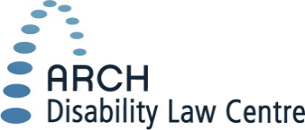
Do you identify as a person with a disability or a family member/ assistant/ supporter/ caregiver of a person with a disability?
Do you have experience using federal tribunals, courts or programs?
If yes, we want to learn from you!
ARCH Disability Law Centre is leading a research project about access to justice for persons with disabilities in Canada.

What is this research project about?
This research aims to better understand barriers that make it difficult for people with disabilities to use federal tribunals, courts, programs and benefits in Canada. This research also aims to better understand things that help make federal tribunals, courts, programs and benefits more accessible for people with disabilities in Canada.
Some examples of federal tribunals are the Canadian Human Rights Commission, the Canadian Human Rights Tribunal, the Canadian Transportation Agency, and the CRTC. Some examples of federal programs and benefits are the Disability Tax Credit or the Canada Pension Plan-Disability benefits. Federal courts include the Supreme Court of Canada and the Federal Court of Canada. There are many more federal tribunals, courts, programs and benefits.

Who can participate?
- People with disabilities who have used federal tribunals, courts, programs or benefits
- Family members/ supporters/ assistants/ caregivers of people with disabilities who have used federal tribunals, courts, programs or benefits

What can you expect?
You will be asked to:
- Sign a consent form about the research project. The consent form will give you information about the research and ask you to decide if you want to participate or not.
- Participate to an online survey. The survey takes 10-15 minutes to complete. It will be in English or French.

Will I get paid for doing this survey?
No. There is no money given to people who fill out this survey.
If you are interested in participating, please click the following link to go to the survey website: http://bit.ly/a2j-eng
Or use your phone/device camera to scan the QR code below, then follow the link.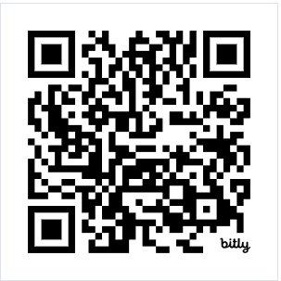
Description video in sign language (ASL): https://youtu.be/qVetOGvpBi0
Description video in sign language (LSQ): https://youtu.be/HUsbEmE1sVg

Principal Researchers:
Dr. Keiko Shikako-Thomas (School of Physical and Occupational Therapy, McGill University)
Kerri Joffe (ARCH Disability Law Centre)
Please contact Dr. Mehrnoosh Movahed to participate or to find out more information.
Email: mehrnoosh.movahed@mcgill.com
*This study has been approved by the McGill University Ethics Review Board*

In this research, we are using the same definition of disability as the Accessible Canada Act: person with a disability means person with any impairment including a physical, mental, intellectual, cognitive, learning, communication or sensory impairment – or a functional limitation – whether permanent, temporary or episodic in nature, or evident or not, that, in interaction with a barrier, hinders a person’s full and equal participation in society.

