Annual Report   
2023-2024

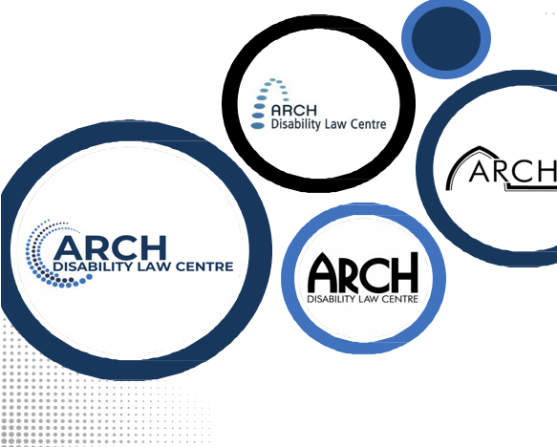

www.archdisabilitlaw.ca

This Annual Report is available in multiple alternate and accessible formats upon request.

ARCH Annual Report, 2023/2024

**© ARCH Disability Law Centre 2024**

Image on this page in the original Annual Report is a decorative image.

# Table of Contents

Table of Contents 3

Who We Are & Our Vision 4

Message from the Executive Director and Chairperson 5

Introducing ARCH Disability Law Centre’s New Logo 6

2024-2029 Strategic Plan 7

Our Impact in Numbers 8

What People Are Saying 9

Social Media and Our Website 10

ARCH in the Media 10

Public Legal Education and Resources 11

Working Toward Systemic Change 12

Respecting Rights 13

Highlights of Select Cases 14

National AccessAbility Week 16

ARCH and Respecting Rights at the UN 17

Statistical Overview of ARCH Activities 19

ARCH’s Board of Directors and Staff 21

Financial Overview 22

Financial Supporters 23

Acknowledgements 24

Contact us 25

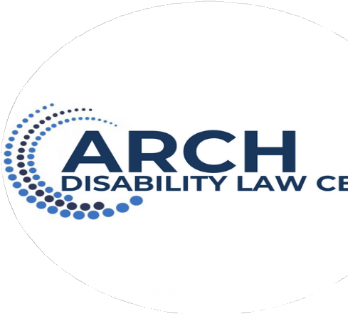

# Who We Are & Our Vision

**Our Vision**

A society in which laws, policies and legal systems ensure full participation, inclusion, dignity, and equal rights without discrimination for persons with disabilities.

**Who We Are**

ARCH Disability Law Centre is a specialty legal clinic that practices exclusively in disability rights law. For over 40 years, ARCH continues to be dedicated to defending and advancing the equality rights, entitlements, fundamental freedoms and the full inclusion of persons with disabilities across Ontario.

ARCH works to eradicate systemic ableism and barriers throughout Ontario by providing a range of legal services and by engaging in law reform work to change laws, regulation and policy, delivering accessible rights education, and building capacity for advocacy directly with our communities. ARCH provides free and confidential legal information and summary legal advice directly to persons with disabilities, and represents persons with disabilities and disability rights organizations in systemic and precedent setting cases.

ARCH Disability Law Centre was granted ECOSOC (Economic and Social Council) consultative status. This recognition enables ARCH to more effectively participate in UN meetings, contribute to global discussions on disability rights, and promote equality and full inclusion for persons with disabilities.

**Our Mission Statement**

ARCH Disability Law Centre, as a specialty legal clinic with a provincial mandate, undertakes to achieve this Vision by:

* Advocating for the rights of persons with disabilities, including the removal of systemic barriers;
* Promoting awareness and providing education on the rights of persons with disabilities;
* Addressing issues that have a particular impact on low income persons with disabilities;
* Ensuring that ARCH’s work has Ontario- wide impact;
* Engaging in national disability rights work and influencing the realization of international disability rights norms in Canada and Ontario;
* Continuously developing and utilizing ARCH’s expertise in local, provincial, national and international law as it affects persons with disabilities;
* Addressing the heightened disadvantage and discrimination faced by persons with disabilities, including as a result of other intersecting grounds of discrimination, including gender, race, age, language, place of origin, economic status, sexual orientation, and others.

# Message from the Executive Director and Chairperson

**Message from the Chair and Executive Director**

On behalf of ARCH Disability Law Centre’s Board of Directors and Staff, we are honoured to present this Annual Report offering highlights of ARCH’s work for the period of September 1, 2023 to August 31, 2024.

It has been another busy and productive year, and our organization remained un- wavered in our efforts addressing systemic ableism, and advancing the rights and full inclusion of persons with disabilities.

This past year, the Board of Directors approved ARCH’s new 5-year Strategic Plan, which focuses on enhancing our strategic test case litigation and systemic advocacy activities, as well as building on our increased national and international presence.

Our new strategic plan also provided us with an opportunity to reconnect with our communities and stakeholders, rebrand and update our materials, develop a new website which will be launched shortly, and review our processes and structures to maximize our efficiencies, effectiveness and impact.

ARCH’s achievements would not be possible without our committed and talented staff team and volunteer board of directors. We wish to convey our deepest gratitude to each staff and board member for their tireless commitment toward our mission.

We wish to sincerely thank our out-going board members, Ashfaq (Kash) Hussain, Harjot Dosanjh, and Jeevan Bains, for all their contributions. This year, we also said goodbye to a number of staff members, Hannah Lee, Charles Hackbarth, Janeille Jackson, and Kerri Joffe who is on a leave of absence. We thank everyone for their countless contributions to ARCH. They will all be missed.

In closing, we want to thank our core funder Legal Aid Ontario, and the other funders listed in our Annual Report. Without their support, none of this amazing work would be possible. We wish to also extend our gratitude to all of our students, volunteers, donors, our membership, community partners, stakeholders and supporters.

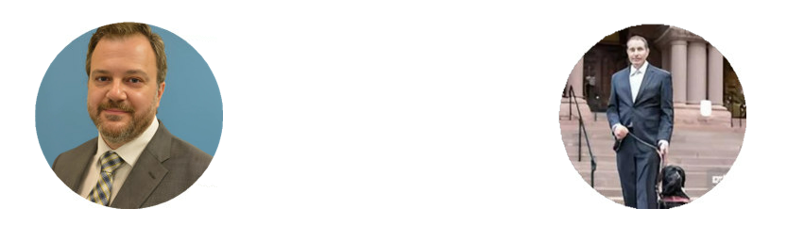

# Introducing ARCH Disability Law Centre’s New Logo

For 44 years, ARCH has been defending and advancing the equality rights, entitlements, fundamental freedoms, and inclusion of persons with disabilities in Ontario. In commemoration of our upcoming 45th anniversary, ARCH is launching our new logo which better reflects our services in English and French and our organization’s Vision and Mission:

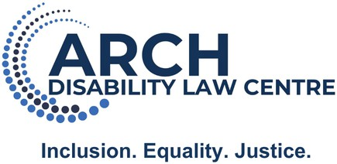

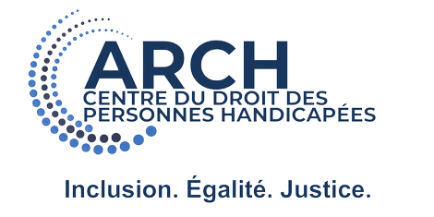

# 2024-2029 Strategic Plan

#1 Maximize internal capacity to deliver core services 
#2 Expand strategic test case litigation and targeted law reform
#3 Expand national reach 
#4 Enhance relationships and outreach activities

Each in detail:
#1 Maximize internal capacity to deliver core services:
-Identify and address inefficiencies and organizational needs
-Continue to address staff wellness, compensation, and retention. 
-Develop strategies to address board recruitment and retention
-Develop metrics and improve data analysis for progress tracking

#2 Expand strategic test case: 
litigation and targeted law reform
-Identify methods of assessing needs and intersectional mapping of persons with disabilities’ experiences
-Allocate resources to increase the impact of systemic test case litigation as a LAO designated test case legal clinic
-Continue to be responsive to issues of greatest concern to disability communities

#3 Expand national reach: 
-Complete a scan of funding options available outside of ARCH’s traditional funding modalities
-Develop and implement a funding strategy to achieve diverse, stable funding
-Develop and implement the plan to structure national work to address internal capacity, decision-making, community involvement, and outreach strategies

#4 Enhance relationships and outreach activities:
-Build and revitalise external relationships impacted by COVID-19
-Build and sustain relationships with community and legal partners across Ontario and Canada to advance disability rights
-Continue outreach initiatives to Indigenous, racialized, Francophone, rural, isolated and vulnerable disability communities

# Our Impact in Numbers

**September 1, 2023 to August 31, 2024**

**2,307intakes** opened on behalf of persons with disabilities cross Ontario.

**20,378** individuals received ARCH’s **publications**

and **public legal education materials** provincially, nationally and internationally.

**82 presentations** and **workshops** delivered, furthering our mission to **educate** and **advocate** for the rights of persons with disabilities.

**6,946** people across Ontario and Canada received **rights education** from ARCH.

**1,294 cases** were handled by ARCH, providing legal support and representation to persons with disabilities.

**28 publications** and **law reform submissions** were produced, contributing to important legal changes and advancing disability rights.

# What People are Saying

**Google Reviews**

The nicest people offering their services to help those with disabilities. Friendly, honest, and caring. I cannot say enough good about them.

I had a wonderful experience with the lawyer from Arch Disability Law Center. She helped me write a letter to my Agency to help me get my rights and needs met and it was written professionally and kindly. I also haven't had excellent service from the intake workers guiding me to the right person for help. I was spoken to respectfully and kindly and no question was disregarded. Best Legal Aide ever! ❤

It was incredibly helpful to speak with a Lawyer from Arch disability law. They provided me with summary legal advice and took the time to answer all my questions and provided references to help me with the matter we are dealing with.

ARCH helped me to fight my Wheel-Trans eligibility status which had been changed to "conditional" despite the fact I have needed the service for the past 34 years. The TTC has been implementing a very unfair process to try to cut people from the service ironically to make more room for newly qualifying disabled people, in compliance with the AODA. It would seem to pit disabled people against each other in an effort to save money on the backs of disabled people. This has to be fought at a government policy level. In the mean time ARCH and TTC Riders Advocacy group are working together to help people through the appeal process.   
My lawyer from ARCH did a great job preparing me for the appeal and seeing me through the hearing. I felt honoured and fortunate to have ARCH on my side as we took on the system. I wouldn't have wanted to face the Wheel-Trans appeal panel on my own. I was lucky to be represented by the legal expertise of my ARCH lawyer and felt I stood a much better chance of succeeding with ARCH on my case. With ARCH's help I won my appeal! I am so grateful. I know ARCH will keep advocating for others like me whom TTC has placed in this unjust position. We have to keep fighting the process.

Images on this page in the original Annual Report include speech balloon with the above reviews in them.

# Social Media and Our Website

We are planning to create a much more live social media presence in 2024/25. We currently have:

**1,690  
Facebook followers4,110**

**X followers8,339**

**Total Engagement**

# ARCH in the Media

**Excluded: The Legal Loophole Barring Hundreds of Ontario Students From School,** July 10, 2024 – Sakeina Syed, The Local

<https://thelocal.to/school-exclusions-ontario/>

**Dependent adult children with disabilities have a say in their care, court rules**, July 9, 2024 – Meagan Gillmore, Canadian Affairs [https://www.canadianaffairs.news/2024/07/09/dependent-adult-children-with- disabilities-have-a-say -in-their-care-court-rules/](https://www.canadianaffairs.news/2024/07/09/dependent-adult-children-with-%20disabilities-have-a-say%20-in-their-care-court-rules/)

**Air Canada contests decision on power wheelchairs. Air Canada appeals regulator's wheelchair decision**, January 11, 2024 – Christopher Reynolds, The Canadian Press

[https://www.thecanadianpressnews.ca/business/air-canada-contests-decision-on- power-wheelchairs/article_c8ab390d-62e0-58ad-b872-89604241e7d4.html](https://www.thecanadianpressnews.ca/business/air-canada-contests-decision-on-%20power-wheelchairs/article_c8ab390d-62e0-58ad-b872-89604241e7d4.html)

**Ontario's accessibility legislation is failing. Advocates say lack of enforcement, complaints process to blame**, January 4, 2024 – Vanessa Balintec, CBC News <https://www.cbc.ca/news/canada/toronto/aoda-ontario-accessibility-enforement-1.7053294>

**Les pannes d’ascenseurs limitent les déplacements des personnes en situation de handicap**, Publié le 18 novembre, 2023 - Caroline Samii-Esfahani, Radio-Canada <https://ici.radio-canada.ca/nouvelle/2027391/handicap-accessibilite-ascenceurs-toronto-batiment>

**'41-storeys, 1 elevator': Toronto highrise dwellers voice frustration with lack of elevator access**, November 13, 2023 – Abby O’Brien, CTV News [https://toronto.ctvnews.ca/41-storeys-1-elevator-toronto-highrise-dwellers-voice- frustration-with-lack-of-elevator-access-1.6642970](https://toronto.ctvnews.ca/41-storeys-1-elevator-toronto-highrise-dwellers-voice-%20frustration-with-lack-of-elevator-access-1.6642970)

**MAID deaths up by 30 per cent in 2022: Health Canada**, October 26, 2023 – Meagan Gillmore, Canadian Affairs <https://www.canadianaffairs.news/2023/10/26/maid-deaths-up-by-30-per-cent-in-2022-health-canada/>

# Public Legal Education and Resources

## Accessible Rights Education

We provide disability rights education to persons with disabilities regarding their legal rights. We also provide public legal education and continuing legal education to disability rights organizations, lawyers, paralegals and advocates. We give presentations, workshops, seminars and produce written materials, including our newsletter the ARCH Alert and our Blog.

## ARCH Alert

The ARCH Alert is our free newsletter which provides timely information on developments in the law, important court decisions, government consultations, community projects, and other disability-related legal issues. ARCH Alert has over 4,000 subscribers. To view it on our website, please visit: <https://archdisabilitylaw.ca/resources/arch-alerts/>

For access to other electronic resources through ARCH library’s online catalog please visit: <https://15285public.rmwebopac.com/>

## Staff Contributions to Published Works

Roberto Lattanzio, “Implementing Policy and Law from a Rights Perspective: Introduction”, and Kerri Joffe & Roberto Lattanzio, “[Law-Making Within a Critical Disability Rights Framework](https://link.springer.com/referenceworkentry/10.1007/978-981-19-6056-7_74)” in Marcia H. Rioux et al, eds, Handbook of Disability: Critical Thought and Social Change in a Globalizing World (Singapore: Springer, 2024) at 1345.

ARCH staff lawyer Kerri Joffe was one of many who gave a testimonial statement in the parliamentary record. Special Issue in Canadian Journal of Disability Studies: Vol. 13 No. 2 (2024): “[Medical Assistance In Dying: Resistance in Canada](https://cjds.uwaterloo.ca/index.php/cjds/issue/view/47)”

Kerri Joffe & Roberto Lattanzio, “Canada’s Medical Assistance in Dying Law and the Rights to Life and Equality at International Law”, in Kotalik, Jaro & Shannon, David (eds.) (2023). Medical Assistance in Dying (MAID) in Canada: Key Multidisciplinary Perspectives. Springer Verlag, at 355.

Image on this page in the original Annual Report has an image of a group of people with and without disabilities.

# Working Toward Systemic Change

## Civic Society Parallel Report

ARCH continues to work with a network of disability organizations and disabled people’s organizations across Canada to coordinate, research, and write a joint civil society parallel report. This report provides community-based information to the United Nations Committee on the Rights of Persons with Disabilities during its review of Canada’s implementation of the *Convention on the Rights of Persons with Disabilities*.

Canada is scheduled to have its review by the UN Committee on the Rights of Persons with Disabilities at the United Nations in Geneva in March 2025. We are currently in the final stages of preparing the parallel report for submission and have been working with organizations across Canada to ensure that the report is up to date before it is sent in as part of the review process.

## Empowering Community and Removal of Barriers (ECRoB)

ARCH is a partner of the ECRoB project and has participated and supported the delivery of workshops and development of education materials to the legal profession across Canada, and other stakeholder groups. ARCH is also leading legal research that explores the treatment of Multiple Chemical Sensitivity by tribunals and courts across Canada. For more information about this project, please visit: <https://aseq-ehaq.ca/en/ecrob/>

## Access to Justice Project

ARCH Disability Law Centre has been leading a research project to better understand the experiences that people with disabilities have while using federal programs, courts, and tribunals in Canada. We want to understand barriers that make it more difficult to use federal programs, courts and tribunals. We also want to understand what makes federal programs, courts and tribunals more inclusive and accessible for people with disabilities. The results from this research will be included in a report that ARCH is writing for Accessibility Standards Canada who has funded us to do this work. In the future, this report might be used to help inform new federal accessibility standards.

We have completed the research stage of our project, which has included a survey and interviews conducted by our partners at McGill University. We have begun work on our final report for this project.

# Respecting Rights

Respecting Rights is a project at ARCH that is led by self-advocates labelled with intellectual disabilities. Since 2011, Respecting Rights has worked on accessible law reform projects and provides accessible rights education to persons labelled with intellectual disabilities and their support networks across Ontario.

Respecting Rights continues to host virtual quarterly meetings for self-advocates across Ontario where they can learn about our work and how to get involved. These meetings are also an opportunity for self-advocates to share concerns and issues they are facing in their communities across Ontario.

Funded by the City of Toronto, Coffee and Advocacy, a program of Respecting Rights meets monthly to encourage self-advocates from Toronto to come together and discuss disability rights issues that are important to them.

**Feedback on the Respecting Rights Program:**

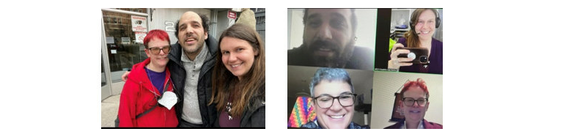

The impact of Respecting Rights and ARCH is just so massive. Please know how much your work is changing lives.

The law students were incredibly helpful, super smart and supportive, and that Rob even brought his service dog Chloe a bowl of water!

The Respecting Rights Coordinator was so warm and welcoming and had a way of making sure everyone understood what was being talked about.

Learning that I could use my voice to tell my story to help others was a turning point - I feel like I have a sense of purpose. Before connecting with ARCH I was giving up on trying.

This program is huge for it’s members. The system screws them over (school system, health care system) to the point that they has basically hide.

I can’t say enough good things – he’s telling everyone he knows about his excellent experiences at ARCH.

Images on this page in the original Annual Report include speech balloon with the above feedback in them.

# Highlights of Select Cases

## Accessible Air Travel Transportation

ARCH is currently defending a significant decision on accessible air travel transportation: Rose v Air Canada.

In December 2023, Air Canada appealed the decision to the Federal Court of Appeal. ARCH continues to represent Mr. Rose and is co-counseling with Lesli Bisgould of Legal Aid Ontario’s Clinic Resource Office against Air Canada’s appeal. ARCH is grateful to the Clinic Resource Office for its ongoing support of this work.

In December 2019, ARCH represented a client in an oral hearing at the Canadian Transportation Agency. The issue to be determined was whether Air Canada, who had denied ARCH’s client access to multiple trans-border flights due to his mobility device, could accommodate him up to the point of undue hardship. On August 11, 2023, the Agency released its final decision, Rose v Air Canada, finding that Air Canada had failed to demonstrate undue hardship and awarded systemic remedies. As a result, in situations where passengers who use power wheelchairs that cannot be collapsed to fit within an aircraft’s cargo door, Air Canada must find an accessible flight or an accessible aircraft for that route.

The decision is available in the Agency’s online database at: [Decision No. 123-AT-A-2023 | Canadian Transportation Agency (otc-cta.gc.ca)](https://otc-cta.gc.ca/eng/ruling/123-AT-A-2023)

## Challenging Accessibility at the Federal Government

ARCH is representing a Complainant in a case dealing with the accessibility of a public facing government application. Following the release of the application ARCH’s client attempted to use it, however was unable to, as it was not compatible with their screen reader. As a result our client filed a complaint at the Canadian Human Rights Commission, which was successfully referred to the Canadian Human Rights Tribunal. We are currently at the early stages of the Tribunal process.

## School Exclusion Appeal

ARCH successfully represented a student who was excluded from school for disability-related behaviour under section 265(1)(m) of the Education Act in an appeal before a large school board. The appeal was heard by the school board’s trustees. In the appeal, ARCH argued that the school improperly excluded the student instead of providing appropriate accommodations to the point of undue hardship and the decision to exclude was quashed. This appeal was part of ARCH’s ongoing litigation advancing inclusive education.

## J.F.R v K.L.L

On July 2, 2024, the Court of Appeal for Ontario released a decision in the appeal of J.F.R v. K.L.L, 2024 ONCA 520. This decision is important because it states that persons with disabilities must be included in cases that directly impact them.

This case was about M, an adult with a disability and his right to be involved in making decisions about where he lived and who he lived with. During his parents’ divorce proceeding, his father asked the Superior Court to make a parenting order under the Divorce Act. The Superior Court agreed to make this parenting order despite M not having the opportunity to be involved in the case. The decision was appealed to the Court of Appeal for Ontario.

ARCH represented the Intervener, People First of Canada, at the Court of Appeal. Our submissions led to the court deciding that persons with disabilities must be provided the dignity of choice. Further highlighting that persons with disabilities must be presumed capable of making decisions. The Court understood and made clear that adults should not be treated like children because of their disability, rather they must be given the same rights as all adults.

To review the decision, please visit: <https://canlii.ca/t/k5khf>

# National AccessAbility Week



ARCH co-hosted our annual National AccessAbility Week event with the Law Society of Ontario on May 29, 2024. The event titled “Navigating Capacity in your Legal Practice with Clients with Disabilities” offered a panel discussion on the topic of capacity to instruct legal counsel, with a focus on building knowledge and skills for legal practitioners who work with clients with disabilities who have capacity issues. They discussed common assumptions and misconceptions about disability and capacity, as well as legal obligations and professional responsibilities to clients with disabilities who have capacity issues. Panelists offered practical tips for accommodating clients with capacity issues, with a particular focus on clients with mental health disabilities, clients labeled with intellectual or developmental disabilities, and clients with communication disabilities.

National Access Awareness Program from May 29, 2024 recording is available on the Law Society of Ontario’s website:

[Law Society of Ontario - ARCH Archived Webcast - Navigating Capacity in Your Legal Practice with Clients with Disabilities](https://lso.freestonelms.com/viewer/eyJ0eXAiOiJKV1QiLCJhbGciOiJIUzI1NiJ9.eyJjaGFwdGVySUQiOjQ3OTM3NX0.FU_6d18tFOUZ4cbcpbQO_JjqhDraJ3mg9hM4JGqU08Y)

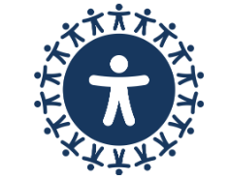

# ARCH and Respecting Rights at the UN

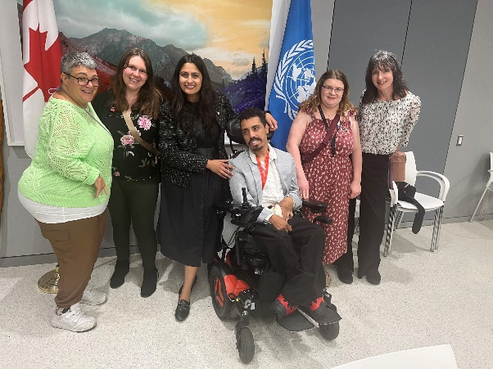

From June 10th to 14th 2024, ARCH and Respecting Rights had the privilege of attending and co-hosting a side event at the 17TH Conference of States Parties to the Convention on the Rights of Persons with Disabilities (CoSP17) at the United Nations in New York.

On June 12th 2024, ARCH and Respecting Rights collaborated with self-advocates from My Home, My Rights in Nova Scotia and Down Syndrome Australia to host a side event called “Art of Inclusion: Human Rights Education and Advocacy Led by People Labeled with Intellectual Disabilities.” During this side event, each self-advocacy group had an opportunity to share examples of their work and discuss why teaching others about human rights in an accessible way is important. We also shared a video from the self-advocates in Kathmandu, Nepal from the organization Parent Federation of Persons with Intellectual Disabilities (PFPID).

During the Cosp17 conference, ARCH and Respecting Rights attended several events at the United Nations headquarters where they learned about the different ways in which governments and self-advocacy groups from across the world are working together to change the laws for persons labelled with intellectual disabilities. On June 11th 2024, they attended a Canadians Mission meeting with Minister Kamal Khera, Minister of Diversity and Inclusion and Ambassador Richard Arbeiter, Deputy Permanent Representative of Canada to the United Nations.

**ARCH and Respecting Rights at the UN**

On June 11th, ARCH and Respecting Rights attended a Canadians Mission meeting with the Minister of Diversity and Inclusion and the Deputy Permanent Representative of Canada to the United Nations. During this meeting, representatives from Canadian Disability organizations had an opportunity to discuss their concerns, ask questions and learn about the work that the United Nations is doing on behalf of the disability community and in support of the Convention of Persons with Disabilities (CRPD). On this day Judy Noonan, a Respecting Rights member was interviewed by self-advocate Nick Herd from L’ARCH International and the UN News. In the interview, Judy explains what the expression “nothing about us without us” means to her.

To watch Judy’s interview and the COSP17 video on “Art of Inclusion: Human Rights Education and Advocacy Led by People Labeled with Intellectual Disabilities.” visit: <https://archdisabilitylaw.ca/respecting-rights/our-work-rr/>

Respecting Rights would like to thank the following community members for their support with making our experience at CoSP17 successful:

Isai Estey

Chantel Meister

Michael Cox

Anne MacRae

Sheila Wildeman

Darryl Steff

Lori Vaanholt

Yan Grenier

PFPID Nepal

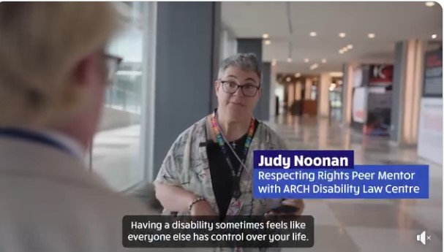

# Statistical Overview of ARCH Activities

**Overview of All Activities by Area of Law   
Initiated between   
September 1, 2023 to August 31, 2024**

Areas of Law:
Accessibility Laws – 6.1%
Attendant Services – 0.7%
Education – 1.9%
Transportation – 1%
Human Rights – 21.3%
Accommodations in the Workplace – 2.1%
Decision Making Rights – 6.2%
Medical Assistance in Dying– 2.1%
Convention on the Rights of Persons with Disabilities – 6.9%
Other – 51.7%


**Areas of Law:**

Accessibility Laws – 6.1%

Attendant Services – 0.7%  
Education – 1.9%

Transportation – 1%

Human Rights – 21.3%

Accommodations in the Workplace – 2.1%

Decision Making Rights – 6.2%

Medical Assistance in Dying– 2.1%

Convention on the Rights of Persons with Disabilities – 6.9%

Other – 51.7%

**ARCH Statistics**

**Summary Advice Cases**

Accessibility Laws – 0.8%

Attendant Services – 4.6%  
Education – 23.6%

Transportation – 3.4%

Human Rights – 25.2%

Accommodations in the Workplace – 15.2%

Decision Making Rights – 1.2%

Other – 27.1%

**Standard Cases**

Attendant Services – 2.2%  
Education – 24.6%

Transportation – 6%

Human Rights – 21.6%

Accommodations in the Workplace – 5.2%

Decision Making Rights – 4.5%

Other – 35.8%

**Test Cases**

Accessibility Laws – 5.6%

Education – 11.1%

Transportation – 5.6%

Human Rights – 27.8%

Accommodations in the Workplace – 5.6%

Other – 44.4%

Images on this page in the original Annual Report include three pie charts with the above details.

# ARCH’s Board of Directors and Staff

**ARCH’s Board of Directors**

**Ashfaq Kash Hussain** (Secretary)

**Claudette Paul**

**Dolly Menna-Dack** (2nd Vice-Chair)

**Ellen Cohen**

**Harjot Dosanjh**

**Hengameh Saberi**

**Jason Mitschele** (Chairperson)

**Jeevan Bains**

**Jennifer Hiseler**

**Logan Wong**

**Natalie MacDonnell**

**Norah Dillon-Cheetham**

**Paul Scotland** (1st Vice-Chair)

**Robert Barber** (Treasurer)

**Ryan Hooey**

**ARCH Staff**

**ROBERT Lattanzio**, Executive Director

**AMANDA Ward**, Intake Coordinator

**DEVIN Glim**, Articling Student

**DOREEN Way**, Office Manager

**GABRIEL Reznick**, Staff Lawyer

**GRACIELA Flores Méndez**, Staff Lawyer

**ILINCA Stefan**, Staff Lawyer

**JESSICA Field**, Respecting Rights Coordinator

**KERRI Joffe**, Staff Lawyer (On Leave)

**LILA Refaie**, Bilingual Intake Lawyer and Student Programs Lead

**MARY Hanson**, Librarian

**THERESA Sciberras**, Operations, Program & Administrative Assistant

**Contract Staff**

**ELSIE Tellier**

**GAYE Jackson**

**MICHELLE Way**

**Staff Who Left ARCH 2023-24**

**CHARLES Hackbarth**, Respecting Rights Coordinator

**HANNAH Lee**, Staff Lawyer

**JANEILLE Jackson**, Litigation Clerk

# Financial Overview

Financial Overview

Total Expenses - $1,818,523
Charitable programs: 81.4%
Management and Administration: 14.9%
Fundraising: 3.7%2023 -2024

Total Revenue: $1,898,425
Government funding: 93.8%
Non-receipted donations: 4.5%
All other revenue: 1.6%

**Total Expenses - $1,818,523**

Charitable programs: 81.4%

Management and Administration: 14.9%

Fundraising: 3.7%

**Total Revenue: $1,898,425**

Government funding: 93.8%

Non-receipted donations: 4.5%

All other revenue: 1.6%

# Financial Supporters

**ARCH’s Financial Supporters**

Legal Aid Ontario / Aide Juridique Ontario

ARCH is grateful to the ongoing funding and support of Legal Aid Ontario (LAO). LAO is ARCH’s primary funder and a critical partner in all our work.



The City of Toronto has once again provided ARCH with a Community Service Partnership Grant that supports our Respecting Rights Toronto Program.



ARCH is licensed by the Ontario Lottery Corporation to participate in the Break Open Ticket program. Receipts from this initiative support our disability accommodations, communications, our website and our Resource Centre.

ARCH received funding for a project from Accessibility Standards Canada to conduct legal research and develop a research report about Access to Justice for persons with disabilities in the Federal sphere.

ARCH is grateful to the British Columbia Aboriginal Network on Disability Society (BCANDS) for their funding of ARCH’s work on the Civil Society Parallel Reporting on Canada’s implementation of the *Convention on the Rights of Persons with Disabilities*.

ARCH also received funding from numerous organizations for deliverable specific legal work.

ARCH thanks the above funders for their support, and our members of the public for their ongoing support through their generous donations.

# Acknowledgements

ARCH is very appreciative of the support of legal clinics, pro bono assistance of lawyers, volunteers, and law students. ARCH gratefully acknowledges the contributions from our volunteers, lawyers and supporters:

**Moving Together Toward Supporting Reconciliation Committee:**

**Board Members:**

Claudette Paul

Ryan Hooey

Robert Barber

Jason Mitschelle

**Community Members:**

Roberta Oshkabewisens

Melanie Marsden-Meyers

Roxanne Mykitiuk

Sandi Bell

**Disability Law Intensive Students 23/24:**

Alessandra Giorgi

Alexandra Daly

Baldeep Bhathal

Daniel Legris

Devin Glim

Dumkelechi Aligwekwe

Florence Kwok

Khaleel Bateman

Merity Issagholian

Rachael Simser

Rosa Glannone

**Volunteers**

Alana Omar

Maguid Nicholas

Brett Balaban

Marissa Blake

Judy Noonan

Sarah J Flint

Peter Park

**Accommodation Providers:**

Canadian Hearing Services

ASIGN (formerly Sign Language Interpreting Associates Ottawa Inc)

AB Captioning & CART Inc

Monique LeDrew, HandSigNow

The Care Company

Gloria Brifoglio

Danielle Leddy

Language Interpreting and Translation: All Languages

MCIS Language Solutions

Traduction Guitard Translation

**Contributors to one or more different ARCH projects and work over the year:**

Anne MacRae

David Lepofsky

Elyse Shumway

Gwen Bang

Keiko Shikako

Kurt Goddard

Lana Frado

Leanne Goldstein

Leslie Bisgould

Matthew Albert

Natalia Hicks

Neil Belanger

Rohini Peris

Ruby Dhand

Susan Hardie

Vince Calderhead

Yan Grenier

Dr. John Molot

**Summer Law Interns:**

Jacob Klein-Goldenberg

Reet Sidhu

Thea Hoaken

# Contact us

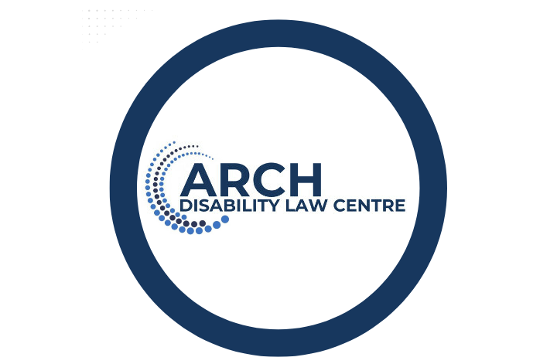

55 University Avenue, 15th Floor

Toronto, ON, M5J 2H7

Phone: 416-482-8255 1-866-482-2724

TTY: 416-482-1254 1-866-482-2728

www.archdisabilitylaw.ca

Facebook: @ARCHDisabilityLawCentre 
X: @ARCHDisability 
LinkedIn: @arch-disability-law-centre