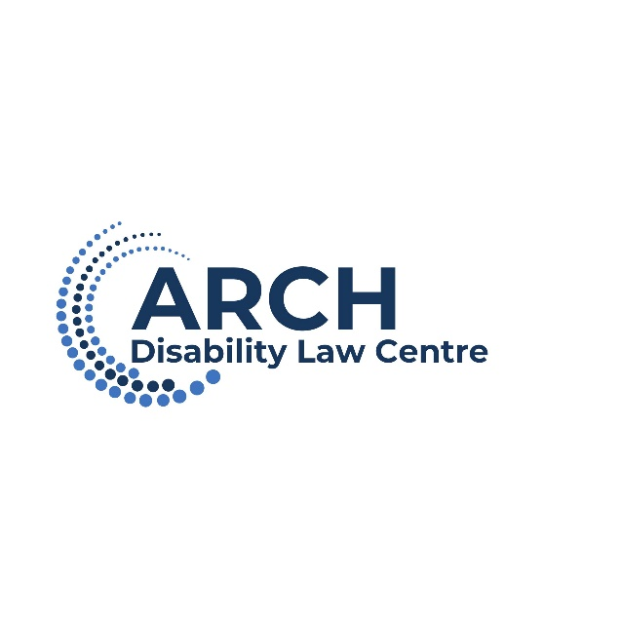

# **Nominations Report**

**October 16, 2025**

ARCH is governed by a Board of Directors comprised of fifteen Directors elected by the members of ARCH. By-law No. 1 requires that a majority of Directors be persons with disabilities.

# The following individuals have completed year one of their two-year term and are in office until AGM 2026:

* Claudette Paul
* Dolly Menna-Dack
* Jason Mitschele
* Jennifer Hiseler
* Katherine Underwood
* Michael Samakayi
* Paul Scotland

# The following Board members are standing for election or re-election for a two-year term:

* Bernard Lyons
* Logan Wong
* Natalie MacDonnell
* Nora Dillon-Cheetham
* Robert Barber
* Ryan Hooey
* Sandi Bell
* Shauna Doracin

# Not returning to the Board:

* Dave Lewis
* Ellen Cohen
* Hengameh Saberi

# **Nominations Committee Recommendation:**

The Nominations Committee recommends the appointment of the following members to the Board of Directors of ARCH Disability Law Centre for a term of two years:

* Bernard Lyons
* Logan Wong
* Natalie MacDonnell
* Nora Dillon-Cheetham
* Robert Barber
* Ryan Hooey
* Sandi Bell
* Shauna Doracin