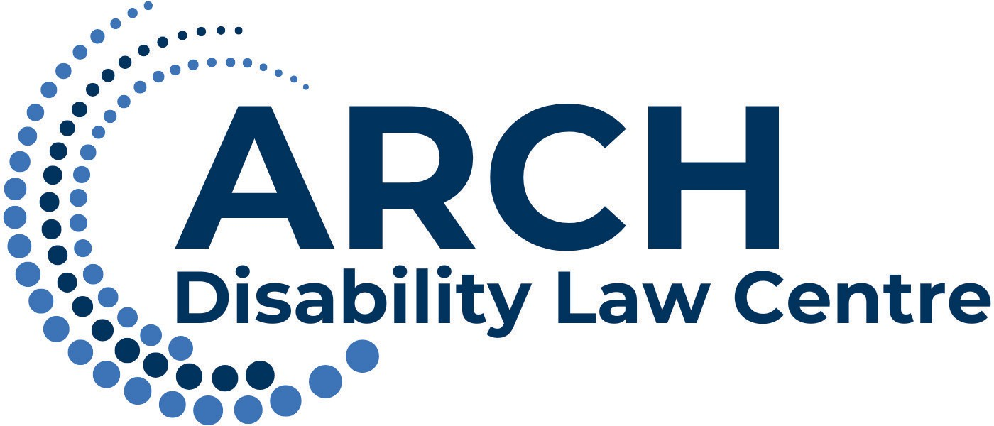 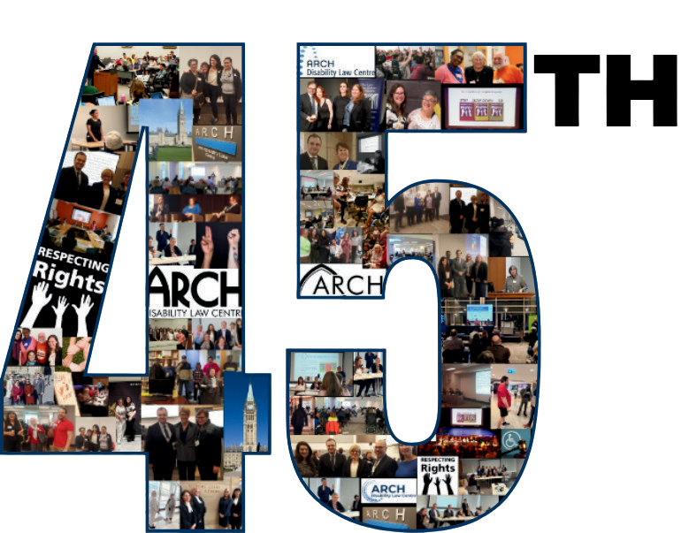

45thANNIVERSARY

**ANNUAL REPORT**

**2024-2025**

[**www.archdisabilitylaw.ca**](http://www.archdisabilitylaw.ca/)

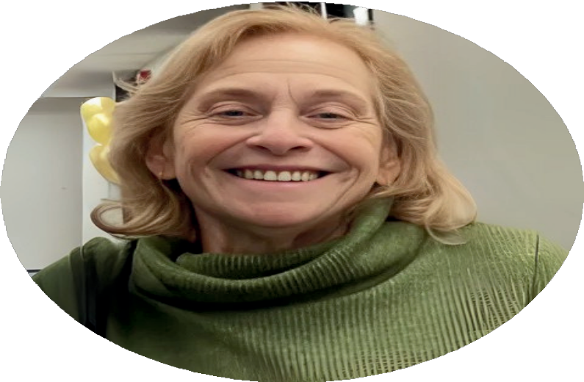

# In Loving Memory Ellen Cohen

**This year’s Annual Report is dedicated to the memory of our colleague and friend, Ellen Cohen, who served on ARCH’s Board of Directors with dedication and compassion. Ellen’s commitment to advancing disability rights, her generosity of spirit, and her unwavering belief in justice touched everyone who had the privilege of working alongside her.**

**We are deeply grateful for her contributions and the lasting impact she made on our community. Ellen’s legacy will continue to guide ARCH in our work and in our shared vision of a more accessible and inclusive Ontario.**

*This Annual Report is available in multiple alternate and accessible formats upon request.*

ARCH Annual Report, 2024/2025

**© ARCH Disability Law Centre 2025**

# Table of Contents

Dedication to Ellen Cohen 2

Table of Contents 3

Our Vision & Who We Are 4

What People are Saying 5

Message from the Executive Director and Chairperson 6

Our Impact in Numbers 8

Public Legal Education and Resources 9

Working Toward Systemic Change 10

Respecting Rights 13

Litigation Highlights 14

Expanding Our Reach 16

ARCH in the Media 17

Top 5 Activities by Area of Law 18

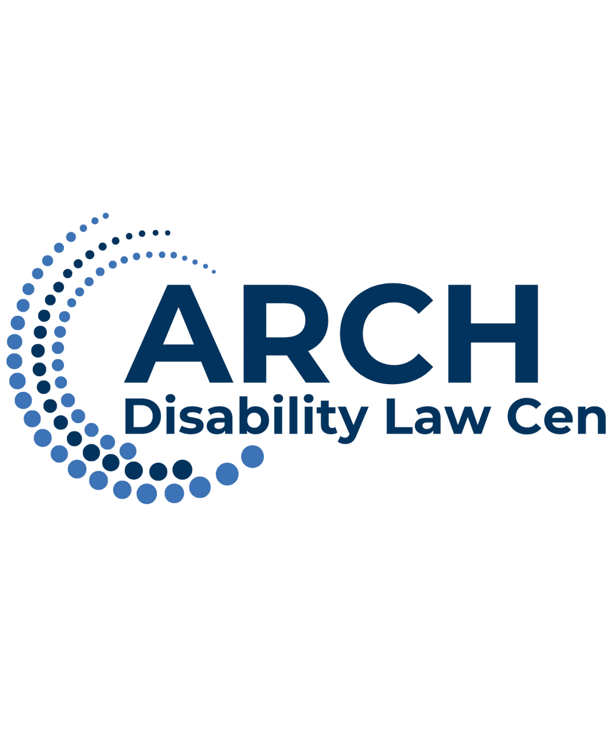

Financial Overview 2024-2025 19

ARCH Board of Directors & Staff 20

Financial Supporters 21

Acknowledgments 22

Contact Us 23

# Our Vision

A society in which laws, policies and legal systems ensure full participation, inclusion, dignity, and equal rights without discrimination for persons with disabilities

# Who We Are

ARCH Disability Law Centre is a specialty community legal clinic that is mandated, since its incorporation in 1979, to advance the equality rights and full inclusion of persons with Disabilities. For 45 years, ARCH has practiced exclusively in disability rights law, and works to remove systemic ableism and barriers throughout Ontario by providing a range of accessible legal services to persons with disabilities, and by engaging in law reform work to change laws, regulation and policy, delivering accessible rights education, and building capacity for advocacy directly within our communities.

ARCH provides free and confidential legal information and summary legal advice directly to persons with disabilities, and represents persons with disabilities and disability rights organizations in systemic and precedent setting cases.

Image in the original Annual Report is a picture of Respecting Rights members and ARCH staff.

**Our Mission Statement**

ARCH Disability Law Centre, as a specialty legal clinic with a provincial mandate, undertakes to achieve this Vision by:

* Advocating for the rights of persons with disabilities, including the removal of systemic barriers;
* Promoting awareness and providing education on the rights of persons with disabilities;
* Addressing issues that have a particular impact on low income persons with disabilities;
* Ensuring that ARCH’s work has Ontario- wide impact;
* Engaging in national disability rights work and influencing the realization of international disability rights norms in Canada and Ontario;
* Continuously developing and utilizing ARCH’s expertise in local, provincial, national and international law as it affects persons with disabilities;
* Addressing the heightened disadvantage and discrimination faced by persons with disabilities, including as a result of other intersecting grounds of discrimination, including gender, race, age, language, place of origin, economic status, sexual orientation, and others.

# What People Are Saying

**Google Reviews**

**Thank you for the friendly service**

**It was incredibly helpful to speak with a Lawyer from Arch disability law. They provided me with summary legal advice and took the time to answer all my questions and provided references to help me with the matter we are dealing with.**

**Lawyer Gabriel Reznick is professional, intelligent and highly dedicated to helping.**

**After years of trying on my own to get a particular public service set up for my family member (but getting stonewalled by the other legal rep), we finally got the victory with Arch Disability.**

**Gabriel—thank you so much for pushing through the stonewall.**

**A HUGE THANK YOU for the help you provided me! As someone with disabilities in Ontario, it can be so hard to find affordable/govt paid if you need human rights related support which is why I am so grateful for the time and help they provided. I also wanted to comment that I have NVLD (Non-verbal learning disorder) & severe chronic pain and was very grateful for their willgness to accommodate me.**

**After our discussions, I feel that I much more educated about the Ontario Human RIghts Code and how to best advocate for myself and others. I encourage anyone with disabilities to go to them for support.**

The reviews above are in speech balloon images in the original Annual Report

# Message from the Chair and Executive Director

On behalf of ARCH Disability Law Centre’s Board of Directors and staff team, we are proud to present to our membership this Annual Report offering highlights of our clinic’s work for the period of September 1, 2024 to August 31, 2025.

We continue to mourn the passing of our dear friend, Ellen Cohen: colleague, long- time mental health and disability advocate, and ARCH’s Board member and 2nd Vice-Chair. Ellen passed on March 13, 2025 while in Geneva, Switzerland as part of the Canadian Civil Society Group advocating on behalf of disability communities at the United Nations. Ellen joined ARCH’s Board in 2022, and had been a partner and supporter of ARCH for decades in her many advocacy roles. Her contributions have been invaluable to ARCH and to our communities. She was an integral part of ARCH’s national and international advocacy work. Ellen was highly respected and regarded within all communities that she worked with. Ellen’s larger than life personality, unparalleled compassion and generosity, unrelenting drive, and unwavering integrity were among the many incredible qualities that made her such an effective leader. We are deeply grateful for Ellen’s invaluable contributions to our organization and to the disability rights movement. Her tireless commitment for full inclusion will continue to inspire us. Ellen is deeply missed.

Amidst the deep sadness felt across our organization following Ellen’s passing, this reporting year also marked some important wins and successes. ARCH began implementing its new Strategic Plan embarking on a 5 year cycle. ARCH successfully litigated a matter regarding accessible air travel against Air Canada before the Canadian Transportation Agency, and successfully defended this decision this past year before the Federal Court of Appeal. ARCH co-coordinated the Civil Society Parallel Report Group, 53 disability rights and civil society groups across Canada, to submit a parallel report to Canada’s Report to the United Nations Committee on the Rights of Persons with Disabilities.

ARCH and representatives from 10 other non-governmental organizations from the coalition travelled to Geneva, Switzerland to speak with the UN Committee during its Dialogue with the Canadian Government about its implementation of the *Convention on the Rights of Persons with Disabilities.*

This year also marked the launch of the inaugural Teresa Daw Student Internship. We were thrilled to welcome Cameron Smith, law student from the University of Toronto, who was a wonderful addition to our team. The Teresa Daw Student Internship was created to offer opportunities for Indigenous (First Nations, Metis, and Inuit) law students to explore disability-related issues that directly affect their communities.

ARCH also edited a section, and contributed with a chapter in the Handbook of Disability: Critical Thought and Social Change in a Globalizing World. It was a true privilege and honour to contribute to such an important global project, in memory of the late Dr. Marcia H. Rioux.

Since opening our doors in 1980 as the Advocacy Resource Centre for the Handicapped (ARCH), we continue to be a trusted legal clinic advancing the rights of people with disabilities across Ontario. Throughout these 45 years, our successes have demonstrated the importance of working alongside communities in collaborative and creative ways, through capacity building and relentless advocacy, in achieving lasting systemic change toward the goal of full inclusion.

From landmark cases to policy reform, our work has shaped disability rights provincially, federally, and internationally. The lessons we have learned along the way remind us why inclusion, equity and persistence matter, and this milestone year is a reminder of both the progress achieved thus far and the work still ahead.

ARCH’s achievements would not be possible without our committed and talented staff team and volunteer board of directors. We wish to convey our deepest gratitude to each staff and board member for their tireless commitment toward our mission.

We wish to sincerely thank our out-going board members, Hengameh Saberi, and David Lewis, for all their contributions. This year, we welcomed Michael Gottheil, in a part-time senior counsel position. Michael has been a wonderful addition to the team, offering his sage advice and experience in an advisory role on advancing ARCH’s test case litigation practice. We also welcomed Devin Glim as our articling student, who joined our team seamlessly from the Disability Law Intensive program and who continues to be an integral part of our legal team.

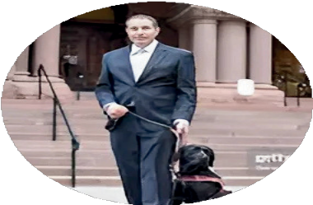In closing, we want to thank our core funder Legal Aid Ontario, and our other funders as listed in this report. We wish to also extend our deepest gratitude to all of our students, volunteers, donors, our membership, community partners, stakeholders and supporters.

**Robert Lattanzio**

**Jason Mitschele**

# Our Impact in Numbers

**September 1, 2024 to August 31, 2025**

**2,876 intakes**

opened on behalf of persons

with disabilities across Ontario.

**5,316** Individuals

received ARCH’s **publications** and **public legal education materials** provincially, nationally and internationally.

**56 presentations** and **workshops** delivered furthering our mission to **educate** and **advocate** for the rights of persons with disabilities.

**3,802** people across Ontario and Canada

received **rights education**

from ARCH

**825 cases were** handled by ARCH, providing legal support and representation to persons with disabilities.

**41 publications and law reform submissions** were produced, contributing to important legal changes and advancing disability rights

.

# Public Legal Education and Resources

## New and Updated Public Legal Education Resources from ARCH

ARCH created, revised and updated public legal education materials that help people with disabilities and their support networks learn about our services and better understand the laws that protect their rights. These materials include new videos, updated factsheets, and the launch of a recorded webinar series.

To access these resources visit our website at <https://archdisabilitylaw.ca/resources/>.

## Staff Contributions to Published Works

**Launch of The Handbook of Disability**ARCH was honoured to participate in the launch of the two volume book titled, “Handbook of Disability: Critical Thought and Social Change in a Globalizing World”. ARCH contributed as a Section Editor, and contributed as author within that section.

Picture of a workshop, from the Launch of the Handbook of Disability

# Working Toward Systemic Change

## ARCH participates in Canada’s review at the United Nations

The *Convention on the Rights of Persons with Disabilities* (CRPD), an important international treaty, includes articles that establish a process for state parties to engage with the United Nations Committee on the Rights of Persons with Disabilities. The Committee is responsible for reviewing the progress that state parties have made in implementing the CRPD. “State Parties" are sovereign countries or regional integration organizations that have consented to be legally bound by the Convention's provisions.

In 2021, 53 national and provincial non-governmental organizations joined together to form a Coalition called the Civil Society Parallel Report Group. The coalition worked together to create a parallel report to share with the Committee. ARCH served as a co-coordinator for these organizations as well as a contributor on various topics including access to justice and equal recognition before the law for people with disabilities.

In March 2025, ARCH and representatives from 10 other non-governmental organizations from the Coalition travelled to Geneva, Switzerland to speak with the Committee. The parallel report and oral submissions made in Geneva contributed to strong Concluding Observations from the Committee which contained clear recommendations for Canada. These recommendations include suggesting that Canada repeal or cancel Track Two MAiD, which refers to the rules that allow a person to receive an assisted death even if they are not near the end of their life, and that Canada should ensure that all disability benefits provide people with disabilities enough money to live and help keep them out of poverty.

The Concluding Observations will serve as an important tool for ongoing advocacy for systemic change.

## The Empowering Community and Remove of Barriers (ECRoB) Project

ARCH is currently partnering on a project titled “Empowering Community and Removal of Barriers (ECRoB)”, which focuses on increasing knowledge and removing barriers for persons with multiple chemical sensitivity. The project is led by L'Association pour la santé environnementale du Québec / Environmental Health Association of Québec.

As part of this project, ARCH participated in numerous presentations across the country on barriers faced by persons with multiple chemical sensitivity, including to human rights commissions, legal and medical professionals, as well as communities of persons with disabilities. ARCH has also been conducting in-depth legal research and is drafting a report on legal barriers experienced by persons with multiple chemical sensitivity. This report is set to be published next year.

In recognition of this work, ARCH’s Executive Director was honoured by being named the 2025 recipient of the Resilience Award, by the Environmental Health Association of Canada. The award was received during the 2025 RESILIENCE: International Conference on Multiple Chemical Sensitivity (MCS).

**Federal and Provincial Disability Debates** ARCH, along with community partners, co- hosted disability debates for both the Provincial Election and the Federal Election. We thank all our partners for making both events possible.

Both events invited representatives from each of the official parties to answer questions from persons with disabilities across Ontario.

**Better off Dead**

ARCH moderated a panel discussion featuring Liz Carr during a screening event of the documentary, “Better off Dead”. The documentary explores themes of assisted suicide and euthanasia, and the impacts of medical assistance in dying in Canada on persons with disabilities.

**Access to Justice in the Federal Sector**

ARCH was funded by Accessibility Standards Canada to develop research and recommendations addressing access to justice barriers within Federal Courts, Tribunals and programs.

Images in the original Annual Report are pictures of a room with people attending one of the election debates & a panel at front table at Better Off Dead panel discussion.

**Working Toward Systemic Change**

## The Teresa Daw Student Internship

ARCH is pleased to have launched the inaugural Teresa Daw Student Internship. The Teresa Daw Student Internship was created to offer opportunities for Indigenous (First Nations, Metis, and Inuit) law students to explore disability-related issues that directly affect their communities. The Teresa Daw Student Internship was made possible by the Teresa Daw Legacy Fund. This fund was generously bequeathed to ARCH by our past Board President, Teresa Daw.

## Disability Law Intensive Program

In partnership with Osgoode Hall Law School, ARCH offers a law student program called the Disability Law Intensive (DLI). Through this program, twelve law students from Osgoode Hall Law School complete a part-time placement at ARCH for the full academic year. DLI students work under the direct supervision of our lawyers on various cases and projects.

As part of the DLI program, ARCH launched two student-led clinics in September of 2024. The purpose of these clinics was to provide additional direct legal services to persons with disabilities beyond ARCH’s Summary Advice and Referral program. The clinics focused on two practice areas: human rights law and education law.

**Human Rights Clinic:** Law students assisted eligible clients with drafting their Application or their Reply form at the Human Rights Tribunal of Ontario. Over the course of seven months, law students helped many clients with their Application or Reply.

**Education Exclusion Clinic:** Law students assisted students with disabilities who were excluded from primary or secondary school under section 265(1)(m) of the *Education Act*. Among other related legal assistance, law students in the DLI program helped eligible students with disabilities to regain access to their education. As a result, over twenty students with disabilities benefited from this student-led clinic.

# Respecting Rights



Respecting Rights Toronto is a project that supports people with intellectual disabilities in the Greater Toronto Area. It is supported by the City of Toronto’s Community Services Partnership Grant. The project hosts monthly meetings and events that promote learning about decision-making rights through accessible arts-based activities.

## Respecting Rights Toronto Video Series on Decision-Making Rights

In May 2025, Respecting Rights and ARCH released a six-part video series. These videos share information about ARCH’s services and explore decision- making in key areas such as: finances, healthcare, and relationships. The series also includes recent changes to Toronto’s Wheel-Trans para-transit services.

To access these videos, visit the Respecting Rights YouTube Channel: <https://www.youtube.com/@respectingrights1618>

## Respecting Rights Toronto Celebrates National AccessAbility Week!

On Thursday, May 29th, Respecting Rights Toronto and ARCH Disability Law Centre hosted our first Map Mission event to celebrate National AccessAbility Week. Five self-advocates took part in an “accessibility hunt,” exploring ARCH’s office and the surrounding neighborhood to see which community spaces are accessible and which are not. Using the AccessNow app, they recorded their findings to share with others. The group also learned about accessibility laws and what to do when a space isn’t accessible. Overall, the event was a success and we look forward to hosting this event again next year.

**You can follow Respecting Rights on social media!**

**@respectingrights on Facebook**



**@respectingrights1618 on YouTube**



# Litigation Highlights

## Precedent-Setting Decision on Accessible Air Travel

ARCH successfully defended a Canadian Transportation Agency (CTA) decision at the Federal Court of Appeal in the case of *Air Canada v Rose*. The Federal Court of Appeal upheld the CTA’s order requiring Air Canada to accommodate passengers with disabilities who use power wheelchairs. This case began in 2018, when ARCH represented Mr. Rose after he was denied access to multiple flights because his mobility device could not fit through the aircraft cargo door. The CTA ruled that Air Canada had not demonstrated undue hardship, and ordered the airline to provide either an accessible aircraft or alternate route.

In December 2019, Air Canada appealed the decision. ARCH, together with Lesli Bisgould of Legal Aid Ontario’s Clinic Resource Office, represented Mr. Rose and successfully defended the CTA’s ruling. The Federal Court of Appeal released its decision in March 2025, confirming the CTA’s analysis.

ARCH is grateful to Lesli Bisgould, who acted as co-counsel, and the Clinic Resource Office for its support of this important case.

## Challenging Exclusions of Students with Disabilities

ARCH successfully appealed a decision to exclude our client, a student with disabilities, from school. As a result of the exclusion under section 265 (1)(m) of the *Education Act*, our client was not allowed on the premises of the school, and forced to receive education at home. ARCH argued that the exclusion should not have occurred, as reasons for the exclusion related to the student’s disabilities.

We argued that students with disabilities must be accommodated in school, and an exclusion should not be used as a tool to avoid the school’s duty to accommodate. The school board’s trustees decided to overturn the exclusion, resulting in the student’s return to school.

## Challenging Accessibility at the Federal Government

ARCH represented a Complainant at the Canadian Human Rights Tribunal in a case dealing with the accessibility of a public-facing government application. In this case, the Complainant is a person with a vision disability who was unable to use the application as it was incompatible with their screen reader. The Complaint centered on the need to ensure accessibility of all public facing products upon release, and that the failure to do so was discriminatory. The matter is now settled, with a focus on ensuring accessibility for public facing products moving forward.

## Advancing Accessible Services

ARCH is currently representing a Complainant in a case dealing with the need for accommodations in human rights matters, and barriers to accessing justice as a person with a disability. In this matter, the Complainant wanted to make complaints about services he had received, however was unable to do so because his disability-related needs were unmet. This matter is currently before the Canadian Human Rights Tribunal with a hearing set for late 2025.

## Advocating for Inclusive and Meaningful Access to Education

Over the past year, ARCH represented multiple clients, who were being denied meaningful access to education. These cases included students who were excluded from school, students who were only allowed to be in school on shortened day schedules, and students who did not receive the necessary accommodations required for them to meaningfully access education. In these cases, ARCH advocated on behalf of the students ensuring that their rights guaranteed under the *Education Act* and Ontario’s *Human Rights Code* were protected. ARCH’s advocacy ensured that our clients were allowed to be in school, for full days, with the necessary accommodations in place.

## Federal Human Rights Judicial Review

ARCH is representing four disability rights organizations before the Federal Court in a case about the jurisdiction under the *Canadian Human Rights Act*. This case is a judicial review of decisions of the Canadian Human Rights Commission (the “Commission”).

This case raises important issues about the Commission’s jurisdictional power as well as the procedural fairness owed to parties. ARCH will be making arguments about the Commission’s reasoning, transparency, and the legal recourse available for persons who have experienced discrimination. The Court’s determination of these issues will be of great significance to disability communities, since it may have far-reaching effects on the federal human rights process as a whole. ARCH expects the case to be heard in early 2026.

# Expanding Our Reach: Strengthening ARCH on Social Media

**1,800 Facebook followers**

**63,284 Active Website Users**

**115,871 Total Engagement**

This year, ARCH launched new social media platforms to strengthen connections with our communities. These platforms allow us to share updates about our work, provide information about the law and legal rights, and promote upcoming events, new publications and educational resources. Our new social media platforms are a part of our continued efforts to make information more available and accessible for people with disabilities across Ontario. In 2024, ARCH suspended its use of X (formerly Twitter) to focus on platforms that better reflect our values of accessibility, inclusion and respectful engagement.

****We invite you to stay connected by following us on social media!

Instagram icon**@archdisabilitylawcentre**

**@archdisabilitylaw**

**@archdisabilitylaw.bsky.social**

TikTok icon**@ARCHDisabilityLawCentre600**

**World wide web icon@ARCHDisabilityLaw**

[**www.archdisabilitylaw.ca**](http://www.archdisabilitylaw.ca/)

# ARCH in the Media

Canada’s Wonderland’s new accessibility pass changes the experience for her child with autism, mom says, June 3, 2025 - Alex Arsenych, CP24 [Article - Canada's Wonderland](https://archdisabilitylaw.ca/arch-lawyer-interviewed-in-cp24-article-on-accessibility-pass-changes-at-canadas-wonderland/) (https://archdisabilitylaw.ca/arch-lawyer-interviewed-in-cp24-article-on-accessibility-pass-changes-at-canadas-wonderland/)

Airline Accessibility with Timothy Rose and ARCH Disability Law Centre, April 10, 2025 – ARCH interviewed on the Pulse Podcast – AMI Audio [Podcast - Airline Accessibility](https://www.youtube.com/watch?v=8JHNi0LZSJE) (https://www.youtube.com/watch?v=8JHNi0LZSJE)

Ontario kids missing more school due to exclusions: Education Ministry data, April 1, 2025 – Sneh Duggal, The Trillium [Article - Kids missing more school due to exclusions](https://www.thetrillium.ca/news/education-and-training/ontario-kids-missing-more-school-due-to-exclusions-education-ministry-data-10445146) (https://www.thetrillium.ca/news/education-and-training/ontario-kids-missing-more-school-due-to-exclusions-education-ministry-data-10445146)

Ontario voters with disabilities face barriers in winter election: advocates, February 27, 2025 – Rianna Lim, The Canadian Press [Article - Barriers in winter election](https://www.thecanadianpressnews.ca/politics/ontario-voters-with-disabilities-face-barriers-in-winter-election-advocates/article_a9c5f7c8-c721-58b3-8c5c-ac805b706479.html) (https://www.thecanadianpressnews.ca/politics/ontario-voters-with-disabilities-face-barriers-in-winter-election-advocates/article_a9c5f7c8-c721-58b3-8c5c-ac805b706479.html)

Legal Rights and Advocacy for People with MCS, January 9, 2025 – ARCH interviewed on Footprints & Impacts podcast: [Podcast - Legal Rights and Advocacy for People with MCS](https://www.buzzsprout.com/2419342/episodes/16309093) (https://www.buzzsprout.com/2419342/episodes/16309093)

[Podcast - Droits Légaux et Défense des droits des personnes atteintes de Sensibilité Chimique Multiple](https://www.buzzsprout.com/2419342/episodes/16317211) (https://www.buzzsprout.com/2419342/episodes/16317211)

Toronto’s high cost of living is leaving disabled people with ‘no hope’, October 21, 2024 – Reagan McSwain, Toronto Star [Article - Cost of living in Toronto for people with disabilities](https://www.thestar.com/news/gta/torontos-high-cost-of-living-is-leaving-disabled-people-with-no-hope/article_f60146f6-8b1c-11ef-ae2d-c7d1819dbf4c.html) (https://www.thestar.com/news/gta/torontos-high-cost-of-living-is-leaving-disabled-people-with-no-hope/article_f60146f6-8b1c-11ef-ae2d-c7d1819dbf4c.html)

Hotel refused guide dog, woman says, September 28, 2024 – Mark Colley, Toronto Star [Article - Hotel refused guide dog](https://torontostar.pressreader.com/1038/20240927/281560886205795) (https://torontostar.pressreader.com/1038/20240927/281560886205795)

Tribunal sides with service dogs in scrap with Waterloo condo, September 11, 2024 – Shane Dingman, Globe & Mail [Article - Tribunal sides with service dogs in scrap with Waterloo condo](https://www.theglobeandmail.com/real-estate/article-tribunal-sides-with-service-dogs-in-scrap-with-waterloo-condo/) (https://www.theglobeandmail.com/real-estate/article-tribunal-sides-with-service-dogs-in-scrap-with-waterloo-condo/)

Top 5 Activities by Area of Law **Initiated between**

**September 1, 2024 to August 31, 2025**

**Summary Advice Cases**

1. Human Rights
2. Education
3. Accommodation in the workplace
4. Transportation
5. Attendant Services

**Standard and Test Cases**

1. Human Rights
2. Accessibility
3. Education
4. Attendant Services
5. Transportation

**Initiatives**

1. Human Rights
2. Accessibility
3. Education
4. Decision-Making Rights
5. *Convention on the Rights of Persons with Disabilities*

# Financial Overview 2024-2025

The following charts represent an overview of ARCH’s Statement of Operations and Funds Balance as presented in our Audited Financial Report for the year ending March 31, 2025. This report was prepared by our auditor, Hilborn LLP, Chartered Accountants.

The auditors expressed their opinion that our statements “present fairly, in all material respects, the financial position of the organization as at March 31, 2025, and the results of its operations and its cash flows for the year then ended in accordance with Canadian accounting standards for not- for-profit organizations”. In their Audit Findings Communication to the Board of Directors, the auditors stated that they did not identify any misstatements or deficiencies in internal controls.

Total Revenue: $2,067,878
Government funding: 82%
Fundraising: 3.3%
Investments and other revenue: 1%
Donations: 0.05%


Total Expenses - $1,968,278
Charitable programs: 84.4%
Management and Administration: 11.9%
Fundraising: 3.7%


**Image of pie chart - Total Revenue**

Total Revenue: $2,067,878

Government funding: 82%

Fundraising: 3.3%

Investments and other revenue: 1%

Donations: 0.05%

**Image of Pie Chart - Total Expenses**

Total Expenses - $1,968,278

Charitable programs: 84.4%

Management and Administration: 11.9%

Fundraising: 3.7%

# ARCH’s Board of Directors

**Claudette Paul**

**David Lewis** (2024)

**Dolly Menna-Dack**, Secretary

**Ellen Cohen**, 2nd Vice-Chairperson (deceased March 13, 2025)

**Hengameh Saberi**

**Jason Mitschele**, Chairperson

**Jennifer Hiseler**

**Kathryn Underwood**

**Logan Wong**

**Michael Samakayi**

**Natalie MacDonnell**

**Norah Dillon-Cheetham**

**Paul Scotland**, 1st Vice-Chairperson

**Robert Barber**, Treasurer

**Ryan Hooey**

# ARCH Staff

**AMANDA Ward,** Intake Coordinator

**DEVIN Glim,** Articling Student/Junior lawyer

**DOREEN Way**, Office Manager

**ELSIE Tellier**, Staff Lawyer

**GABRIEL Reznick**, Staff Lawyer

**GRACIELA Flores Méndez**, Staff Lawyer

**ILINCA Stefan**, Staff Lawyer

**JESSICA Field**, Community Education and Outreach Coordinator

**KERRI Joffe**, Staff Lawyer *(On Leave)*

**LILA Refaie**, Bilingual Intake Lawyer and Student Programs Lead

**MARY Hanson**, Law Librarian

**MICHAEL Gotthiel**, Senior Counsel

**MICHELLE Way,** Social Media and Communications Coordinator

**ROBERT Lattanzio**, Executive Director

**THERESA Sciberras**, Operations, Program & Administrative Assistant

**Contract Staff**

**GAYE** Jackson

**JOLIANA** Yalda

# Legal Aid Ontario / Aide Juridique Ontario logoThank you!ARCH’s Financial Supporters

ARCH is grateful to the ongoing funding and support of Legal Aid Ontario (LAO). LAO is ARCH’s primary funder and a critical partner in all our work.

The City of Toronto has once again provided ARCH with a Community Service Partnership Grant that supports our Respecting Rights Toronto Program.

ARCH is licensed by the Ontario Lottery Corporation to participate in the Break Open Ticket program. Receipts from this initiative

support our disability accommodations, communications, our website and our Resource Centre.

ARCH received funding for a project from Accessibility Standards Canada to conduct legal research and develop a research report about access to justice for persons with disabilities in the Federal sphere

ARCH received funding from the Council of Canadians with Disabilities (CCD) to provide legal research for a Canada funded research project titled “Identifying and resolving barriers to upgrade existing transit accessibility standards and their implementation”.

ARCH is grateful to the British Columbia Aboriginal Network on Disability Society (BCANDS) for their funding of ARCH’s work on the Civil Society Parallel Reporting on Canada’s implementation of the *Convention on the Rights of Persons with Disabilities.*

ARCH also received funding from numerous organizations for deliverable specific legal work.

ARCH thanks the above funders for their support, and members of the public for their ongoing support through their generous donations.

# Acknowledgements

ARCH is deeply grateful for the continued support of Ontario’s community legal clinics, the generous pro bono assistance of lawyers, and the dedication of our volunteers and law students. Their contributions play an important role in advancing disability rights and ensuring access to justice for people with disabilities. We sincerely acknowledge and appreciate their time, expertise, and commitment to our shared work.

**Moving Together Toward Supporting Reconciliation Committee:**

**Board Members:**

Claudette Paul

Ryan Hooey

Robert Barber

Jason Mitschelle

Logan Wong

**Community Members:**

Roberta Oshkabewisens

Melanie Marsden-Meyers

Roxanne Mykitiuk

Sandi Bell

**Disability Law Intensive Students 24/25:**

Amanda Jessop

David Petrina

Jashandeep Kaur Mavi

Liat Benchluch

Madison Skoblo

Manpreet Bharj

Mansi Narula

Micaela Corcoran

Ryan Eros

Saul Rosal

Scott Lu

Victoria Cassar

**Volunteers**

**Respecting Rights:**

Andreas Petrei

Brett Balaban

Marissa Blake

Judy Noonan

Sarah J Flint

Marc Caroll

Tara Gibson

Peter Park

**Other Volunteers:**

Alana Omar

**Summer Law Interns**

Robert Rynard, Western Law’s SA1L Program

Cameron Smith, Teresa Daw Student Internship

**Accommodation Providers:**

AB Captioning & CART Inc.

All Languages Translators & Interpreters

Arbitration Place

ASIGN Inc. – ASIGN Interpreting and

ASIGN Translation

Cindy Muskat, ASL-English Interpreter

Francine Gillis, ASL-English Interpreter

InTouch Braille

Kate Lewis, ASL-English Interpreter

Kathryn Bezan, ASL-English interpreter

Lesley Roach, ASL-English interpreter

Monique LeDrew, ASL-English Interpreter

TK Keslick, ASL-English interpreter

TraduSigne

Wayne Nicholson, Deaf Interpreter

**Contributors to ARCH Projects and**

**Case Work**

Adam Lorant, Management Advisory Service

Krishan Jayatunge, Kro Works

Lesli Bisgould, Clinic Resource Office

David Lepofsky, AODA Alliance

Rohini Peris, ASEQ-EHAQ

Neil Belanger, IDC/BCANDS

Susan Hardie, Eviance

Anne MacRae

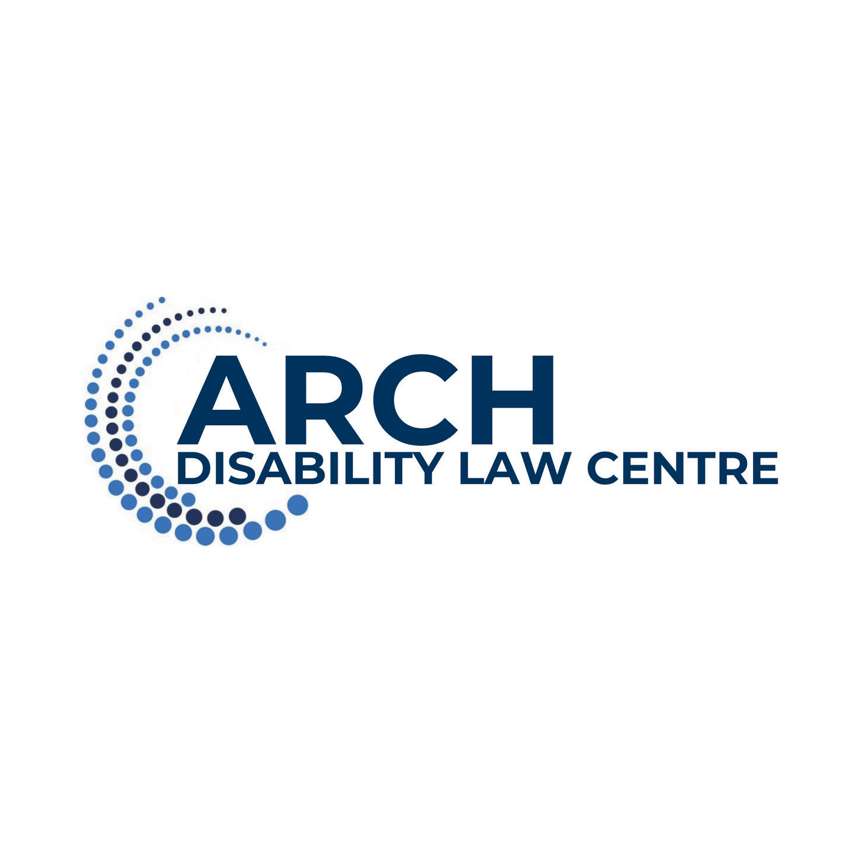

**55 UNIVERSITY AVENUE, 15TH FLOOR  
TORONTO, ON, M5J 2H7**

**Phone: 416-482-8255 1-866-482-2724**

**TTY: 416-482-1254 1-866-482-2728**

[**www.archdisabilitylaw.ca**](http://www.archdisabilitylaw.ca/)

**@archdisabilitylawcentre**

Bluesky iconInstagram icon **@archdisabilitylaw @archdisabilitylaw.bsky.social**

**@ARCHDisabilityLawCentre600**

world wide web iconTikTok icon **@ARCHDisabilityLaw** [**www.archdisabilitylaw.ca**](http://www.archdisabilitylaw.ca/)